

ATHENA - AUTONOMOUS TRIAGE AND HEALTHCARE ELECTRONIC NEURAL ASSISTANT
ATHENA: Fusing scanned reports and vitals into an explainable emergency triage priority
A project report submitted in partial fulfilment of the requirements for the award of the degree of
BACHELOR OF TECHNOLOGY
in
COMPUTER SCIENCE AND ENGINEERING
Submitted by
BADAVENI SRINATH | 23K91A0523
BASANI AVINASH | 23K91A0532
DEGALA PRANEETH | 23K91A0561
BONTHA SAISREE | 23K91A0545
Batch A7 (CSE-A)
Under the esteemed guidance of
K. SHALINI
[DESIGNATION]
DEPARTMENT OF COMPUTER SCIENCE AND ENGINEERING
TKR COLLEGE OF ENGINEERING & TECHNOLOGY (AN AUTONOMOUS INSTITUTION)
Medbowli, Meerpet, Balapur, Hyderabad, Telangana - 500 097
Academic year [ACADEMIC YEAR]

CERTIFICATE
This is to certify that the project report entitled "ATHENA - Autonomous Triage and Healthcare Electronic Neural Assistant" is a bonafide record of the work carried out by BADAVENI SRINATH (23K91A0523), BASANI AVINASH (23K91A0532), DEGALA PRANEETH (23K91A0561), BONTHA SAISREE (23K91A0545), in partial fulfilment of the requirements for the award of the degree of Bachelor of Technology in Computer Science and Engineering, during the academic year [ACADEMIC YEAR], under my supervision.

Project Guide | Head of the Department | Principal
K. Shalini | [HOD NAME] | [PRINCIPAL NAME]
[DESIGNATION] | Department of Computer Science and Engineering | TKR College of Engineering & Technology

External Examiner: [NAME AND SIGNATURE]
Place: [PLACE]
Date: [DATE]

DECLARATION
We hereby declare that the project report entitled "ATHENA - Autonomous Triage and Healthcare Electronic Neural Assistant", submitted to the Department of Computer Science and Engineering, TKR College of Engineering & Technology, in partial fulfilment of the requirements for the award of the degree of Bachelor of Technology in Computer Science and Engineering, is a record of original work carried out by us under the guidance of K. Shalini, [DESIGNATION]. The results embodied in this report have not been submitted to any other university or institution for the award of any degree or diploma.

BADAVENI SRINATH 23K91A0523
BASANI AVINASH 23K91A0532
DEGALA PRANEETH 23K91A0561
BONTHA SAISREE 23K91A0545

Place: [PLACE]
Date: [DATE]

ACKNOWLEDGEMENT
We express our sincere gratitude to our project guide, K. Shalini, [DESIGNATION], for valuable guidance, encouragement and constructive suggestions throughout this project.
We thank [HOD NAME], Head of the Department of Computer Science and Engineering, for providing the facilities and support needed to complete this work, and [PRINCIPAL NAME], Principal, TKR College of Engineering & Technology, for the encouragement given to us.
We thank the project coordinators and all faculty and staff members of the department for their help, and our families and friends for their constant support.
We also acknowledge the authors of the base paper, whose study of diagnostic classification under incomplete clinical data shaped our evaluation, and the maintainers of the open-source software used in this project (FastAPI, React, Vite, XGBoost, SHAP, scikit-learn, RapidOCR, pypdf, ReportLab, SQLAlchemy, pandas and Playwright).

BADAVENI SRINATH
BASANI AVINASH
DEGALA PRANEETH
BONTHA SAISREE
Emergency departments must decide within minutes which patient is seen first. Triage varies with the person on duty, models built on structured fields cannot see what is written only in a scanned report, and a prediction without reasons is hard to accept. This project builds ATHENA, a decision-support tool that reads a PDF or scanned clinical report (text layer or local OCR), extracts symptoms, findings, history and six laboratory values with a lexicon that handles negation, and fuses them with eight vitals into 36 inputs. An isotonic-calibrated XGBoost assigns a priority from 1 (critical) to 5 (non-urgent), a risk level and a confidence; per-patient SHAP shows which findings and vitals drove it. A clinician accepts or changes the priority with a stored reason; a live queue, a performance page and a summary PDF complete the FastAPI and React application.
The model is trained and evaluated on 6,000 seeded synthetic cases, because no real patient records were available, so the figures measure recovery of a known rule, not agreement with clinicians. On 1,200 held-out cases it reaches 69.4% exact accuracy and 99.7% within one level (macro F1 0.670); label noise caps any model near 86%. Fusing report and vitals gives 68.25% against 40.58% for vitals alone, but a logistic-regression baseline (72.4%) scores higher than the chosen model. Priority-1 recall is only 43.9%, so the sickest patients are under-triaged most often. The report reader is exact on generated samples but reaches 84% recall on hand-written fragments. A PDF report is read and triaged in a median 30 ms and a scanned image in about 2.1 s. BioBERT, retrieval and multi-agent orchestration were not built.
Keywords: emergency triage, clinical decision support, optical character recognition, explainable AI, SHAP, XGBoost, probability calibration, healthcare AI.

TABLE OF CONTENTS
CERTIFICATE i
DECLARATION ii
ACKNOWLEDGEMENT iii
TABLE OF CONTENTS v
LIST OF FIGURES vii
LIST OF TABLES viii
LIST OF ABBREVIATIONS x
CHAPTER 1: INTRODUCTION 1
1.1 Domain 1
1.2 Background and Motivation 1
1.3 Problem Statement 2
1.4 Need for the Work 2
1.5 Objectives 3
1.6 Scope 3
1.7 Contributions 4
1.8 Limitations and Assumptions 4
1.9 Organisation of the Report 5
CHAPTER 2: LITERATURE SURVEY 6
2.1 Overview 6
2.2 Base Paper Analysis 6
2.3 Related Work 9
2.4 Datasets and Algorithms Used in This Project 11
2.5 Strengths and Limitations of the Surveyed Work 11
2.6 Research Gap 11
CHAPTER 3: FEASIBILITY STUDY 13
3.1 Technical Feasibility 13
3.2 Economic Feasibility 14
3.3 Operational Feasibility 14
3.4 Schedule Feasibility 15
3.5 Advantages and Constraints 15
CHAPTER 4: SYSTEM REQUIREMENTS AND ANALYSIS 17
4.1 Existing System and Its Limitations 17
4.2 Proposed System and Its Advantages 17
4.3 Functional Requirements 18
4.4 Non-Functional Requirements 18
4.5 Hardware Requirements 19
4.6 Software Requirements 19
4.7 User Roles and Constraints 19
4.9 Data Requirements 20
CHAPTER 5: SYSTEM DESIGN 21
5.1 Design Goals and Architecture 21
5.2 High-Level Workflow 22
5.3 Data Flow Diagrams 23
5.4 UML Design 25
5.5 Data Design 26
5.6 Algorithm Design 28
5.7 Module Design 30
5.8 API Design 30
5.9 User Interface Design 31
5.10 Key Design Decisions 31
5.11 Security and Error-Handling Design 32
CHAPTER 6: METHODOLOGY AND SOFTWARE IMPLEMENTATION 34
6.1 Overall methodology 34
6.2 Dataset 34
6.3 Preprocessing and fusion 36
6.4 Algorithm choice and justification 37
6.5 Mathematical formulation 39
6.6 Model architecture and training configuration 40
6.7 Application architecture 41
6.8 API design 42
6.9 Security and error handling 43
6.10 Installation and execution 44
CHAPTER 7: SYSTEM TESTING 46
7.1 Testing strategy 46
7.2 Unit testing 46
7.3 Integration testing 48
7.4 Functional testing 48
7.5 Security testing 49
7.6 Validation and edge cases 49
7.7 Performance testing 51
7.8 User acceptance testing 53
7.9 Defects and observations from testing 53
7.10 Limits of the testing done 54
7.11 Requirements traceability 55
CHAPTER 8: RESULTS AND OUTPUT SCREENS 56
8.1 Experimental set-up 56
8.2 Output screens 57
8.3 Triage model performance (synthetic hold-out) 60
8.4 Comparison of eight model types 61
8.5 What fusing the report with the vitals adds 62
8.6 Calibration and the confidence threshold 63
8.7 The safety view: under-triage and missed high-risk cases 65
8.8 Robustness to missed report findings 65
8.9 What the model relies on 66
8.10 Report reading 67
8.11 Comparison with the base paper 67
8.12 Sample inputs and outputs 68
8.13 Success and failure analysis 69
8.14 Limitations of the evaluation 70
8.15 Objectives versus outcomes 71
CHAPTER 9: CONCLUSION 72
9.1 Summary of the work 72
9.2 Objectives achieved 72
9.3 Key findings 72
9.4 Practical applications 73
9.5 Known limitations 73
9.6 Lessons learned 73
CHAPTER 10: FUTURE SCOPE 75
10.1 Improvements to the existing system 75
10.2 Additional features 75
10.3 Scalability and deployment 76
10.4 Further research 76
REFERENCES 77
APPENDIX A: IMPORTANT CODE 79
A.1 Report reading: negation and the sentence loop (`extract.py`) 79
A.2 Fusing the record and predicting the priority (`features.py`, `triage.py`) 79
A.3 Training and calibration (`train.py`) 80
A.4 The clinician override route (`routes/api.py`) 80
APPENDIX B: INSTALLATION AND USER GUIDE 81
B.1 Requirements and start 81
B.2 Using the application 81
B.3 Checks and troubleshooting 81
APPENDIX C: ADDITIONAL SCREENS 82

LIST OF FIGURES
Figure 1: Three-tier architecture of ATHENA (React application, FastAPI services, SQLite and model files). 21
Figure 2: Workflow from a scanned report and vitals to a clinician-approved priority. 22
Figure 3: Data flow diagram, level 0 (context). 23
Figure 4: Use-case diagram. 23
Figure 5: Data flow diagram, level 1. 24
Figure 6: Data flow diagram, level 2, of report reading and triage. 24
Figure 7: UML class diagram of the data model and services. 25
Figure 8: Sequence diagram from report upload to clinician override. 26
Figure 9: Entity-relationship diagram of the ATHENA database. 27
Figure 10: Flowchart of report reading. 28
Figure 11: Flowchart of triage scoring and the clinician decision. 29
Figure 12: Architecture of the triage model (fusion, XGBoost, calibration, SHAP). 29
Figure 13: Distribution of priorities and archetypes in the synthetic dataset. 36
Figure 14: Accuracy and macro F1 of the eight models on the synthetic hold-out. 38
Figure 15: Architecture of the triage model: fused record, XGBoost, isotonic calibration, arg-max, SHAP. 40
Figure 16: Precision and recall of the report reader on the hand-written stress fragments, by kind of wording. 50
Figure 17: Median and 95th-percentile latency of the API calls; a scanned image costs about two orders of magnitude more than a text PDF because of OCR. 52
Figure 18: Output screen: the triage queue. Twelve sample cases, counts per priority along the top (0 / 0 / 5 / 1 / 6), filter tabs, a search box, and rows with the main drivers, risk level, confidence and arrival time. 57
Figure 19: Output screen: model performance. Accuracy 69.4 %, within one level 99.7 %, macro F1 0.670, 0.30 s average per patient in that session, recall per priority and the confusion matrix. The blue banner states that the data are synthetic. 57
Figure 20: Output screen: new patient. Sample report 01 was chosen and read in 0.234 s; its symptoms, findings and history are listed with the page each came from, and the vitals fields were filled from the sample. 58
Figure 21: Output screen: result for the live patient. Priority 1 Critical, High risk, calibrated confidence 100 %, top drivers named, with the fused record (report items and vitals) below. 58
Figure 22: Output screen: why this priority. The report's findings with their pages, the vitals, and SHAP bars toward the chosen priority: ST elevation +3.11, troponin +2.19, lactate +1.51, heart rate +1.49. 59
Figure 23: Output screen: after a clinician changed the priority from 1 to 2 with a reason. The banner states the change, the case is marked REVIEWED, and the model's original suggestion stays visible. 59
Figure 24: Confusion matrix of the shipped model on the synthetic hold-out set; the diagonal is correct, nearly every error is one level away. 60
Figure 25: Recall for each priority on the synthetic hold-out set: highest for the non-urgent end, lowest for priority 1. 60
Figure 26: Accuracy and macro F1 of eight model types on the synthetic hold-out set. 61
Figure 27: Accuracy and macro F1 for vitals only, report only and the fused record (synthetic hold-out). 63
Figure 28: Reliability diagram of the calibrated and uncalibrated model on the synthetic hold-out set. 64
Figure 29: Exact accuracy and coverage as the confidence threshold is raised (synthetic hold-out). 64
Figure 30: Accuracy and within-one accuracy as report findings are dropped at random. 66
Figure 31: Mean absolute SHAP value of the fifteen most influential inputs on the synthetic hold-out set. 66
Figure 32: Landing page (light theme): headline, evaluation figures and a scrolling ticker of the key numbers. 82
Figure 33: Sign-in page with the two demo accounts. 82
Figure 34: New patient screen before a report is chosen. 82
Figure 35: The accept-or-change dialog on the result screen. 82
Figure 36: Triage queue after a clinician changed a priority. 82

LIST OF TABLES
Table 1: Abbreviations used in this report x
Table 2: Project objectives and how each was addressed 3
Table 3: The base paper at a glance 7
Table 4: Base paper compared with this project 9
Table 5: Datasets and algorithms of this project 11
Table 6: Related work compared 11
Table 7: Technical feasibility checks and what was measured 13
Table 8: Components, licences and cost to the project 14
Table 9: Limitations of the existing approach 17
Table 10: Advantages of the proposed system over the existing practice 17
Table 11: Functional requirements 18
Table 12: Non-functional requirements and the evidence 18
Table 13: Hardware 19
Table 14: Software: versions that ran 19
Table 15: User roles 19
Table 16: Database tables and their columns 27
Table 17: Other data structures 27
Table 18: Modules, responsibilities and size 30
Table 19: API route groups 30
Table 20: Application screens 31
Table 21: Decisions and their reasons 31
Table 22: Controls and their limits 32
Table 23: Stages of the methodology 34
Table 24: Clinical archetypes (shares are measured on the generated data) 35
Table 25: Severity score terms 35
Table 26: The report lexicon: 22 text flags in three groups 36
Table 27: Lab values read from the report 37
Table 28: Eight models on the same split (synthetic hold-out) 38
Table 29: Value of fusing the two sources (XGBoost, same split) 38
Table 30: Training configuration (ml/train.py) 40
Table 31: Modules and their responsibilities 42
Table 32: API routes of ATHENA (all under /api) 42
Table 33: Test levels, tools and results. 46
Table 34: Unit tests of the report reader. 47
Table 35: Unit tests of the fused record and the model. 47
Table 36: Functional checks by screen. 48
Table 37: Security checks and known gaps. 49
Table 38: Report reader on the 40 stress fragments, by kind of wording. 50
Table 39: Edge cases and how they were checked. 51
Table 40: API latency over HTTP on 127.0.0.1 (milliseconds). 52
Table 41: Findings of the test and measurement runs. 53
Table 42: What was and was not tested. 54
Table 43: Requirements against the evidence in this chapter. 55
Table 44: Data used in the evaluation 56
Table 45: Shipped model: per-priority results on the 1,200 synthetic test cases. 60
Table 46: Confusion matrix (rows: recorded priority, columns: model priority). 60
Table 47: Eight model types on the synthetic hold-out set (same split, uncalibrated). 61
Table 48: Modality ablation (XGBoost, uncalibrated, synthetic hold-out). 62
Table 49: Accuracy of the calibrated model when only cases above a confidence threshold are kept (synthetic hold-out). 64
Table 50: Direction and size of the model's errors (synthetic hold-out, 1,200 cases). 65
Table 51: Accuracy when report findings are dropped at random (shipped model, synthetic hold-out). 65
Table 52: The base paper [1] and ATHENA, feature by feature. 67
Table 53: Three illustrative cases (computed with the shipped model; synthetic sample data). 68
Table 54: The six objectives of the project against what was achieved. 71
Table 55: The six objectives of the batch against the outcome 72
Table 56: Demo accounts 81

LIST OF ABBREVIATIONS
Table 1: Abbreviations used in this report
Abbreviation | Expansion
AI | Artificial Intelligence
API | Application Programming Interface
ATHENA | Autonomous Triage and Healthcare Electronic Neural Assistant
AUC | Area Under the Curve
CDSS | Clinical Decision Support System
COPD | Chronic Obstructive Pulmonary Disease
CORS | Cross-Origin Resource Sharing
CPU | Central Processing Unit
CSE | Computer Science and Engineering
CSV | Comma-Separated Values
CT | Computed Tomography
DFD | Data Flow Diagram
ECE | Expected Calibration Error
ECG | Electrocardiogram
ED | Emergency Department
EHR | Electronic Health Record
ER | Entity-Relationship
ESI | Emergency Severity Index
FHIR | Fast Healthcare Interoperability Resources
GPU | Graphics Processing Unit
HL7 | Health Level Seven
HTTP | Hypertext Transfer Protocol
ICD-10 | International Classification of Diseases, 10th Revision
JSON | JavaScript Object Notation
JWT | JSON Web Token
LIME | Local Interpretable Model-agnostic Explanations
MLP | Multi-Layer Perceptron
NLP | Natural Language Processing
OCR | Optical Character Recognition
ONNX | Open Neural Network Exchange
ORM | Object-Relational Mapping
PDF | Portable Document Format
QWK | Quadratic Weighted Kappa
RAG | Retrieval-Augmented Generation
REST | Representational State Transfer
SHAP | SHapley Additive exPlanations
SPA | Single-Page Application
SpO2 | Peripheral Oxygen Saturation
SQL | Structured Query Language
UI | User Interface
UML | Unified Modeling Language
XGBoost | Extreme Gradient Boosting

CHAPTER 1: INTRODUCTION
This chapter introduces the domain of the project, the motivation for building ATHENA, the problem it addresses, the objectives set for it, the scope that was actually delivered, its contributions, and the limitations and assumptions that govern every result reported later. It closes with a map of the rest of the report. One fact shapes everything that follows and is therefore stated at the start: the triage model was trained and evaluated on a seeded synthetic dataset, because no real patient records were available to the team. Every accuracy figure in this report describes that dataset.

1.1 Domain
An emergency department receives patients in no useful order. Someone with a sprained ankle may arrive just before someone with a heart attack, and the department has to decide within minutes who is seen first. That decision is called triage. Most departments use a five-level scale such as the Emergency Severity Index [14], in which level 1 is a patient who needs immediate life-saving action and level 5 is a patient who can safely wait. The nurse on duty assigns the level from the patient's vitals (heart rate, blood pressure, oxygen saturation, temperature, respiratory rate), the complaint, and whatever the patient or the paperwork says about their history.
The paperwork is the difficult part. Patients arrive with referral letters, discharge summaries and laboratory printouts, many of them scanned or photographed, and the findings that matter (an ST elevation on an ECG, a raised troponin, a prior stroke, an anticoagulant) are written in free text. Reading them takes time that a busy triage desk does not have, and when they are not read the priority is set from the vitals and the first impression alone.
This project sits in the field of clinical decision support and medical informatics. A decision support system does not decide; it reads the available data, proposes a priority, and shows the reasons so that the clinician can accept it or change it. The base paper of the project [1] is a large comparison of machine-learning classifiers for exactly this kind of support, applied to the diagnosis of disease categories from incomplete medical histories.

1.2 Background and Motivation
Triage by scale is known to be uneven. A systematic review of triage performance [9] found that the three most studied scales behave alike, that sensitivity for patients who later turn out to be critically ill is below 80 % in many studies, and that a substantial proportion of patients who die or become critically ill were not designated as high acuity at triage. The same review points to room for improvement in interrater reliability, which is what the batch problem statement means when it calls triage subjective.
Machine learning has been applied to the problem for several years. Models trained on triage data predict hospital admission [10], critical care and emergency procedures [11], [12], and public benchmarks now exist for such tasks [13]. A review of intelligent triage systems [8] concludes that the contributions range from improved triage to prediction of critical care, but that many studies stop before an implementation phase and that the effect on quality of care has still to be assessed. Almost all of this work uses structured fields: vitals, an age, a coded complaint, a few history flags. What is written only in a scanned report does not reach the model.
Two further requirements decide whether such a tool is used at all. The first is explanation. A clinician will not act on a priority that cannot be explained, and a model-agnostic attribution method such as SHAP [16], [17] makes it possible to show, for one patient, which findings pushed the priority up or down. The second is a trustworthy confidence. A score of 0.9 should mean that about nine such predictions in ten are right, and calibration methods [18], [20] exist to make that so.

1.3 Problem Statement
The batch problem statement lists four weaknesses of current practice:
• triage decisions are subjective and vary with the experience of the staff on duty;
• existing systems analyse only structured fields and ignore scanned reports and clinical narrative;
• predictions delivered without justification are not accepted into a clinical workflow;
• delay in prioritising a critical patient directly worsens outcomes.
The problem addressed here is to build and evaluate a multi-source triage assistant that reads a scanned report and the vitals, assigns an explainable priority and risk level, and supports the clinician rather than replacing them.

1.4 Need for the Work
The work is needed because triage models built on structured fields cannot see what is written only in a scanned report; because a priority without reasons is hard to accept at the bedside; and because a model trained on generated data can look reasonable while saying nothing about real patients, so every figure must state the data behind it.

1.5 Objectives
The six objectives set for the project, and what each became, are summarised in the table below. Chapter 8 returns to it with the measured outcome for each.
Table 2: Project objectives and how each was addressed
No. | Objective | How it was addressed
1 | Build an OCR stage that converts scanned medical reports into machine-readable clinical text | PDF text layer read with pypdf; image scans and image-only pages read by RapidOCR (ONNX, local, no network). Met.
2 | Apply a medical language model to extract symptoms, findings and history from that text | Rule-based lexicon of 22 flags with negation handling and six lab parsers; no BioBERT. Partly met: precision 100% and recall 100% on the 12 generated samples, 84.3% recall on 40 hand-written fragments.
3 | Combine text-derived features with tabular vitals in a single patient representation | Fused record of 36 inputs: 8 vitals and 28 report flags (11 symptom, 5 finding, 6 history, 6 lab). Met.
4 | Train a model that assigns a clinical risk level and a triage priority to each patient | XGBoost with isotonic calibration, priority 1 to 5, risk High / Moderate / Low, trained on synthetic data: accuracy 69.4% on the synthetic hold-out. Met on synthetic labels.
5 | Add an explainability layer that shows which findings drove the assigned priority | Per-patient SHAP contributions, strongest first, beside the decision on the result screen. Met.
6 | Evaluate triage accuracy against clinician-assigned priority and measure processing time per patient | Accuracy measured against the recorded priority of the synthetic data only; time per patient measured (PDF flow 30 ms, scan flow 2150 ms, HTTP medians). Partly met.

Three objectives differ from the original wording. Objective 1 asks for deep-learning OCR; the implementation uses RapidOCR, which runs PaddleOCR-family models through ONNX Runtime, and reads the text layer of a PDF directly. Objective 2 asks for a medical language model; the reader is a rule-based lexicon with negation handling, so this objective is only partly met. Objective 6 asks for accuracy against clinician-assigned priority; no clinician-labelled data was available, so accuracy is measured against the recorded priority of a synthetic dataset.
The abstract of the batch also mentions retrieval-augmented generation, a multi-agent architecture, LIME, MongoDB, a Node.js and Flask pair of services and risk models for six diseases. None of these was built; the product uses FastAPI, React and SQLite, and the report treats the others as future work.

1.6 Scope
ATHENA consists of four parts:
• Report reader: PDF text layer or local OCR, a lexicon of 22 clinical flags with negation handling, six laboratory parsers with reference ranges, and the page number of every item found.
• Triage model: the fused record of 36 inputs, an XGBoost classifier of 220 trees and depth 4, isotonic calibration on a separate split, risk level and a per-patient SHAP explanation.
• Clinician workflow: accept or change the priority with a stored reason, a live queue ordered by priority and then arrival, and a downloadable triage-summary PDF.
• Interfaces: a FastAPI service on port 8307 with 13 routes, SQLite storage of users, patients and overrides, JWT sign-in for a clinician and an administrator, and a React 19 application on port 5307 with landing, sign-in, new patient, result, queue and performance screens.
Out of scope are real patient data, integration with a hospital information system, retrieval-augmented generation, a medical language model, multi-agent orchestration, disease-specific risk models, audit-grade security, a user study with clinicians and any regulatory approval. The system is decision support: the treating clinician makes the final triage decision.

1.7 Contributions
1. A working pipeline that reads a scanned report, fuses it with the vitals and returns a calibrated priority with a per-patient explanation, a clinician override loop and a live queue, tested by 47 automated tests and 17 smoke checks.
2. A measured effect of fusion on the synthetic data: 68.2% accuracy for the fused record against 40.6% for vitals alone, with within-one-level agreement of 99.7% and macro F1 0.670 for the shipped model.
3. An honest evaluation that reports weaknesses: recall for priority 1 of 43.9%, high-risk recall of 66.2%, a logistic-regression baseline that scores 72.4%, a label-noise ceiling of 86.25%, and the defects found by a 40-fragment stress test of the reader.
4. Measured processing time: a PDF report is read and triaged in 30 ms and an image scan in 2.1 s (HTTP medians on the development machine).

1.8 Limitations and Assumptions
The conclusions of this report hold under the following limitations and assumptions.
• The model is trained and tested on a seeded synthetic dataset of 6,000 rows built from seven clinical archetypes and a hand-written severity rule. Accuracy measures recovery of that rule, not agreement with clinicians, and real hospital data would give different numbers.
• The labels contain noise by design, so no model can exceed 86.25% exact accuracy on them; the shipped model reaches 69.4%.
• Recall for the most urgent priority is low (43.9%), and the model places the sickest patients one level too low more often than any other group; a clinician must review every priority.
• The report reader is a rule-based lexicon. It is exact on the generated samples it was written with and weaker on wording it does not contain; it was not tested on real scans.
• Security is demonstration grade: a default signing secret unless one is configured, no HTTPS, no rate limiting, seeded demo accounts.
• Timings were measured on one shared machine (Intel Core i5-12500 (12 threads), 15.7 GB RAM, Windows 11 Pro, no GPU, Python 3.11.9, Node 24.19.0) and are indicative; no multi-user load, clinician usability study or prospective evaluation was done.
The base paper's task is the diagnosis of ICD-10 categories from real clinical records; ATHENA's task is five-level triage on synthetic records. Where this report compares the two it says that the tasks, the data and the conditions differ.

1.9 Organisation of the Report
The report continues with the literature survey (Chapter 2), the feasibility study and requirements (Chapters 3 and 4), the design (Chapter 5), the methodology and implementation (Chapter 6), testing (Chapter 7), results with the comparison against the base paper (Chapter 8), the conclusion and future scope (Chapters 9 and 10), the references and three appendices.

CHAPTER 2: LITERATURE SURVEY

2.1 Overview
The survey covers four strands of work that meet in this project: triage in the emergency department and how well it performs, machine-learning models trained on triage data, clinical decision support that reads clinical text, and the explanation and calibration techniques that make a model's output usable at the bedside. The batch literature survey lists five works, led by the base paper [1]. Of the other four, one [3] is a prospective comparison of two triage scales in a Turkish hospital and one [5] is a questionnaire study of how much patients' attendants know about triage in Nepal; neither uses a model. A third, on identifying the high-risk obstetric patient at triage [2], could not be located in any index searched, so it is listed but not used as evidence, and the fourth [4] is a chapter of a book on emergency triage of the horse, which is veterinary and outside the human-triage domain of this project. The review therefore leans on the base paper's own analysis and on the triage and decision-support literature found and checked for this report. Results quoted below are the authors' own claims; none was reproduced.

2.2 Base Paper Analysis

2.2.1 Problem and approach
The base paper, by Mlodawski et al. [1], addresses a problem that every decision-support system meets in practice: clinical data are incomplete. A history may omit symptoms that were not asked about, laboratory tests that were not ordered, and details the clinician had no time to record. The authors classify the kinds of incompleteness (systemic, cognitive, procedural, temporal, semantic and disproportionate) and argue that a system should work directly on incomplete records, without imputation, and should keep a broad list of diagnostic hypotheses instead of a single answer.
Their system takes the symptoms, examination findings and laboratory results of an internal-medicine or paediatric consultation, encodes them as binary indicators, and passes them to 19 trained classifiers. Each classifier returns a probability for each ICD-10 category. The top-ranked category is the TOP-1 answer; the three most probable categories form the TOP-3 list, which formalises the differential diagnosis a physician keeps in mind. For high-risk disease categories a higher probability threshold is required before the TOP-1 answer is accepted alone; otherwise the system falls back on the TOP-3 list. The processing chain is a pipeline: user interface, orchestrator, symptom encoder, dataset converter, feature engineering, trainers, an Optuna hyper-parameter optimiser, an evaluation module, a packaging and reporting layer, and a deployment layer with a REST API, real-time prediction and batch prediction.

2.2.2 Evaluation protocol and reported numbers
Because real records were scarce for 87 diagnostic classes, the authors trained on rule-based synthetic cases generated from ICD-10 diagnostic criteria and symptom co-occurrence patterns, and evaluated on 1,655 authentic cases. They add that this synthetic-to-real route is a feasibility approach, not a substitute for real training data. The table below summarises the design and the numbers as printed in the paper.
Table 3: The base paper at a glance
Item | As reported in the paper
Task | Classify the disease category (ICD-10) of a patient from the symptoms, examination findings and a few laboratory results of a medical history; 87 classes (32 paediatric, 55 internal medicine)
Data | 1,655 authentic clinical cases from electronic records (616 internal medicine, 1,039 paediatrics); 479 clinical parameters (65 reported symptoms, 386 examination signs, 28 laboratory and imaging values); mean feature completeness 74.91 % (paediatrics) and 82.31 % (internal medicine)
Training data | Rule-based synthetic cases generated from ICD-10 criteria and symptom co-occurrence patterns, with partial feature shifting, adaptive noise and synthetic combinations; evaluation on the authentic cases
Algorithms | 19 classifiers in five families (tree-based, ensemble, linear and probabilistic, distance and kernel based, neural network), each tuned per specialty by Optuna TPE with a median pruner, 100 trials for standard models
Missing data | No imputation: a symptom that is not documented is set to 0 (absent); histogram gradient boosting handles missing values natively
Uncertainty | Two-stage TOP-1 / TOP-3 ranking from class probabilities; a confidence threshold of 0.85 marks a diagnosis as highly probable; entropy of the probability distribution as an uncertainty measure
Explanation | SHAP (KernelExplainer, k-means background) and LIME; top-feature agreement between the two of 43.1 % (GB) and 31.9 % (MLP); physician review of SHAP heatmaps
Statistics | McNemar paired tests with exact p-values; bootstrap 95 % confidence intervals with 1,000 resamples
Headline results | TOP-1: Gradient Boosting 84.74 % (internal medicine), Multi-Layer Perceptron 87.20 % (paediatrics); mean TOP-3 77.43 % and 81.99 %; best TOP-3 91.72 % and 94.71 %
External validation | 120 cases from another facility: TOP-1 73.33 % / 78.33 %, TOP-3 86.67 % / 90.00 % (internal medicine / paediatrics); treated by the authors as the primary benchmark
Deployment | Core module of the PARROT AI multimodal medical assistant [27]; REST API, real-time and batch prediction modes

Two points in the paper's own discussion matter for this project. The authors state that the internal-set accuracies reflect synthetic-to-real transfer and may be inflated by the shared ICD-10 framework, and therefore treat the external validation (73.33 % and 78.33 % TOP-1) as the primary benchmark. They also write that no claim of clinical utility can be substantiated without an adequately powered prospective study on real data from several facilities.

2.2.3 Strengths
• A broad, fair comparison: 19 algorithms, tuned with the same sampler and seed, with McNemar tests and bootstrap confidence intervals to separate real differences from noise.
• A realistic treatment of missing data: no imputation, absent symptoms set to zero, and an algorithm family (histogram boosting) that handles gaps natively.
• The TOP-3 mechanism, which turns a single fallible answer into a ranked differential, together with a confidence threshold and a sensitivity analysis of that threshold.
• Explanation checked by physicians: SHAP heatmaps per ICD-10 category were reviewed for consistency, and a referral-feature ablation showed the models do not lean on referrals as a proxy for the label.
• Candour about limits: external validation on 120 cases from another region, a reported fall in TOP-1 accuracy, and an explicit warning about synthetic-to-real evaluation.

2.2.4 Limitations
• The input is a list of typed binary indicators. Nothing in the system reads a scanned or photographed report, although much of the information in real records lives there.
• The target is an ICD-10 diagnosis, not an urgency. A system that names a probable diagnosis does not say who must be seen first.
• Vital signs enter only as binary examination findings such as normal blood pressure, not as measured values; the 479 parameters are symptoms, examination signs and a few laboratory and imaging results.
• The data come from one healthcare system; the external set is only 120 cases; rare diseases were excluded by the three-case minimum, and the low-prevalence classes are called exploratory by the authors.
• The paper reports accuracy, precision, F1 and TOP-3 but no processing time per patient and no description of how a clinician would act on a prediction.
• SHAP and LIME agree on only 31.9 % to 43.1 % of top features, which the authors explain as methodological complementarity but which leaves the explanation partly unsettled.

2.2.5 What this project keeps from the base paper and what it changes
ATHENA reuses the ideas of the base paper that carry over to triage, and changes the input, the target and the workflow. The table below sets the two side by side. The tasks and data differ, so no accuracy in this report is set against the base paper's as a competing figure.
Table 4: Base paper compared with this project
Aspect | Base paper | This project
Probability ranking instead of a bare label | TOP-1 and TOP-3 lists with class probabilities | Calibrated probabilities for all five priorities; Top-2 accuracy 95.3% reported beside exact accuracy 69.4%
High-confidence threshold | 0.85, with a sensitivity analysis from 0.70 to 0.95 | Same sweep on the synthetic hold-out: at 0.85 coverage 25.5% and accuracy 87.6%
Absent symptom is 0, no imputation | Binary indicators default to 0 | Every report flag defaults to 0 when the reader does not find it; robustness to dropped flags measured
Several algorithms compared | 19 classifiers | 8 models on the same split (Chapter 8); XGBoost kept for calibration and SHAP, not because it won
SHAP explanation | KernelExplainer, global heatmaps per ICD-10 group | TreeExplainer, one list per patient beside the decision
Input data | Typed symptom indicators and a few laboratory values | A scanned report read by OCR and a lexicon, fused with eight vitals
Target | ICD-10 diagnosis, 87 classes | Five-level triage priority with a risk level
Training data | Rule-based synthetic training, real evaluation | Rule-based synthetic training and synthetic evaluation: weaker evidence
Workflow | Decision-support module after the consultation | Clinician accept-or-change loop with a stored reason, live queue, summary PDF
Not carried over | Optuna tuning, LIME, dynamic ensemble, McNemar tests, external validation | Not done; listed as future work

2.3 Related Work

2.3.1 Triage scales and their performance
Emergency triage is organised around a small number of five-level scales: the Emergency Severity Index [14], the Canadian Triage and Acuity Scale, the Manchester Triage System and the Australasian Triage Scale. The systematic review of Hinson et al. [9] searched four databases through 2016, found 6,160 publications and analysed 50 with sufficient data. The three most studied scales showed similar performance; most studies found high sensitivity for identifying patients who died in the emergency department, but sensitivity for identifying critical illness was below 80 %, and a substantial proportion of patients who die after the encounter or are critically ill were not designated as high acuity at triage.
A prospective study in a Turkish state hospital [3] triaged 6,000 patients with ESI and 6,000 with the Manchester system and compared clinical outcomes, patient satisfaction and risk management; its authors favour expanding the use of ESI. It is a process study with no learning component, which makes it useful as evidence that the five-level target is the one the field already uses.

2.3.2 Machine learning on emergency-department triage data
Hong, Haimovich and Taylor [10] trained logistic regression, XGBoost and deep neural networks on 560,486 visits from one academic and two community emergency departments to predict hospital admission. Models using only triage information reached a test AUC of about 0.87 and models with the full variable set about 0.91 to 0.92, so history added measurable information. Levin et al. [11] built a random-forest electronic triage on 172,726 visits that used vital signs, chief complaint and history to predict critical care, an emergency procedure and hospitalisation; AUCs ranged from 0.73 to 0.92 and the model matched or outperformed ESI.
Raita et al. [12] compared Lasso regression, random forest, gradient-boosted trees and a deep neural network on 135,470 adult visits from the NHAMCS survey, with an ESI-based logistic regression as reference. For critical care all four learned models beat the reference; the deep network reached an AUC of 0.86 against 0.74. Xie et al. [13] released a benchmark built on MIMIC-IV-ED so that such models can be compared on public records. The review of Fernandes et al. [8] covers this body of work and notes that several studies lack an implementation phase and that the impact on quality of care still has to be assessed.

2.3.3 Clinical text, language models and OCR
Clinical language models such as BioBERT [22] are pre-trained on biomedical text and improve information extraction from clinical notes. The base paper itself points to a coding system that combines a deep contextualised language model with rule-based methods for ICD-10 coding [28], where the combination of a pre-trained model with expert rules was credited for the result, and to a multimodal medical assistant that integrates documentation and decision support [27]. Reading a scan first requires optical character recognition; PP-OCR [23] is a practical lightweight system whose family of models is available through ONNX Runtime and is used in this project through the RapidOCR package. A systematic review of generative AI against physicians [29] and a review of clinician performance with decision-support systems [32] are cited by the base paper in its discussion of how AI diagnosis compares with physicians and how decision support is evaluated; they are used here to argue for careful evaluation.

2.3.4 Explanation and calibration
SHAP [16] assigns each input an additive contribution to one prediction, and the TreeExplainer algorithm [17] computes exact values for tree ensembles quickly enough to run inside a request. LIME [26] fits a local linear surrogate. The base paper reports that the two agree on only part of the top features and recommends a consolidated view, with SHAP as the primary explanation. For probabilities, isotonic regression [18] and other methods [19] map raw scores to frequencies, and the observation that modern models are often over-confident [20] explains why a calibration stage is worth its cost in a clinical setting. Explanation and calibration are treated here as part of the product, not as an afterthought: the result screen shows the SHAP list and the calibrated confidence together.

2.4 Datasets and Algorithms Used in This Project
Table 5: Datasets and algorithms of this project
Element | Choice | Why
Training and test data | Seeded synthetic dataset, 6,000 rows, seven archetypes, 36 inputs, five priorities (ml/make_data.py, seed 7307) | No real patient records were available to the team; the synthetic set is reproducible and carries a known rule and noise level
Intended real source | Kaggle 'Hospital Triage and Patient History Data' (licence not stated); scripts/download_data.py exists but was never run | Would give clinician-recorded outcomes; not used, so no real-data claim is made
Sample reports | 12 generated reports (8 two-page PDFs, 4 PNG scans) with expected findings | Demonstrate both intake paths; they test the pipeline, not real-world scan variety
Report reading | pypdf text layer; RapidOCR for images; lexicon of 22 flags with negation; six lab parsers | Offline, no key, inspectable; a medical language model was beyond the data and time available
Triage model | XGBoost, 220 trees, depth 4, learning rate 0.1 [15] | Strong on tabular data [21], native TreeSHAP, fast on CPU
Calibration | Isotonic regression on a separate 20 % calibration split [18] | Makes the displayed confidence a probability
Explanation | SHAP TreeExplainer on the same trees [17] | Exact, per patient, cheap enough for one request
Comparison models | Logistic regression, decision tree, random forest, extra trees, k-NN, MLP, histogram boosting [25], [24] | Same split, to show what the shipped choice costs or gains

2.5 Strengths and Limitations of the Surveyed Work
Table 6: Related work compared
Work | Approach | Reported result | Limitation for this project
Mlodawski et al. [1] (base paper) | 19 classifiers, TOP-1 / TOP-3, SHAP and LIME | GB 84.74 %, MLP 87.20 % TOP-1 | Typed indicators; no scanned input; no timing
Fernandes et al. [8] | Review of intelligent triage support | Contributions from better triage to critical-care prediction | Many studies never reached implementation
Hinson et al. [9] | Review of triage scale performance | 182 eligible studies; sensitivity for critical illness below 80 % | Describes the scales, proposes no model
Hong et al. [10] | Logistic regression, XGBoost, deep nets | 560,486 visits; triage-only AUC about 0.87, full about 0.92 | Predicts admission, not priority
Levin et al. [11] | Random-forest e-triage | 172,726 visits; AUC 0.73 to 0.92; matched or beat ESI | Predicts outcomes; structured fields
Raita et al. [12] | Lasso, forest, boosting, deep net | 135,470 visits; deep net AUC 0.86 against 0.74 for ESI | Structured fields only

Taken together, the surveyed work is strong on scale: hundreds of thousands of visits, statistical tests, external validation. It is weaker on three counts that matter here. It rarely uses the content of scanned documents; it rarely targets the five-level priority; and it seldom reports what the whole path costs in time or how a clinician's agreement with the model would be recorded.

2.6 Research Gap
The gap identified by the batch survey is that the surveyed models are evaluated on single-modality structured data, and that a pipeline fusing scanned-report reading, clinical text and tabular vitals, and exposing the reasoning behind each decision, is missing. The survey of this report refines it into five points:
1. The surveyed models are evaluated on single-modality structured data: no pipeline fuses a scanned report with the vitals
2. Triage priority (five levels) is rarely the target; most work predicts admission, critical care or ICD-10 diagnoses [10], [1]
3. Explanations are usually global or offline; a per-patient reason shown next to the decision is missing in deployed designs
4. Calibrated confidence and an accept-or-change record for the clinician are seldom reported together
5. Processing time per patient, including report reading, is almost never measured
ATHENA addresses these points on a small scale and under an honest limit: it fuses a scanned report with the vitals, targets the five-level priority, shows a per-patient explanation with a calibrated confidence, stores the clinician's decision, and measures time per patient; and it does so on synthetic data, so it demonstrates the pipeline and not clinical performance.

CHAPTER 3: FEASIBILITY STUDY
A feasibility study asks whether a project can be built, run and maintained with the resources at hand. For ATHENA the question was answered partly by analysis and partly by building the system and measuring it on the development machine, so most entries below carry a measured value rather than an estimate. Where a question could not be settled with the data available to the team, the entry says so.

3.1 Technical Feasibility
The technical risk lay in five places: whether a scanned report could be read well enough on an ordinary processor without a cloud service; whether the text could be turned into clinical flags reliably with rules; whether a calibrated, explainable multi-class model could be trained and served on a CPU; whether report features and vitals could be fused in one representation; and whether the pieces could be combined behind one API and one web application. The development machine is Intel Core i5-12500 (12 threads), 15.7 GB RAM, Windows 11 Pro, no GPU, Python 3.11.9, Node 24.19.0. It was shared with other jobs during every measurement, so the figures are indicative.
Table 7: Technical feasibility checks and what was measured
Question | Measurement | Verdict
Can a scan be read offline on a CPU? | RapidOCR (ONNX Runtime) reads a generated PNG scan in a median 2.23 s over HTTP; text-layer PDFs are read in 9.3 ms | Feasible; scans are the slow path
Can the report be turned into clinical flags? | 22 text flags and 6 lab flags by lexicon and parsers: precision 100% and recall 100% on the 12 generated samples; precision 95.2% and recall 84.3% on 40 hand-written fragments | Feasible for known wording; weaker for paraphrase
Can a calibrated multi-class model be trained on a CPU? | XGBoost with 220 trees trains in 0.44 s on 3,840 rows; calibration on 960 more | Feasible
Is inference fast enough for a nurse waiting at a desk? | Model alone about 0.012 ms per patient; POST /patients with SHAP 21.7 ms median over HTTP; a PDF report is read and triaged in 30 ms, a scan in 2.1 s | Feasible
Can report features and vitals be fused? | One 36-input record; on the synthetic data the fused model reaches 68.2% against 40.6% for vitals alone | Feasible; gain is measured on synthetic data
Can everything run behind one API and one web application? | FastAPI with 13 routes and React 19 with six screens; smoke test of 17 checks and 47 automated tests pass | Feasible
Was real clinical data available? | No. The Kaggle triage dataset needs a user token and its licence is not stated; the download script was never run | Not feasible within the project; synthetic data used

The one technical question that was not settled in the project's favour is data. Without clinician-recorded priorities the model can only be trained and tested against a rule the team wrote, and the report says so wherever a result is quoted.

3.2 Economic Feasibility
The project was built with open-source software only and runs on a standard desktop. No licence, cloud service or GPU was bought. The only paid component that was considered, a multimodal language-model API for reading reports, was dropped, which removed both a recurring cost and a dependence on the network.
Table 8: Components, licences and cost to the project
Item | Role | Licence | Cost
Python, FastAPI, SQLAlchemy, SQLite | Backend, storage | Open source | Nil
XGBoost, scikit-learn, SHAP | Model, calibration, explanation | Open source | Nil
RapidOCR, ONNX Runtime, pypdf, Pillow | Report reading | Open source | Nil
ReportLab | Triage-summary PDF | Open source | Nil
React, Vite, Recharts, Framer Motion, GSAP | Web application | Open source | Nil
Development machine | Intel Core i5-12500 (12 threads), 15.7 GB RAM, Windows 11 Pro, no GPU, Python 3.11.9, Node 24.19.0 | Owned | No new purchase
Training data | Seeded synthetic data generated by ml/make_data.py | Own work | Nil

Operating costs would arise only in a real deployment: clinical data under a governance process, hosting with encryption in transit, an audit trail, and clinician time for validation. None of these was costed, because the project is not a deployment.

3.3 Operational Feasibility
The system is meant to be used by a triage nurse or clinician in the role of the user, and by an administrator who watches queue load and model performance. The operator starts the application with run.bat, which creates a virtual environment, installs the packages, trains the model if the file is missing, starts the API on port 8307 and the web application on port 5307, and opens the browser. From the web application the user can pick a sample report or upload a PDF or image, enter the vitals, read the priority with its reasons, accept or change it, watch the queue reorder, download the summary and read the performance page.
• Skills needed: none beyond using a browser; Python 3.11 or newer and Node.js 18 or newer must be installed once.
• Resources: about 1.5 GB of disk for the Python environment; the model file is about 1.6 MB; an internet connection only for the first installation.
• Maintenance: retraining is two commands (ml/make_data.py, ml/train.py); the database is reset by deleting data/app.db.
• What operations would still need: real data, integration with the hospital's records, a clinician validation study, stronger security (HTTPS, a configured secret, rate limiting) and an audit trail. None of these exists yet (Chapter 10).
The fresh-environment path of setup.bat and the Kaggle download script were not exercised during the documentation run, so operational feasibility from a clean machine is untested.

3.4 Schedule Feasibility
The repository does not record a calendar plan, and inventing dates would be misleading. The table below therefore gives the order in which the work was done, as the documents and the version-control history show, with a planning estimate of relative effort in weeks. The estimates are the team's allocation and not a measured record.
The plan held because the design is small: a reader, a model, a database and six screens. The part that could not be scheduled, obtaining real clinical data, was left out of the plan.

3.5 Advantages and Constraints

3.5.1 Advantages
• The report, the vitals, the priority, the reasons and the clinician's decision sit in one record, so disagreement between model and clinician can be counted.
• Everything runs offline after installation: no cloud OCR, no language-model API and no patient data leave the machine.
• The whole path is quick on a PDF (30 ms median) and usable on a scan (2.1 s median), and the model itself takes about 0.012 ms.
• Each priority comes with a per-patient explanation and a calibrated confidence, and the performance page states that its numbers are synthetic.
• Everything is open source, small and reproducible from a seed, and runs on one ordinary machine.

3.5.2 Constraints
• The model is trained and tested on synthetic data; its accuracy is not clinical accuracy.
• The report reader is a lexicon and does not understand wording it does not contain.
• Recall for priority 1 is 43.9% on the synthetic hold-out, so the model is a second opinion and not a gatekeeper.
• No clinician has used the system, and no regulatory review has taken place.
• Security is demonstration grade: seeded demo accounts, a default signing secret unless one is configured, no HTTPS.
The base paper [1] states that its synthetic-to-real route is a feasibility approach and that no claim of clinical utility can be made without a prospective study on real data; the feasibility judgement here is the same in spirit: the engineering is feasible and measured, the clinical value is not shown.

CHAPTER 4: SYSTEM REQUIREMENTS AND ANALYSIS
This chapter describes the situation the project starts from, the system that was built in response, the functional and non-functional requirements it was built to meet, and the hardware, software, users and constraints involved. Requirement identifiers (FR-n and NFR-n) are used again in Chapter 7 where each is tested.

4.1 Existing System and Its Limitations
In most emergency departments triage is done by a nurse using a five-level scale such as ESI [14]. The nurse measures the vitals, asks about the complaint, looks at whatever the patient has brought and assigns a level. Where an electronic record exists it holds structured fields; the scanned or photographed reports the patient brings are viewed as images or files, and the findings in them reach the decision only if the nurse reads them. Research systems add machine-learning models trained on structured fields [10], [11], [12], and the base paper adds a comparison of 19 classifiers on typed symptom indicators [1].
Table 9: Limitations of the existing approach
Limitation | Consequence
The level depends on the person on duty | Sensitivity for critical illness below 80 % in many studies [9]
Scanned reports are not machine-readable | Findings such as ST elevation, raised troponin or an anticoagulant do not reach any model
Structured-field models see only the fields | A model cannot weigh what is written only in a report
Output is a label or a score with no reasons | The clinician cannot see why, and so cannot challenge it quickly
Confidence is not calibrated | A score of 0.9 may not mean nine in ten; calibration is a known need [20]
No record of agreement | Nobody can count how often the clinician changes the machine's priority, or why
Time per patient is not reported | A tool that is accurate but slow cannot be judged for a triage desk

4.2 Proposed System and Its Advantages
ATHENA is a decision-support application with six screens and thirteen API routes. A nurse picks a sample report or uploads a PDF or image; the system reads it, shows the symptoms, findings, history and lab values it found with their page numbers, and fills the form with the vitals. On request it assigns a priority from 1 to 5 with a risk level and a calibrated confidence, and shows the factors behind the priority, strongest first. The clinician accepts the priority or changes it with a reason; the change is stored, the queue reorders, and a one-page triage summary can be downloaded. A performance page shows the offline metrics, a confusion matrix and the live counts.
Table 10: Advantages of the proposed system over the existing practice
Advantage | Evidence
Reads the scanned report | 22 text flags and 6 lab flags; 100% recall on the generated samples, 84.3% on the stress set
Fuses report and vitals | Synthetic hold-out accuracy 68.2% fused against 40.6% vitals-only and 63.2% report-only
Shows the reasons | Per-patient SHAP list on the result screen, strongest first
Calibrated confidence | Isotonic calibration; ECE 0.041 against 0.047 before it
Records the clinician's decision | Accept or change with a required reason, stored with the old and new priority
Fast | Median 30 ms for a PDF report and 2.1 s for a scan, end to end over HTTP
Offline and inspectable | No cloud service or key; every rule is in the repository

4.3 Functional Requirements
The functional requirements follow the seven features of the overview document (F1 to F7) and the supporting needs of sign-in and demonstration. Every requirement is met in the build; the evidence column names where it is shown.
Table 11: Functional requirements
ID | Requirement | Status and evidence
FR-1 | A user signs in with email and password; roles clinician and administrator; every patient route needs a token | Met; bcrypt hashes, 12-hour JWT; API tests of 401 on missing and invalid tokens
FR-2 | Upload a PDF, PNG or JPG report of at most 15 MB; read its text by text layer or OCR | Met; empty (400) and unsupported (422) uploads tested; 15 MB cap in code; 12 samples read
FR-3 | Extract symptoms, findings, history and six lab values with the page of each item, handling negation and reference ranges | Met for known wording (Chapter 7); defects listed
FR-4 | Enter age, heart rate, systolic and diastolic blood pressure, SpO2, temperature, respiratory rate and arrival mode, with range checks | Met; out-of-range values rejected with 422
FR-5 | Build one fused record of 36 inputs from the vitals and the report flags | Met; shown side by side on the result screen
FR-6 | Assign priority 1 to 5, a risk level and a calibrated confidence | Met on synthetic data (Chapter 8)
FR-7 | Explain the priority for that patient with signed contributions, strongest first | Met; SHAP TreeExplainer; order tested
FR-8 | Let the clinician accept or change the priority, requiring a reason for a change, and store the decision | Met; 422 without a reason; override log per patient
FR-9 | Show a queue ordered by priority then arrival, with filter and search | Met; order tested on the sample queue
FR-10 | Download a one-page triage summary as a PDF | Met; the response starts with the PDF header and is tested
FR-11 | Show model performance (accuracy, recall per priority, confusion matrix) and live counts (overrides, seconds per patient) | Met; page labels the data as synthetic
FR-12 | Provide labelled sample reports and a seeded sample queue so the application is not empty | Met; 12 reports and 12 sample cases, marked as samples

4.4 Non-Functional Requirements
Table 12: Non-functional requirements and the evidence
ID | Requirement | Measured evidence
NFR-1 | A PDF report is read and triaged in well under a second; a scan in under five seconds | Median 30 ms (p95 43 ms) for a PDF; median 2.15 s for a scan; end-to-end maximum 4.32 s on the samples
NFR-2 | Model inference does not dominate the path | About 0.012 ms per patient in batch; POST /patients 21.7 ms median including SHAP and the database write
NFR-3 | Priority errors stay small: nearly all predictions within one level | 99.67% within one level on the synthetic hold-out; exact accuracy 69.4%
NFR-4 | Every result carries an explanation | SHAP list returned with every POST /patients; tested
NFR-5 | Displayed confidence behaves like a probability | ECE 0.041; the 0.8 to 0.9 bin is over-confident (Chapter 8)
NFR-6 | Basic security: authentication on patient routes, hashed passwords, input validation, upload limit, no path traversal | Tested; known gaps listed (default secret, no HTTPS, no rate limiting)
NFR-7 | Clear errors instead of crashes | 400, 401, 404, 413, 422 and 503 paths with plain messages; empty and unsupported uploads tested
NFR-8 | Usable at phone, tablet and desktop widths, in light and dark, by keyboard | Responsive check at 360, 768 and 1440 px passed when the interface was built; not re-run in this session
NFR-9 | Runs offline on a Windows desktop after installation | Yes; no network call at run time; Windows only was tried
NFR-10 | Maintainable and testable | 47 pytest tests (46 pass, 1 expected failure) in about 15 s; retraining in two commands
NFR-11 | Honest about data: synthetic data labelled wherever numbers appear | Performance page banner and landing text state it; results documents repeat it

4.5 Hardware Requirements
Table 13: Hardware
Item | Minimum stated by the project | Machine used for all measurements
Processor | Not stated; CPU only | Intel Core i5-12500, 12 threads
Memory | Not stated | 15.7 GB
Disk | About 1.5 GB for the Python environment and packages | Local SSD
Graphics processor | Not needed | Not used
Display | Any modern browser, 360 px wide or more | 1440 x 900 for the screenshots

4.6 Software Requirements
Table 14: Software: versions that ran
Component | Requirement | Used for the measurements
Operating system | Windows with run.bat | Windows 11 Pro
Python | 3.11 or newer | 3.11.9
Node.js | 18 or newer | 24.19.0
FastAPI / Uvicorn / SQLAlchemy / Pydantic | listed in requirements.txt (unpinned) | 0.162.0 / 0.54.0 / 2.1.6 / 2.14.1
XGBoost / scikit-learn / SHAP | listed (unpinned) | 3.2.0 / 1.9.1 / 0.51.0
NumPy / pandas | listed (unpinned) | 2.4.6 / 3.1.0
RapidOCR with ONNX Runtime / pypdf / Pillow | listed (unpinned) | onnxruntime 1.31.0 / 6.21.2 / 13.0.0
ReportLab / PyJWT / bcrypt | listed; bcrypt pinned to 4.0.1 | 5.1.0 / 2.15.1 / 4.0.1
React / Vite | package.json | React 19.3 / Vite 8
pytest | development only | 9.1.1

4.7 User Roles and Constraints
Table 15: User roles
Role | What the role does | Interface
Clinician | Enters patients, reads the result and the reasons, accepts or changes the priority, downloads the summary | New patient, Result, Queue
Administrator | Watches queue load and the performance page; seeded with the same rights in this build | Queue, Performance
Developer | Retrains the model, regenerates data and samples, runs the tests | Command line

• The application never replaces the clinician: the final priority is always the clinician's, and a change needs a stated reason.
• Both roles have the same rights in this build; role-based permissions are future work.
• Ports are fixed: API 8307, web application 5307.
• The demo accounts are seeded and their password is documented, which is acceptable for a demonstration and not for a deployment.

4.9 Data Requirements
The model needs, for each patient, the eight vitals and the 28 report flags, with the unreported flags set to 0, as in the base paper. Training needs a priority for every row. The project generates 6,000 rows from seven clinical archetypes: minor 33.6%, cardiac 14.6%, respiratory 11.9%, trauma 11.7%, abdominal 10.3%, infection 9.4% and neuro 8.5%. The priority is a noisy function of a hand-written severity score. Real data would replace these rows with clinician-recorded priorities and with reports that were scanned in the department, under ethical and data-protection approval that this project did not seek.

CHAPTER 5: SYSTEM DESIGN
This chapter describes how ATHENA is built: the architecture and workflow, the data flow, the class and sequence design, the data design, the two core algorithms (report reading and triage scoring), the module and API design, the user interface and the security and error-handling design. Every diagram was drawn from the code (backend/app/, ml/ and frontend/src/) and is reproduced with an explanation; the full set is also collected in the Block Diagrams document.

5.1 Design Goals and Architecture
Five goals shaped the design. First, one patient record from two sources: the scanned report and the vitals must end up in a single representation that one model reads. Second, a decision with its reasons: the priority, a calibrated confidence and the factors behind it appear together on one screen, because a prediction that cannot be explained is not accepted into a clinical workflow. Third, the clinician stays in charge: every priority can be accepted or changed, a change needs a reason, and both are stored. Fourth, runs offline on a CPU: report reading uses a local OCR engine and no network call, so the system works on the ordinary workstation of a ward. Fifth, small and runnable: one API, one browser application and one SQLite file.
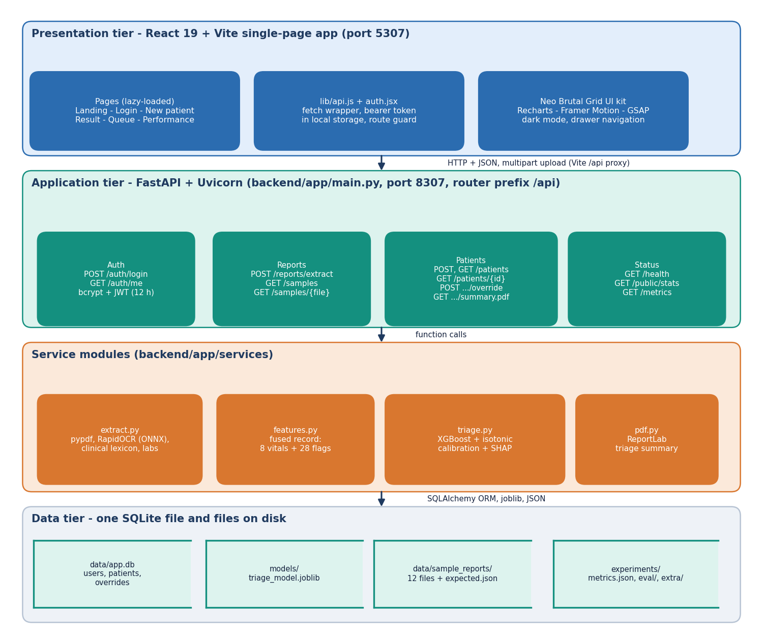
Figure 1: Three-tier architecture of ATHENA (React application, FastAPI services, SQLite and model files).
The presentation tier is a React 19 and Vite single-page application on port 5307; it reaches the API through a Vite proxy on the path /api. The application tier is FastAPI on port 8307. Its router (routes/api.py) calls four services: extract.py reads a report, features.py defines and builds the fused record, triage.py runs the calibrated XGBoost model and the SHAP explainer, and pdf.py renders the triage summary with ReportLab. Authentication (auth.py) issues and checks signed tokens. The data tier is a SQLite database (data/app.db) with three tables, plus the trained model file models/triage_model.joblib and the evaluation reports in experiments/.
The services do not import each other except through features.py, which is the single definition of the 36 model inputs. The model is trained offline by ml/train.py, so serving needs only the saved file, and the experiments in Chapter 8 can time each service on its own and together.

5.2 High-Level Workflow
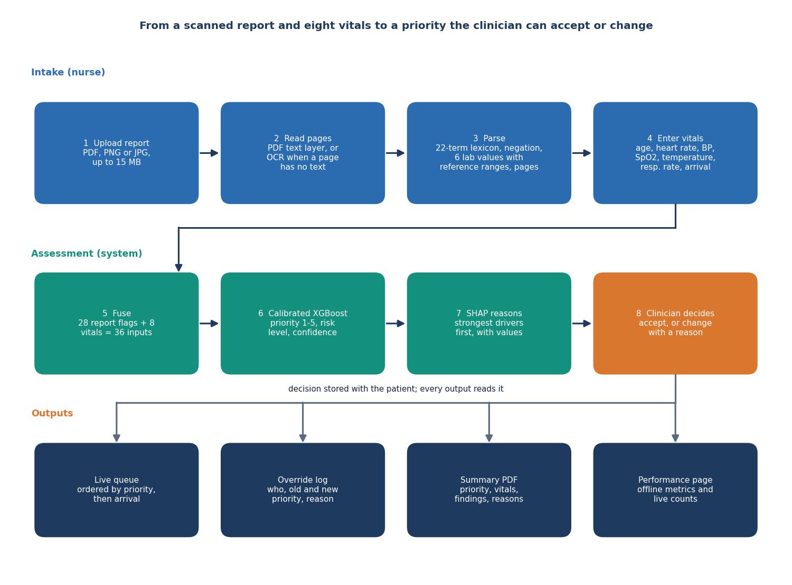
Figure 2: Workflow from a scanned report and vitals to a clinician-approved priority.
A nurse signs in, opens New patient, and uploads a PDF or an image of the report (or picks one of the twelve generated sample reports). The server reads the report and returns symptoms, findings, history and lab values, each with the page it came from. The nurse enters eight vitals. The server fuses the 28 report flags and the vitals into 36 inputs, the model returns a priority from 1 to 5 with a calibrated confidence, and SHAP lists the strongest factors. The patient is stored and the queue, which is ordered by priority and then by arrival time, is updated. A clinician opens the result and either accepts the priority or changes it with a reason; the decision is stored with the patient and the model's original suggestion is kept.
Every step runs in the same request cycle as the screen that triggers it. Reading a PDF takes about 9 ms and an image scan about 2.2 s on the CPU of the measurement machine; assigning a priority takes about 22 ms (medians over HTTP, Chapter 8).

5.3 Data Flow Diagrams

5.3.1 Level 0
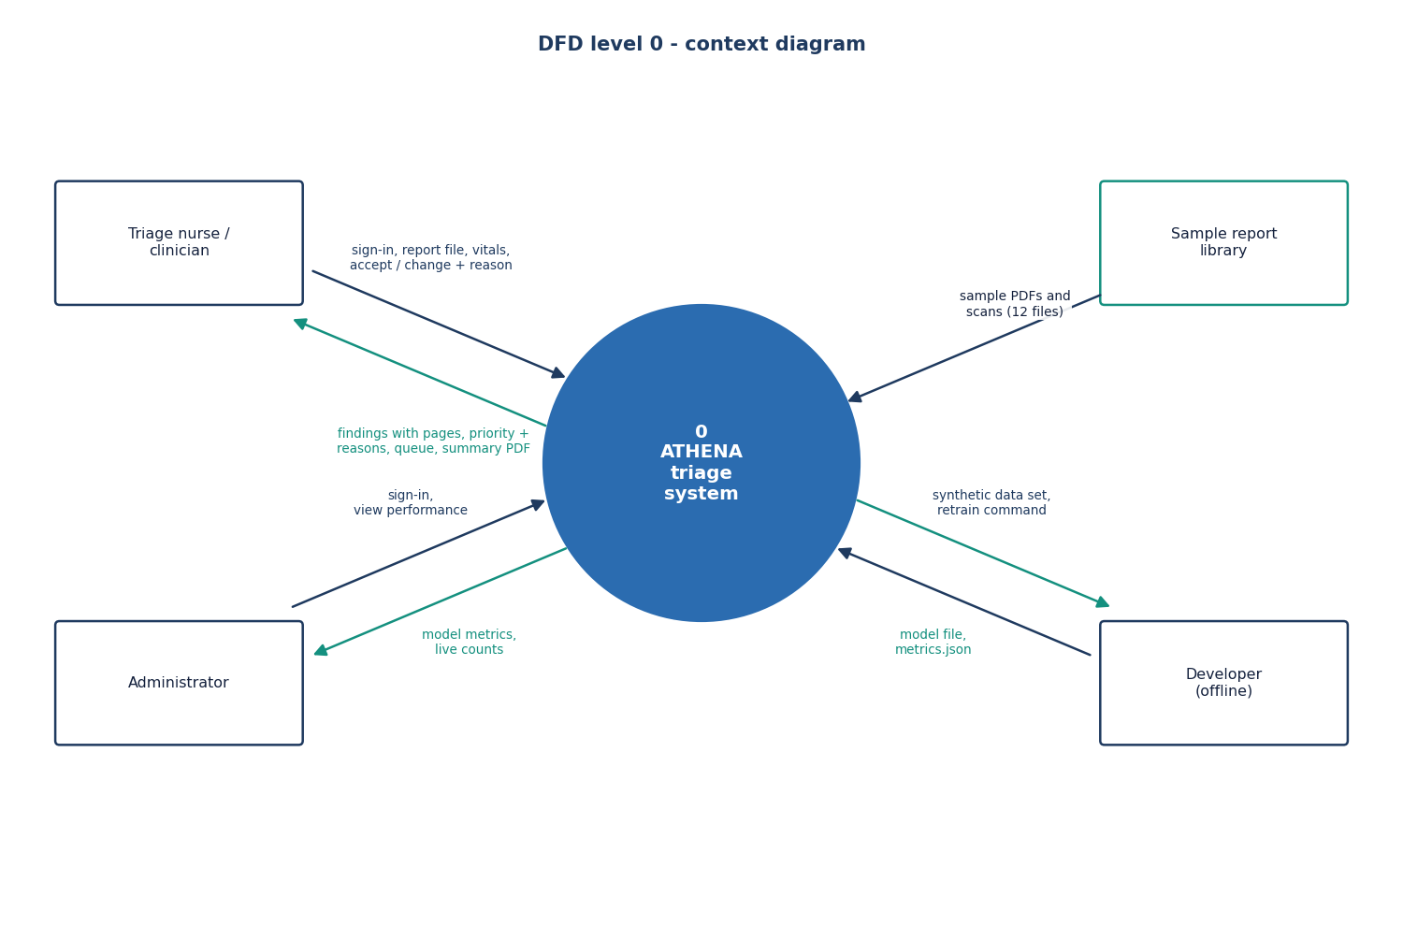  Figure 3: Data flow diagram, level 0 (context). | 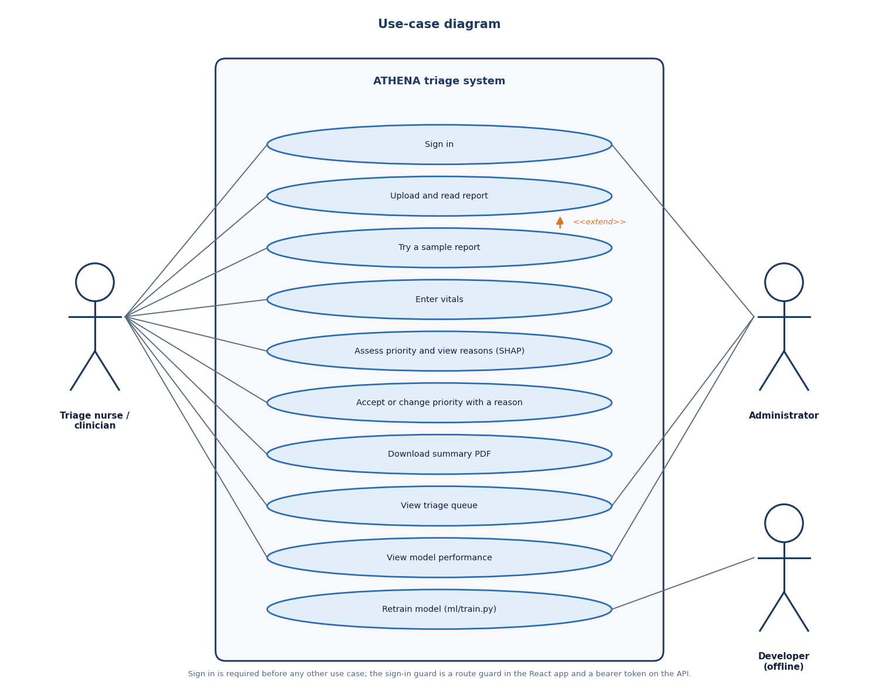  Figure 4: Use-case diagram.

At the context level ATHENA is one process with three neighbours. The triage nurse provides a report file, the vitals and a sign-in, and receives the extracted findings, the priority with its reasons and the queue. The clinician provides a decision (accept or change, with a reason) and receives the patient record and a summary PDF. The administrator reads the performance figures. Training data enters only offline, when the model is built.

5.3.2 Level 1
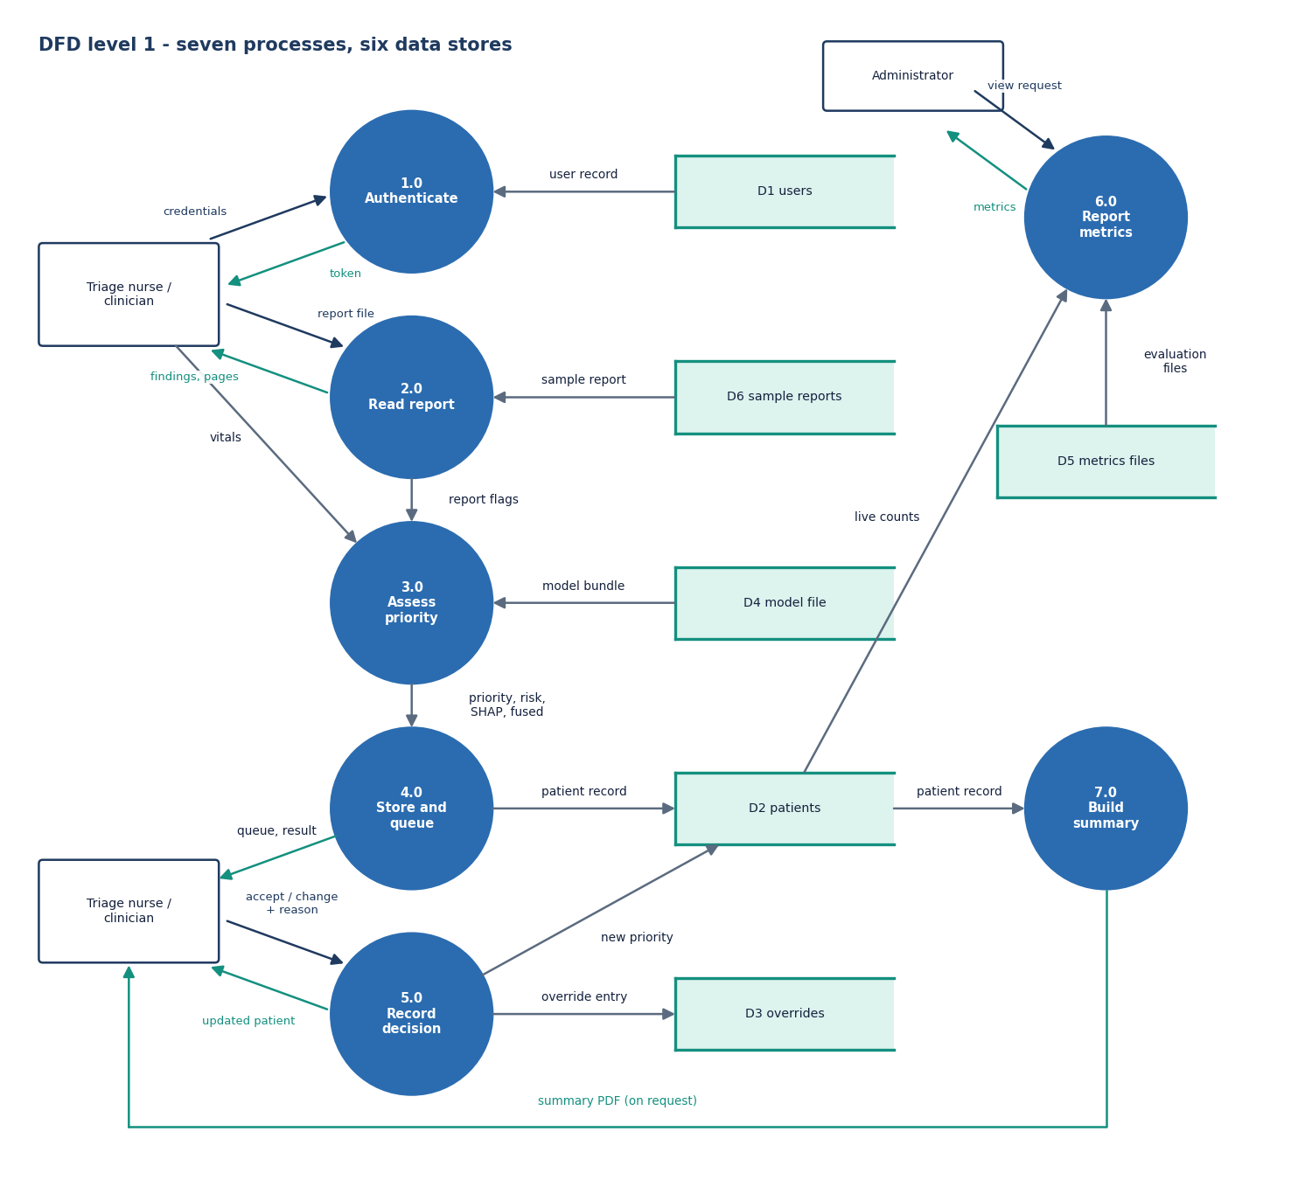
Figure 5: Data flow diagram, level 1.
Level 1 shows the main processes: authentication, report reading, fusion and triage, queue management, clinician review, summary generation and metrics. The database holds the users, patients and overrides; the model file is read by the triage process; the evaluation reports are read by the metrics process. Review writes an override and updates the patient's current priority, which the queue process then uses for its ordering.

5.3.3 Level 2
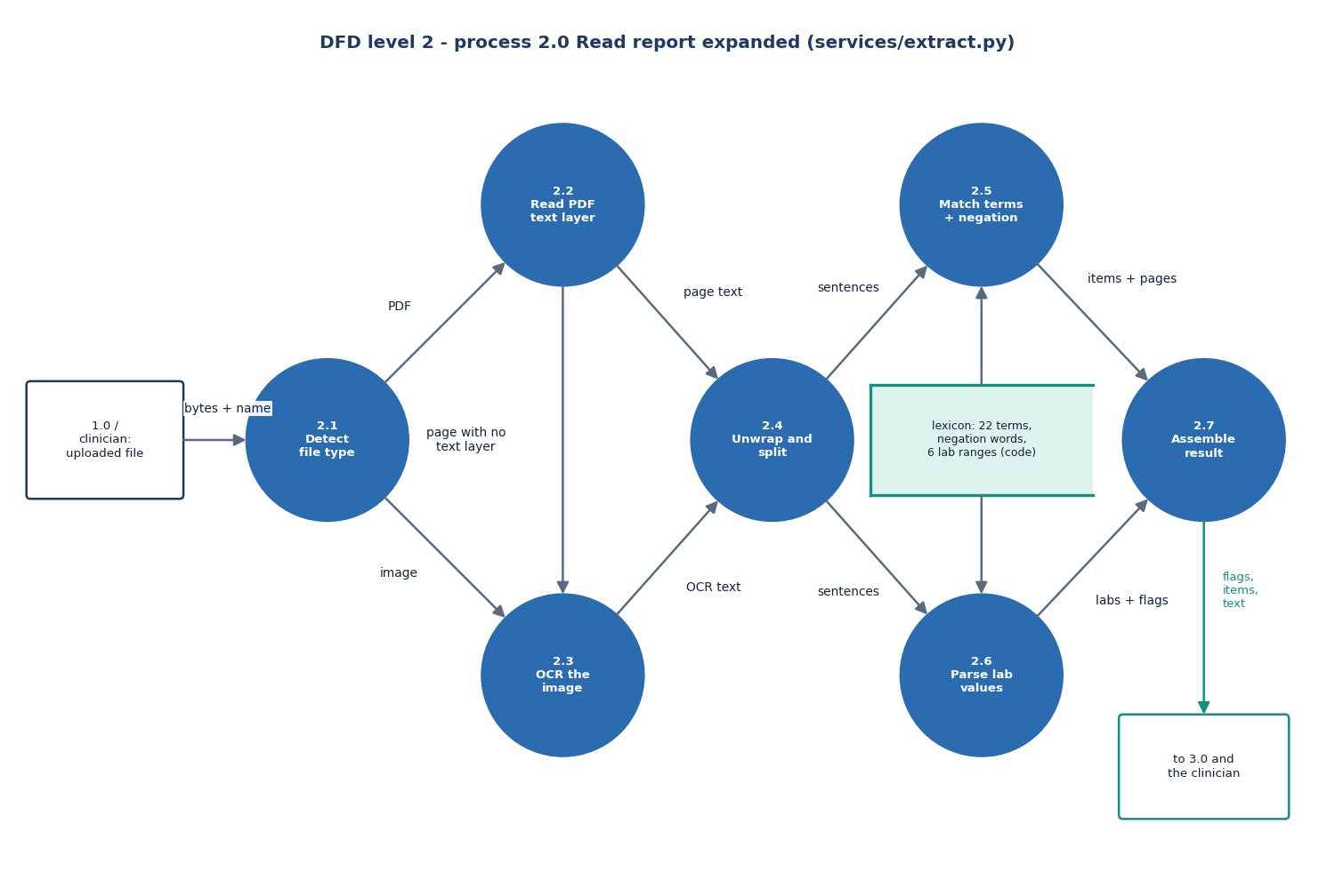
Figure 6: Data flow diagram, level 2, of report reading and triage.
The second level follows one report through the system. Page text is read (text layer or OCR), wrapped lines are re-joined and split into sentences, each sentence is matched against the clinical lexicon and the lab patterns, matches preceded by a negation are dropped, and the surviving items become the 28 report flags. The fusion step adds the eight vitals, the model gives calibrated probabilities, the priority is their arg-max, and the explainer returns the attributions for that priority.

5.4 UML Design

5.4.1 Class Diagram
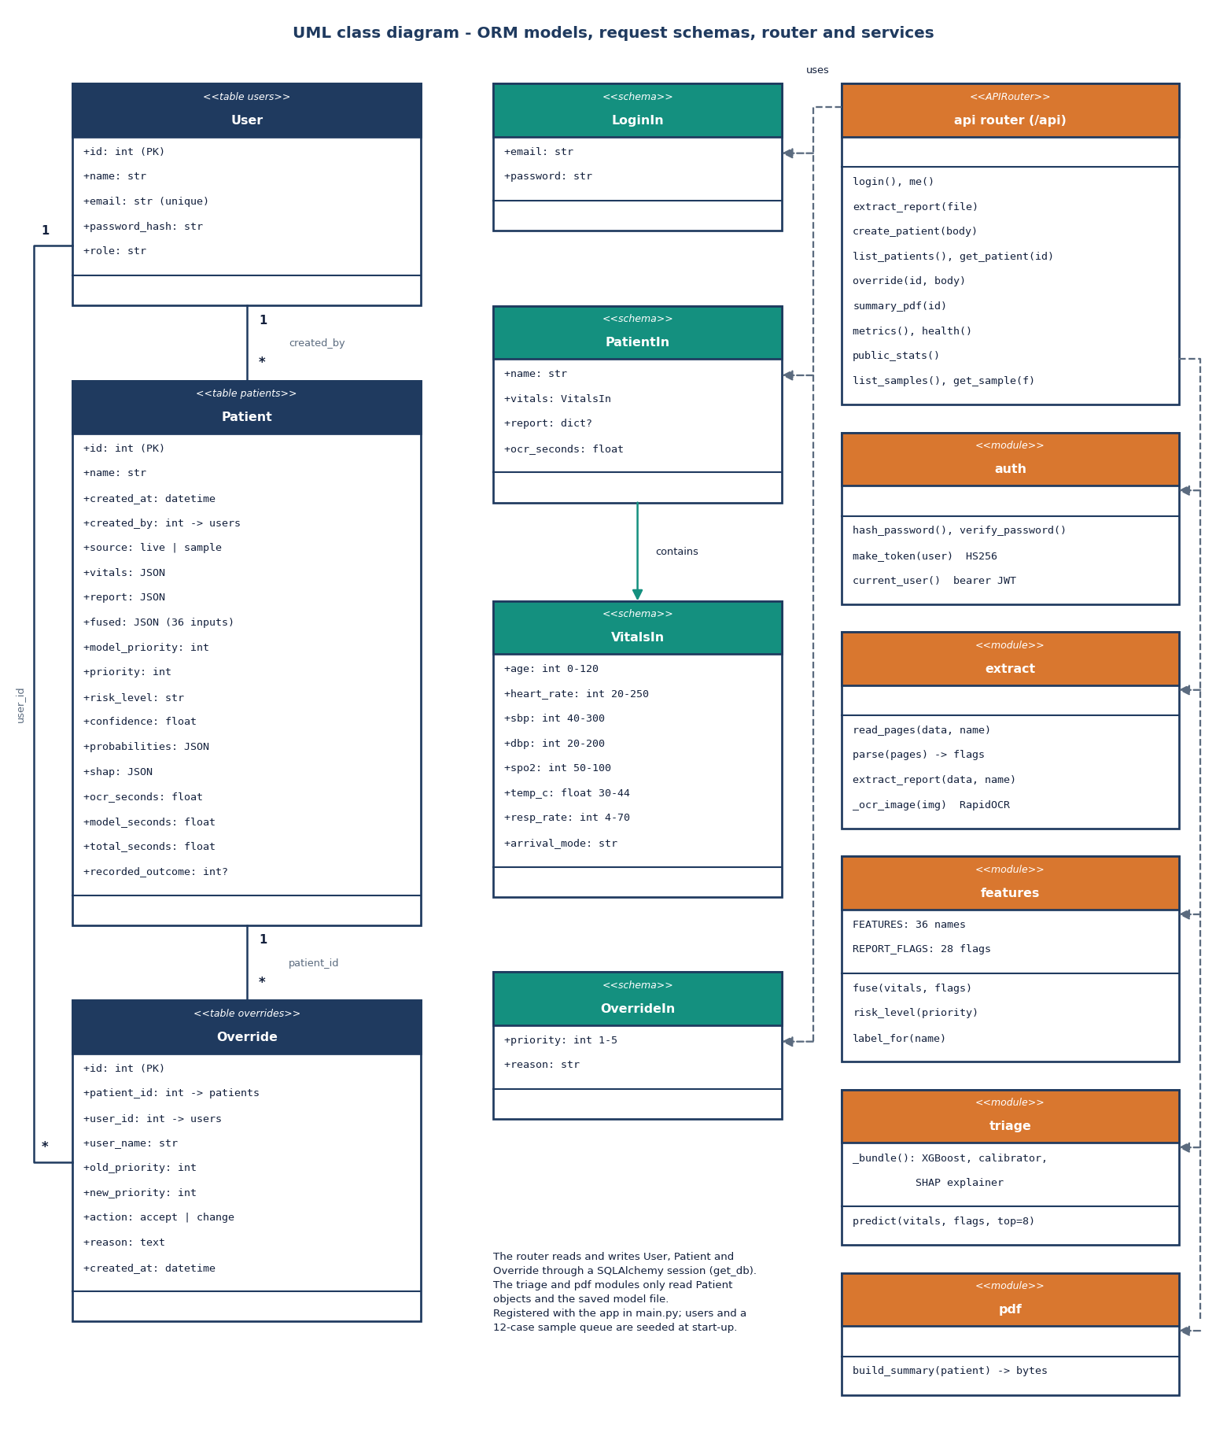
Figure 7: UML class diagram of the data model and services.
Three persistent classes carry the data: User (name, e-mail, password hash, role), Patient (vitals, report, fused record, model priority, current priority, risk level, confidence, probabilities, SHAP list and timings) and Override (the old and new priority, the action, the reason and who made it). The Pydantic classes LoginIn, VitalsIn, PatientIn and OverrideIn validate every request; for example VitalsIn limits SpO2 to 50-100 and heart rate to 20-250. The services are modules of functions, not classes: extract.parse and extract.extract_report, features.fuse, triage.predict and pdf.build_summary.

5.4.2 Sequence Diagram
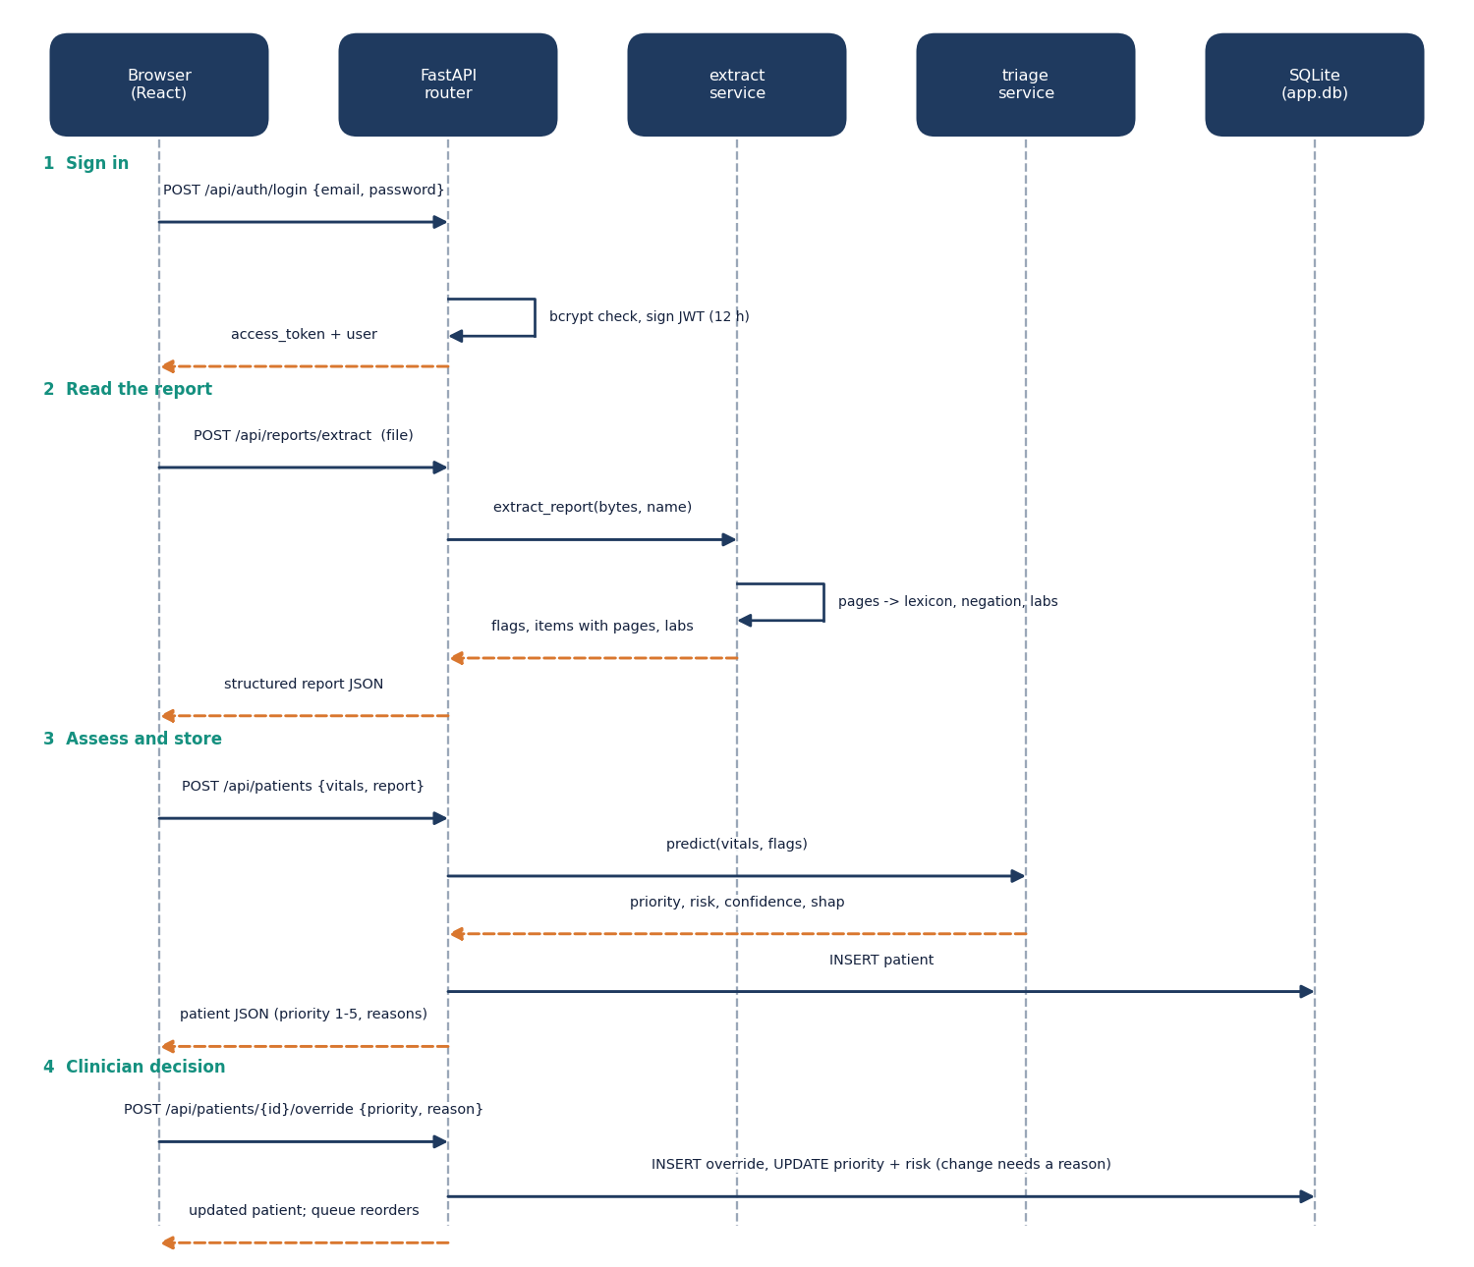
Figure 8: Sequence diagram from report upload to clinician override.
The sequence follows the main flow. The browser uploads the file to /api/reports/extract and receives the structured report. It then posts the vitals and the report flags to /api/patients; the server fuses them, calls the model, stores the patient and returns the full record. When the clinician decides, the browser posts to /api/patients/{id}/override; the server validates that a change carries a reason, writes an override row, updates the patient and returns the new record.

5.4.3 Use-Case Diagram
The nurse uses report intake, vitals entry and the queue; the clinician uses the result screen, the decision and the summary PDF; the administrator uses the performance page. Retraining the model is a command-line action of the developer and has no screen.

5.5 Data Design
ATHENA stores its data in SQLite through SQLAlchemy. The schema has three tables. Patient fields that are structured but variable (vitals, report, fused record, probabilities and the SHAP list) are kept as JSON columns, because they are always read and written together with the patient and never filtered on.
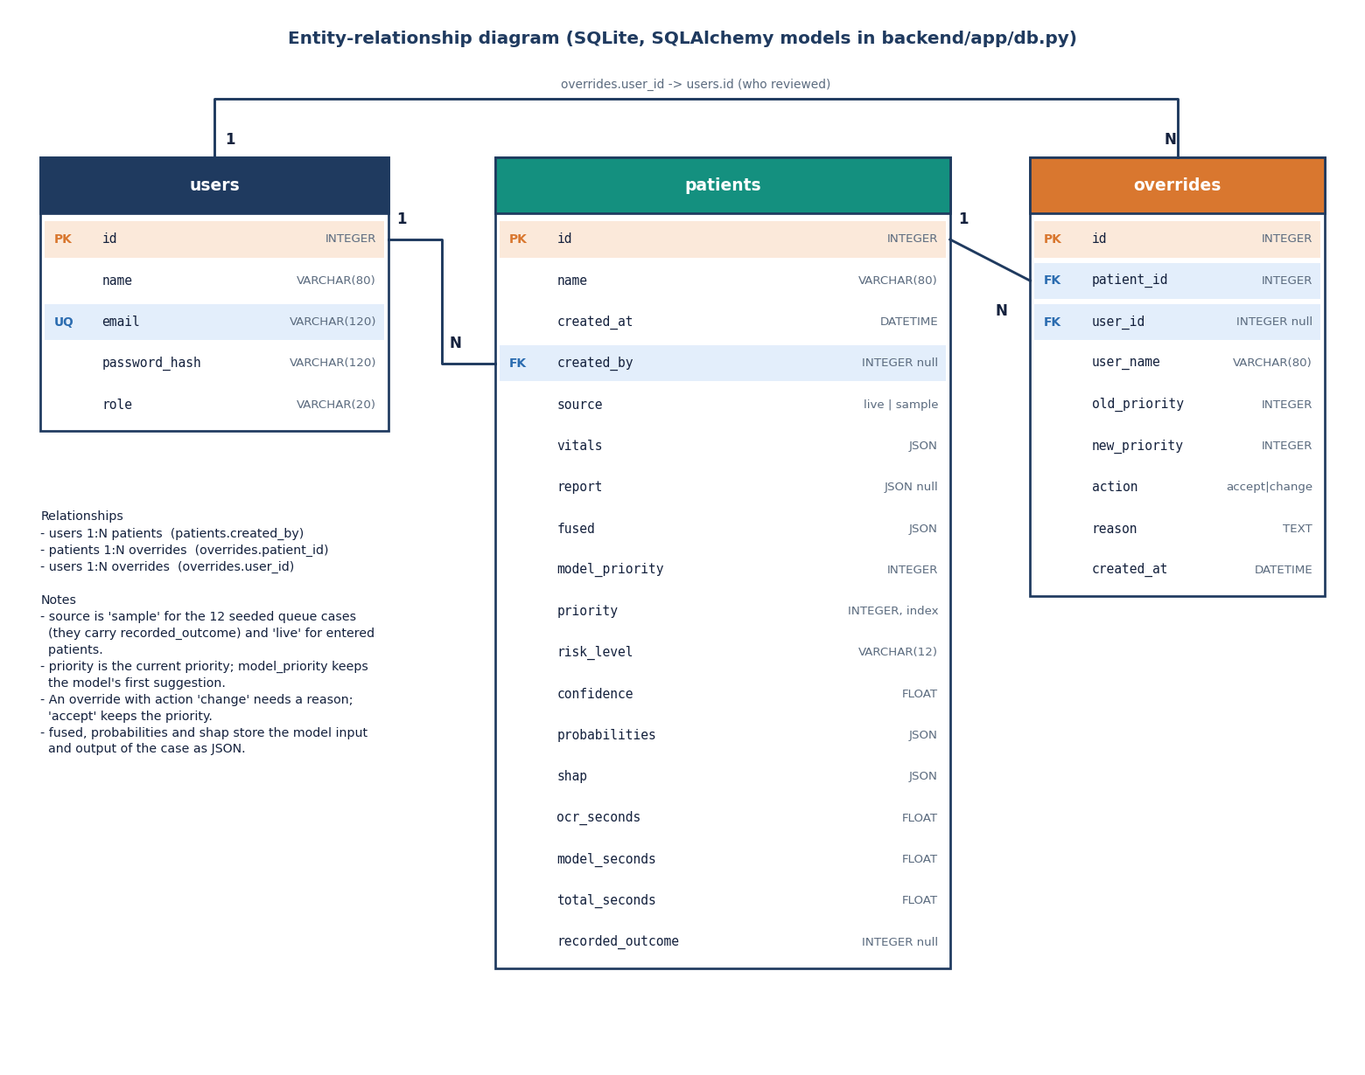
Figure 9: Entity-relationship diagram of the ATHENA database.
Table 16: Database tables and their columns
Table | Columns | Notes
users | id, name, email (unique, indexed), password_hash, role | roles: clinician, admin; passwords stored as bcrypt hashes; two demo users seeded
patients | id, name, created_at, created_by (FK users), source, vitals (JSON), report (JSON), fused (JSON), model_priority, priority (indexed), risk_level, confidence, probabilities (JSON), shap (JSON), ocr_seconds, model_seconds, total_seconds, recorded_outcome | source is live or sample; priority is the current value after any override, model_priority is never changed; recorded_outcome is set only on sample cases
overrides | id, patient_id (FK, indexed), user_id (FK), user_name, old_priority, new_priority, action, reason, created_at | action is accept or change; reason required for a change

A user has many patients (through created_by) and many overrides; a patient has many overrides, ordered by id. A new database is seeded with the two demo users and twelve sample cases built from rows of data/sample/holdout_sample.csv; they carry source = sample and a recorded_outcome, so the queue and the performance page are not empty on the first run and sample cases are always labelled as such in the interface.
Table 17: Other data structures
Structure | Content | Lives in
Fused record | 36 numbers in model column order: 8 vitals and 28 report flags | built per request, stored with the patient
Report flags | 28 flags: 11 symptom, 5 finding, 6 history, 6 lab | features.REPORT_FLAGS
Model bundle | XGBoost base model, isotonic-calibrated wrapper and the feature list | models/triage_model.joblib
Evaluation reports | held-out metrics, confusion matrix, reading and timing results | experiments/metrics.json, experiments/eval/metrics.json
Sample reports | 8 PDFs and 4 PNG scans with the expected flags and vitals | data/sample_reports/

5.6 Algorithm Design

5.6.1 Report reading
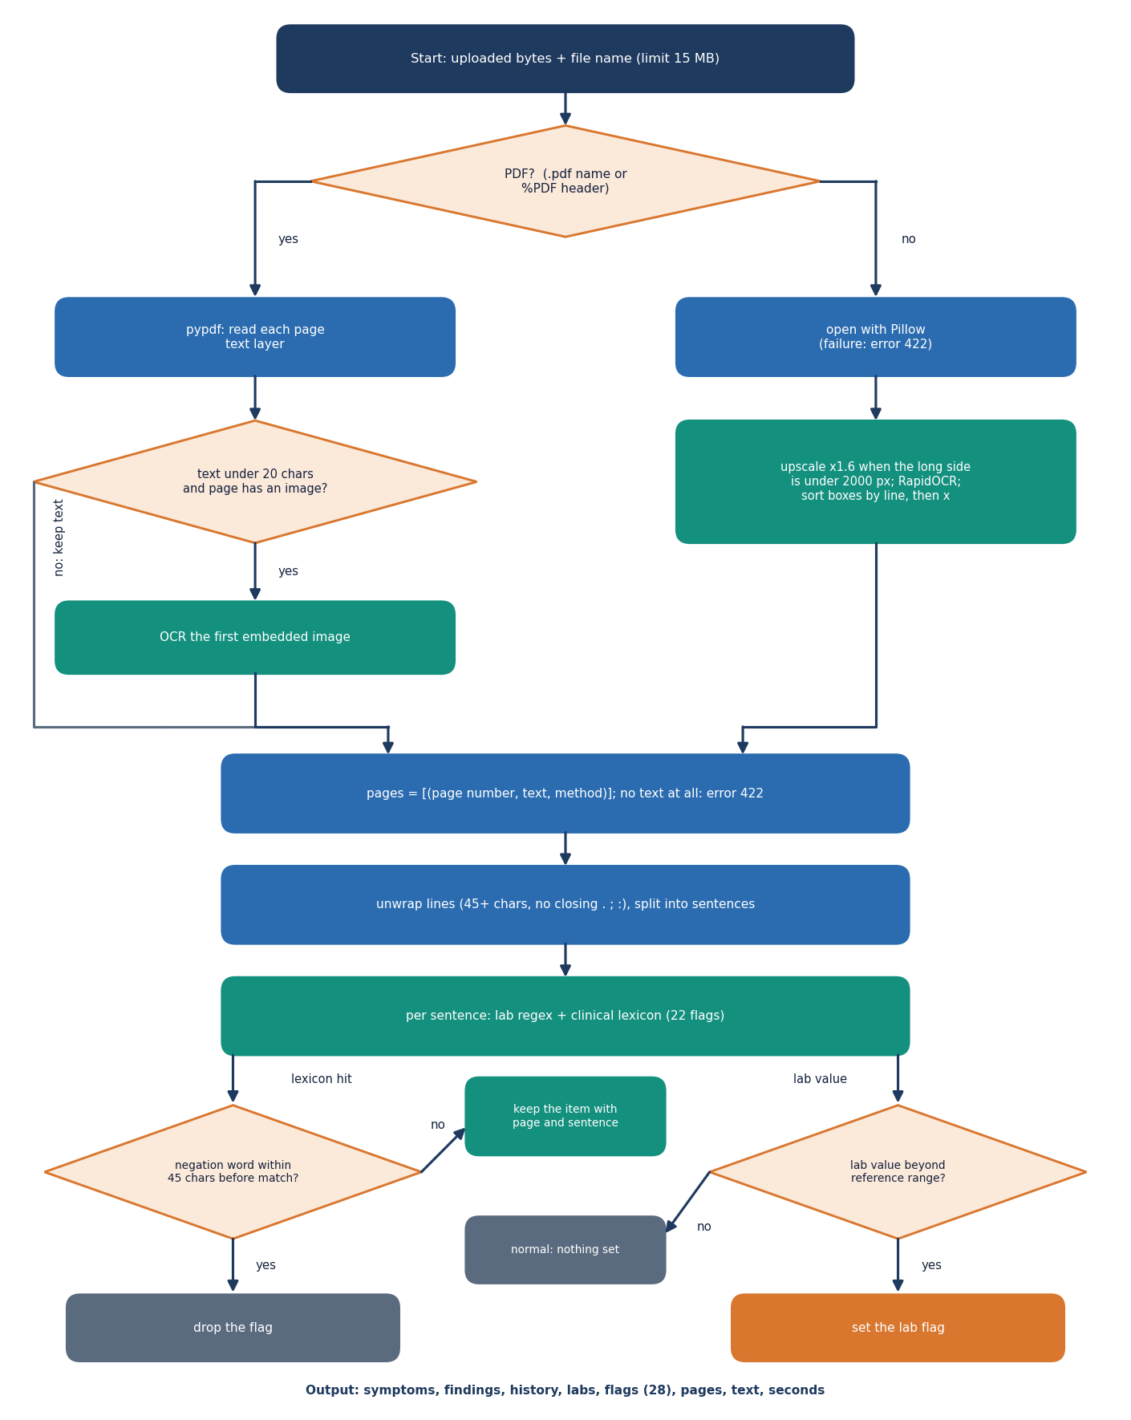
Figure 10: Flowchart of report reading.
A PDF page is read with its text layer; a page with fewer than 20 characters of text is treated as a scan and its first embedded image goes to OCR. An image upload goes straight to OCR. The OCR engine is RapidOCR, which runs PaddleOCR-family detection and recognition models on ONNX Runtime and needs no network [23]; the image is enlarged by a factor of 1.6 when its longer side is under 2,000 pixels, and the recognised boxes are put in reading order by line. Wrapped lines are joined, the text is split into sentences, and each sentence is tested against a lexicon of 22 regular expressions for symptoms, findings and history. Spaces inside a phrase match zero or more whitespace characters, so a run-on such as "shortnessofbreath" still matches. A match is dropped when one of the words no, denies, denied, without, negative for, absence of, not, nil, free of, ruled out occurs within 45 characters before it in the same sentence. Six lab values (troponin, lactate, white cell count, glucose, creatinine, haemoglobin) are read with their value and compared with a reference limit; an abnormal value sets the lab flag. Every item keeps the page it was found on.

5.6.2 Triage scoring
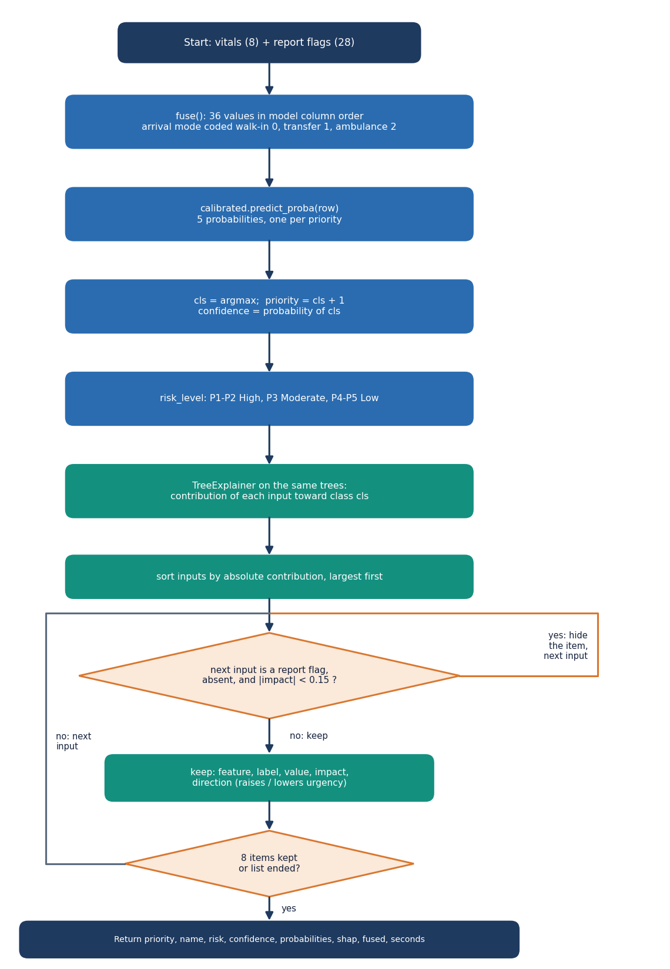
Figure 11: Flowchart of triage scoring and the clinician decision.
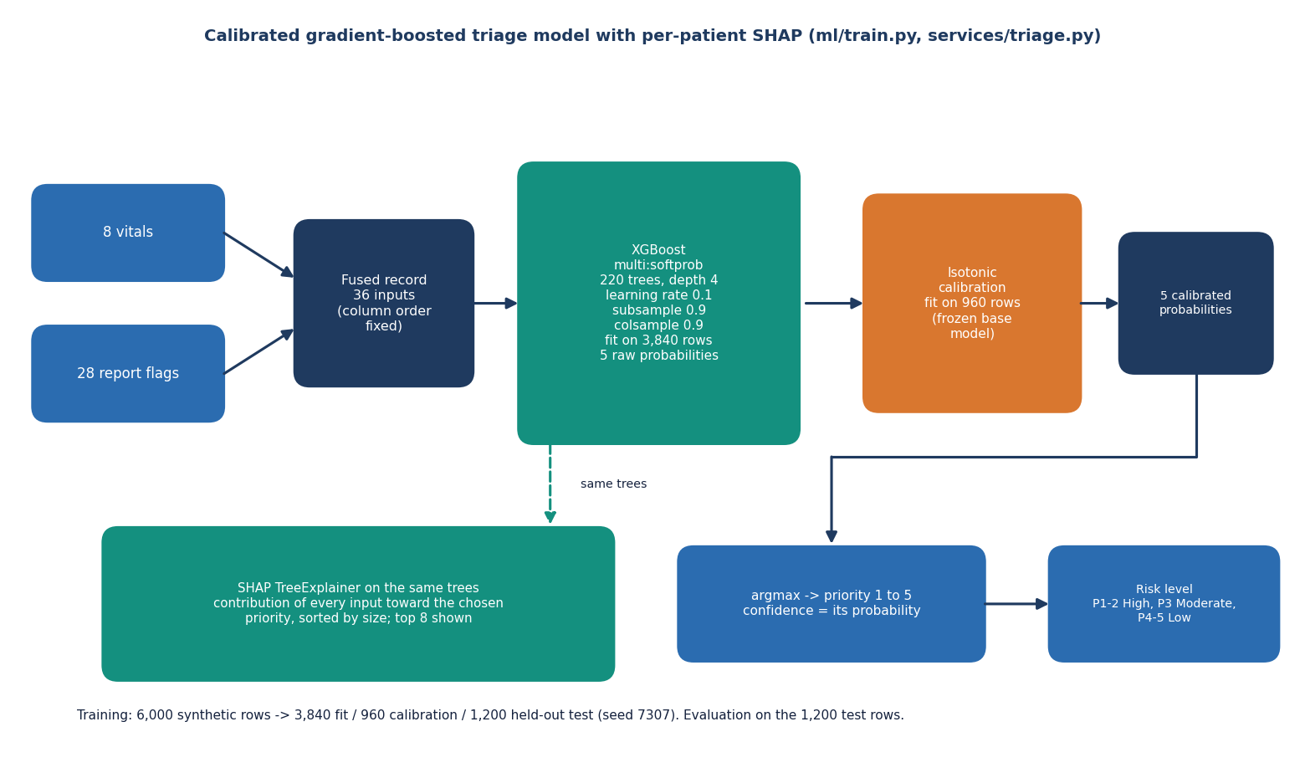
Figure 12: Architecture of the triage model (fusion, XGBoost, calibration, SHAP).
features.fuse builds a dictionary in the fixed column order: the eight vitals (arrival mode coded walk-in 0, transfer 1, ambulance 2) followed by the 28 flags, each 0 or 1. A flag that the report does not mention is 0, which is the same rule the base paper applies to symptoms that were not documented [1]. The model is an XGBoost classifier [15] with 220 trees of depth 4 that returns five scores; an isotonic calibrator fitted on a separate split turns them into probabilities [18], and the priority is the class with the largest probability. The risk level is High for priorities 1 and 2, Moderate for 3 and Low for 4 and 5. SHAP's tree explainer [17] then gives the contribution of each of the 36 inputs towards the chosen priority; the list is sorted by absolute value, absent flags with a contribution below 0.15 are hidden, and the top eight are returned.
On the synthetic hold-out the factors with the largest mean absolute SHAP value over all five classes are SpO2 (0.42), arrival mode (0.32), shortness of breath (0.27), systolic blood pressure (0.24) and respiratory rate (0.23). This matches the weights used to build the synthetic labels, so it checks that the explainer reads the model correctly; it says nothing about clinical importance.

5.7 Module Design
Table 18: Modules, responsibilities and size
Module / file | Responsibility | Lines
backend/app/main.py | FastAPI application, start-up (create tables, warm the model and OCR engine, seed users and the sample queue), CORS | 84
backend/app/routes/api.py | 13 routes, request schemas, serialisation, queue ordering, override rules, metrics | 225
backend/app/db.py | SQLAlchemy engine, session factory and the three models | 79
backend/app/auth.py | bcrypt hashing, HS256 token creation and checking, current-user dependency | 47
backend/app/services/extract.py | PDF text, OCR, lexicon, negation, lab parsing | 187
backend/app/services/features.py | vital and flag definitions, labels, arrival codes, risk level, fuse | 87
backend/app/services/triage.py | model loading, calibrated prediction, SHAP attribution | 73
backend/app/services/pdf.py | triage summary PDF (ReportLab) | 63
ml/make_data.py, ml/train.py, ml/eval.py | synthetic dataset, training and calibration, evaluation of reading and timing | 108 / 74 / 59
frontend/src/ | 31 files: 6 pages, a design kit of UI components, API client, auth, theme and storage helpers | about 3,400
scripts/ and tests/ | sample reports, smoke test, screenshots, responsive check, experiments, API timing; 47 pytest tests | see Chapter 7

The modules are small and each has one reason to change. features.py is the single source of the column order that triage.py, make_data.py, train.py and the tests import, so the schema cannot drift between training and serving. routes/api.py is the only module that touches HTTP.

5.8 API Design
The API is JSON over HTTP under the prefix /api, plus one multipart upload route and one PDF download. All routes except health, public/stats and auth/login need a bearer token. The routes fall into five groups; request and response details are in Chapter 6.
Table 19: API route groups
Group | Routes | Purpose
Service | GET /health, GET /public/stats | liveness and model presence; headline numbers for the landing page
Authentication | POST /auth/login, GET /auth/me | sign in, who am I
Report intake | POST /reports/extract, GET /samples, GET /samples/{file} | read an upload; list and fetch the generated sample reports
Patients | POST /patients, GET /patients, GET /patients/{id}, GET /patients/{id}/summary.pdf, POST /patients/{id}/override | triage, queue, record, summary, decision
Evaluation | GET /metrics | offline evaluation and live counts

Validation is strict and returns a meaningful status instead of a stack trace: an empty upload is 400, an upload over 15 MB is 413, an unreadable file is 422, vitals outside their physical limits are 422, a missing patient is 404, and a missing or expired token is 401. A model that is not trained returns 503.

5.9 User Interface Design
The interface is a React single-page application built on the shared Neo Brutal Grid design kit: hard-edged boxes with a 3-pixel border and offset shadow, flat colour with no gradients, an Archivo Black display face with IBM Plex Sans and Mono for text, and one fixed colour for each priority (1 coral, 2 amber, 3 sky, 4 lime, 5 paper). A dark theme, reduced-motion support, a drawer navigation on narrow screens and visible keyboard focus are provided. The token is kept in the browser's local storage, and any 401 response signs the user out.
Table 20: Application screens
Route | Screen | What the user does
/ | Landing | reads what ATHENA does and the headline evaluation numbers, marked as synthetic
/login | Sign in | enters credentials or uses a demo button
/app/new | New patient | uploads or picks a report, reviews what was found (with pages), enters the vitals and assigns a priority
/app/patients/:id | Result | sees priority, risk and confidence, the fused record, the SHAP bars and probabilities; accepts or changes the priority; downloads the PDF
/app/queue | Triage queue | sees patients sickest first, filters by priority tab or search; the list refreshes every 15 seconds
/app/performance | Model performance | reads accuracy, per-priority recall, the confusion matrix, seconds per patient and the live review counts

• Every screen that shows model output carries the notice that the evaluation is on a seeded synthetic dataset.
• The result screen shows the report-derived and the vitals-derived halves of the fused record side by side, so a clinician can see what the model was given.
• Errors from the API are shown as messages with a retry action and never as blank screens; sample cases are labelled as samples in the queue.

5.10 Key Design Decisions
Table 21: Decisions and their reasons
Decision | Reason | Consequence
Local OCR (RapidOCR) and a clinical lexicon instead of a cloud multimodal model | no network, no API key, no patient text leaving the machine | reading is rule-based: 100% on the generated samples but recall 84.3% on the hand-written stress set
Fuse 28 report flags with 8 vitals in one table of 36 inputs | one model sees both sources; flags are interpretable | a missed flag is a 0, so reading errors reach the model
XGBoost with isotonic calibration and a tree explainer | calibrated probabilities and exact tree SHAP at millisecond cost; room for non-linearity on real data | on the synthetic data logistic regression scored higher (72.4% against 68.2%)
Five-level priority as the target | matches the clinical scale and the batch objective | ordinal errors matter: within-one accuracy is reported next to exact accuracy
Priority and model suggestion stored separately | overrides become feedback and agreement can be measured | the live agreement rate needs real use to mean anything
SQLite with JSON columns | no database server; the demo runs from one folder | single-writer; not a multi-site design
Synthetic training data | no real patient records were available | all accuracy figures describe a simulated rule, not clinical performance

5.11 Security and Error-Handling Design
The security design is described against a simple threat model and the limits of that model are stated. The system is meant for a trusted ward network. Against a user without credentials it provides authentication on every patient route, bcrypt password hashes, signed tokens that expire after 12 hours, a path check on the sample-file route, a 15 MB upload limit and range validation on every vital. Database access goes through the ORM, so request values are never concatenated into SQL.
Table 22: Controls and their limits
Control | What it does | Limit
Bearer token (HS256, 12 h) | protects every patient, queue and metrics route | default secret dev-secret-change-me when JWT_SECRET is unset; no refresh or revocation
bcrypt password hashes | no plain passwords in the database | two demo accounts with a published password
Role field (clinician, admin) | stored with the user and the token | routes do not yet check the role: any signed-in user can do everything
Pydantic validation | age, heart rate, blood pressure, SpO2, temperature and respiratory rate within physical limits | limits are plausible bounds, not clinical alarms
Upload limits | 15 MB, PDF / PNG / JPG only, empty file refused | no virus scanning; no rate limiting
CORS fixed to the two local origins | browsers from other origins are refused | plain HTTP; no TLS
Override audit | who, when, old and new priority, action and reason are stored | no tamper-proofing of the log; the database is a single file

Errors follow one rule: a failure is reported with a status code and a short message the user can act on, and the server keeps running. If the model file is missing, scoring routes answer 503 with the instruction to train; at start-up a missing model only skips the warm-up and the sample queue. The browser shows API messages in the interface and turns a lost connection into a single Cannot reach the ATHENA API message.
None of this makes the system safe for real patients. There is no HTTPS, no rate limiting, no role enforcement, no audit beyond overrides and no regulatory review, and the model has never seen a real patient record. ATHENA is a decision-support prototype; the treating clinician makes the final triage decision.

CHAPTER 6: METHODOLOGY AND SOFTWARE IMPLEMENTATION

6.1 Overall methodology
ATHENA was built in eight stages, each producing a file or a measurement that the next stage uses. The stages are the same for the documents and for the code, so every claim in this report can be traced to a script.
Table 23: Stages of the methodology
Stage | What is done | Output
1 Problem framing | read the batch objectives and the base paper; decide the target (five-level priority) and the inputs (report + vitals) | 36-input fused record, priority 1 to 5
2 Data | generate a seeded synthetic dataset of 6,000 patients (no real records were available) | data/sample/triage_synthetic.csv
3 Report reading | PDF text layer or local OCR, then a clinical lexicon with negation and lab limits | 28 report flags with page numbers
4 Fusion | append the eight vitals to the flags in a fixed column order | one record per patient
5 Model | train XGBoost, calibrate its probabilities with isotonic regression on a separate split | models/triage_model.joblib
6 Explanation | SHAP tree attribution for the chosen priority, strongest first | per-patient factor list
7 Serving | FastAPI services, SQLite storage, React screens, clinician accept-or-change loop | running application
8 Evaluation | hold-out metrics, model comparison, ablation, calibration, robustness, reader stress test, tests and timing | experiments/**/metrics.json

The methodology follows the base paper in three respects: several algorithms are compared on the same split before one is chosen, a probability (not only a label) is reported together with a confidence threshold analysis, and a symptom that is not documented is treated as absent without imputation [1]. It departs from the base paper in the input (a scanned report fused with vitals instead of a typed symptom checklist), in the target (five triage priorities instead of ICD-10 diagnoses) and in the data (synthetic, where the base paper uses real clinical records).

6.2 Dataset

6.2.1 Why the data is synthetic
The batch plan named a public Kaggle dataset of hospital triage and patient history records. Accessing it needs a personal Kaggle token and its licence is not stated, so it was not used; the download script scripts/download_data.py exists but was never run or tested. The model is therefore trained on a seeded synthetic dataset, and every accuracy figure in this report is measured on that synthetic data. It measures how well the model recovers a known rule, not how well it agrees with clinicians.

6.2.2 How the dataset is generated
ml/make_data.py (seed 7307) simulates 6,000 patients. For each patient an archetype is drawn, then age, vitals, report flags and the arrival mode are sampled from that archetype, a severity score is computed from clinical rules, Gaussian noise is added, and the score is cut into a priority. The priority plays the role of the clinician-recorded outcome.
Table 24: Clinical archetypes (shares are measured on the generated data)
Archetype | Share | Report flags and their probability | Vital shifts (HR, SBP, SpO2, T, RR)
minor | 33.6% | fever .12, trauma .12, hypertension .15, vomiting .08, abdominal pain .08, diabetes .08 | none
cardiac | 14.6% | chest pain .80, dyspnoea .35, ST elevation .22, troponin raised .35, cardiac history .50, hypertension .50 | +8, +5, -1, 0, +2
respiratory | 11.9% | dyspnoea .90, fever .40, infiltrate .40, COPD .50, WBC raised .30 | +10, 0, -5, +0.5, +7
neuro | 8.5% | stroke signs .50, headache .45, altered mental state .35, haemorrhage on CT .12, hypertension .60 | 0, +22, -1, 0, +1
trauma | 11.7% | trauma .95, fracture .45, bleeding .35, Hb low .12, free fluid .08 | +12, -6, -1, 0, +3
infection | 9.4% | fever .85, WBC raised .65, lactate raised .22, altered mental state .15, diabetes .25 | +18, -12, -2, +1.4, +5
abdominal | 10.3% | abdominal pain .95, vomiting .55, WBC raised .30, fever .20, free fluid .12 | +8, -3, 0, +0.3, +2

Vitals are drawn from normal distributions and clipped to physical limits: age from a gamma distribution (shape 4.2, scale 11, plus 3, clipped to 1-98), heart rate N(82 + shift, 14), systolic pressure N(124 + shift + 0.25 (age - 45), 17), SpO2 N(97.5 + shift, 2), temperature N(36.8 + shift, 0.5), respiratory rate N(16 + shift, 3), and diastolic pressure 0.62 times systolic plus N(0, 7). The arrival mode is walk-in, ambulance or transfer with probabilities .55 / .35 / .10 for minor and abdominal patients and .25 / .60 / .15 for the others. A flag that an archetype does not list has probability .01 (.02 for the six lab flags, .06 for hypertension and diabetes).

6.2.3 The severity rule and the labels
The severity score s is the sum of the terms below plus a weight for each report flag that is present; noise from N(0, 0.4) is added, and s is cut into priorities.
Table 25: Severity score terms
Term | Contribution to s
Heart rate | +2 above 130; +1 above 110; +1.5 below 45
Systolic pressure | +3 below 90; +1.5 below 100; +1 above 180
SpO2 | +3.5 below 90; +1.5 below 94
Temperature | +1.5 above 39.5 or below 35; +0.7 above 38.3
Respiratory rate | +2 above 28; +1 above 22
Age and arrival | +0.8 above 75; transfer +0.5; ambulance +0.8
Report flags (weight each) | ST elevation 4, haemorrhage on CT 4, focal weakness 3, altered mental state 2.5, troponin raised 2.5, lactate raised 2.5, free fluid 2, dyspnoea 1.5, syncope 1.5, bleeding 1.5, chest pain 1.2, trauma 1, infiltrate 1, glucose abnormal 1, Hb low 1, fracture 0.8, severe headache 0.8, creatinine raised 0.8, WBC raised 0.7, abdominal pain 0.6, cardiac history 0.5, anticoagulant 0.5, COPD 0.4, fever 0.4, diabetes 0.3, prior stroke 0.3, hypertension 0.2, vomiting 0.2

priority = 1 if s ≥ 8; 2 if 5.2 ≤ s < 8; 3 if 3.0 ≤ s < 5.2; 4 if 1.2 ≤ s < 3.0; 5 otherwise (1)
The generated priorities are 5.5% / 19.9% / 26.1% / 26.7% / 21.8% for priorities 1 to 5. The label noise has a consequence that matters when the results are read: a model that knew the exact severity score would still disagree with the stored label on 13.7% of the rows, so exact accuracy cannot exceed about 86.2% on this data (Chapter 8).
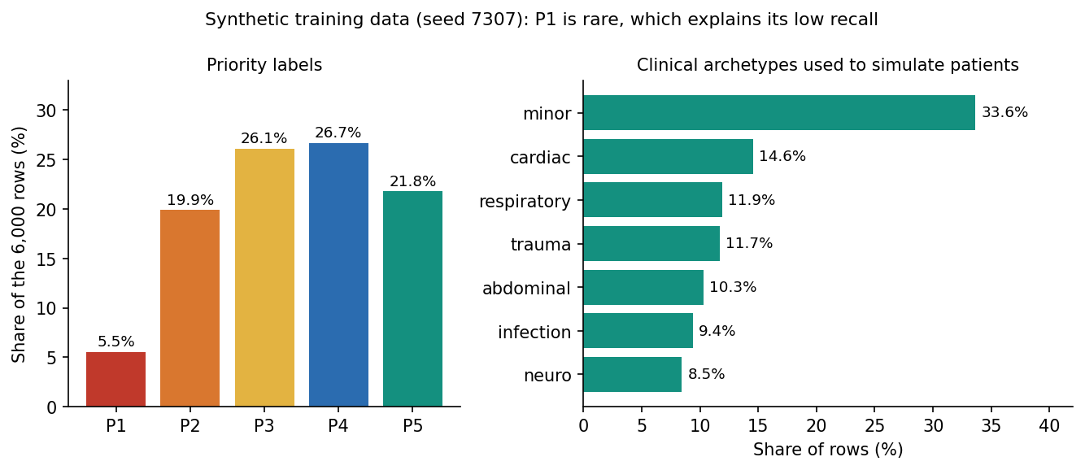
Figure 13: Distribution of priorities and archetypes in the synthetic dataset.

6.2.4 Splits and sample reports
The data is split with stratification on the priority: 80% training pool and 20% test (1,200 cases), then the training pool is split 80/20 into 3,840 rows for fitting the model and 960 rows for fitting the calibrator. The test cases are never used for fitting or calibration. Twelve sample reports (eight two-page PDFs and four PNG scans, scripts/make_sample_reports.py) were generated with the same seed and are stored with the flags and vitals a correct reading must find; they are used for the demonstration and to test the reader, and they are written in the vocabulary of the lexicon, which makes them an easy test.

6.3 Preprocessing and fusion

6.3.1 Reading the report
A PDF page is read with its text layer (pypdf); a page with fewer than 20 characters is treated as a scan and its first embedded image is sent to OCR. An image upload is sent to OCR directly. The OCR engine is RapidOCR, which runs PaddleOCR-family text detection and recognition models on ONNX Runtime [23]: it is installed as one Python package, needs no separate download and no network. Images with a longer side under 2,000 pixels are enlarged by 1.6, and the recognised boxes are sorted into lines and then left to right. Lines that were wrapped mid-sentence (45 characters or more and no closing punctuation) are re-joined, and the text is split into sentences.
Table 26: The report lexicon: 22 text flags in three groups
Group | Flags (examples of phrases matched)
Symptoms (11) | chest pain (chest pressure, tightness, angina); shortness of breath (dyspnoea, breathless, SOB); altered mental state (confusion, drowsy, lethargic, unresponsive); syncope (collapsed, passed out); fever (febrile, chills, rigors); abdominal pain; bleeding (haematemesis, melaena, haematuria); stroke signs (facial droop, slurred speech, one-sided weakness); severe headache (worst, sudden, thunderclap); vomiting; trauma (fall from, road traffic, laceration, head injury)
Findings (5) | ST elevation (STEMI); lung infiltrate (consolidation, pneumonia, effusion); fracture; free abdominal fluid; intracranial haemorrhage (subdural, subarachnoid)
History (6) | diabetes (T2DM, DM2); hypertension (HTN); cardiac disease (CAD, prior MI, heart failure, atrial fibrillation, stent, CABG); COPD or asthma; prior stroke (TIA); anticoagulant (warfarin, apixaban, clopidogrel, heparin)

Each sentence is tested against all 22 expressions. Two rules reduce false matches. A match is discarded when a negation word (no, denies, denied, without, negative for, absence of, not, nil, free of, ruled out) occurs within 45 characters before it in the same sentence, so "denies chest pain" produces nothing. A bleed described as intracranial, subarachnoid, cerebral or subdural is recorded as the finding haemorrhage on CT and not as the symptom bleeding. Spaces inside phrases match zero or more white-space characters because OCR often drops them ("shortnessofbreath"). Every item keeps the page it came from.
Table 27: Lab values read from the report
Lab | Abnormal when | Unit
Troponin | above 0.04 | ng/mL
Lactate | above 2.0 | mmol/L
White cell count | above 11.0 | x10^9/L
Glucose | below 70 or above 250 | mg/dL
Creatinine | above 1.3 | mg/dL
Haemoglobin | below 10.0 | g/dL

A lab is recognised by its name followed by a number; repeated readings of the same lab on the same page are listed once, and an abnormal value sets the lab flag. The result of reading is the 28 flags (22 text flags and 6 lab flags) together with the list of items, labs and pages shown to the nurse.

6.3.2 Fusion with the vitals
The fused record is a vector of 36 numbers in a fixed order that features.py defines for training, serving and the tests: age, heart rate, systolic pressure, diastolic pressure, SpO2, temperature, respiratory rate and the arrival code (walk-in 0, transfer 1, ambulance 2), followed by the 28 flags, each 0 or 1. A flag the report does not mention is 0; there is no imputation, as in the base paper. Vitals are validated on entry (age 0-120, heart rate 20-250, systolic 40-300, diastolic 20-200, SpO2 50-100, temperature 30-44 degrees Celsius, respiratory rate 4-70). Tree models are invariant to monotone rescaling, so the vitals are used unscaled.

6.4 Algorithm choice and justification
Eight classifiers were trained on the same 3,840 fitting rows and scored on the same 1,200 test cases (all on the synthetic data), in the spirit of the base paper's comparison of 19 algorithms [1]. The shipped model is XGBoost with isotonic calibration; the table gives the uncalibrated XGBoost so that the comparison is like for like.
Table 28: Eight models on the same split (synthetic hold-out)
Model | Accuracy | Within one | Macro F1 | QWK | Top-2
Logistic regression | 72.4% | 99.7% | 0.727 | 0.897 | 96.4%
Decision tree | 54.7% | 94.7% | 0.530 | 0.761 | 80.5%
Random forest | 67.2% | 99.7% | 0.623 | 0.871 | 95.1%
Extra trees | 69.1% | 99.2% | 0.653 | 0.872 | 94.3%
k-nearest neighbours | 62.6% | 97.8% | 0.564 | 0.830 | 89.2%
MLP | 70.9% | 99.3% | 0.701 | 0.888 | 97.2%
HistGradientBoosting | 70.3% | 99.6% | 0.669 | 0.884 | 95.6%
XGBoost (shipped config) | 68.2% | 99.7% | 0.653 | 0.877 | 95.5%

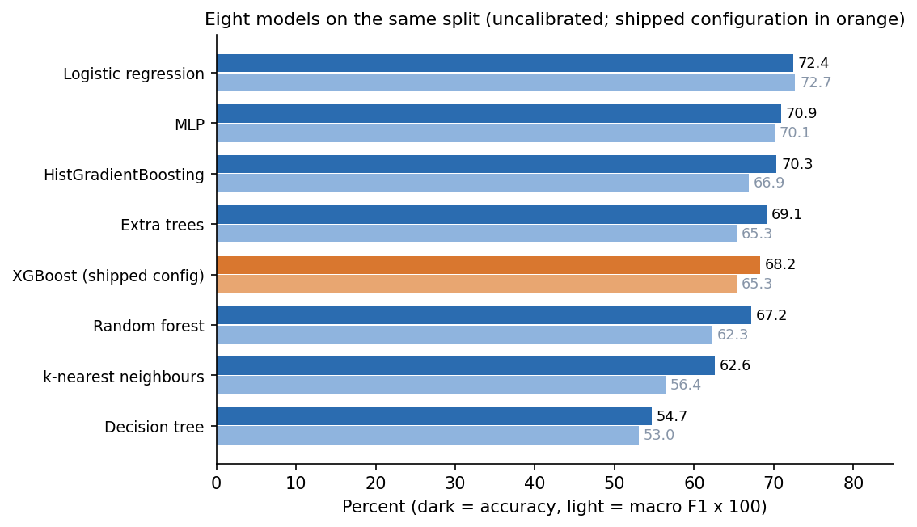
Figure 14: Accuracy and macro F1 of the eight models on the synthetic hold-out.
The result does not favour the shipped model. Logistic regression is the most accurate (72.4%) and XGBoost sits in the middle (68.2%); five-fold cross-validation on all 6,000 rows gives 71.6% for logistic regression, 71.1% for the random forest and 72.4% for XGBoost, with standard deviations of one to two points, so the three are close. The reason is in the data: the labels come from an additive severity score, which a linear model recovers almost exactly. The single decision tree (depth 8) and k-nearest neighbours are clearly worse.
XGBoost was kept for four reasons, and only the first three are supported by this study. (1) It gives probabilities that can be calibrated and used as a confidence. (2) SHAP's tree explainer computes exact attributions for it in milliseconds [17]. (3) It handles the 0/1 flags and the numeric vitals without scaling. (4) On real tabular data tree ensembles usually keep an edge over linear and neural models [21]; this is an assumption carried over from the literature, not something this study showed, and with real records the choice should be repeated.
Table 29: Value of fusing the two sources (XGBoost, same split)
Inputs | Count | Accuracy | Within one | Macro F1 | Top-2
Vitals only (8) | 8 | 40.6% | 82.2% | 0.367 | 70.3%
Report only (28) | 28 | 63.2% | 97.2% | 0.615 | 92.2%
Fused (36) | 36 | 68.2% | 99.7% | 0.653 | 95.5%
Vitals + text flags (30) | 30 | 61.5% | 96.9% | 0.577 | 89.7%
Vitals + lab flags (14) | 14 | 46.9% | 87.9% | 0.429 | 77.8%

The ablation measures the gap named in the literature survey. Vitals alone reach 40.6%, the report alone 63.2% and the fused record 68.2%: fusion adds 27.7 points over vitals alone and 5.1 over the report alone. Because the synthetic severity rule puts large weights on report flags, the size of the gain is partly a property of the generator, but its direction is what the design assumed.
Two components named in the batch abstract were not built. BioBERT would replace the lexicon with a learned reader [22]; it needs labelled clinical text that was not available and a GPU-class model on a CPU-only workstation. Retrieval-augmented generation and a multi-agent orchestration (the companion paper [6]) were left as future work.

6.5 Mathematical formulation
Let x in R^36 be the fused record and K = 5 the number of priorities. XGBoost builds an additive model of regression trees, one score per class:
F(x, k) = Σ f(t, k; x) over t = 1 … 220, p(k | x) = exp F(x, k) / Σ exp F(x, j) over j = 1 … 5 (2)
Each tree f(t, k) is a function of depth at most 4 that is fitted greedily to the gradient of the multi-class log loss, with learning rate 0.1, row sampling 0.9 and column sampling 0.9 [15]. The softmax gives raw probabilities p(k | x), which are usually too confident or not confident enough. Calibration learns, for every class, a non-decreasing function g(k) on a separate split by isotonic regression [18], and the calibrated probabilities are renormalised:
g(k) = non-decreasing map that minimises Σ [ 1(y = k) − g(p(k | x)) ]² over the calibration rows; q(k | x) = g(p(k | x)) / Σ g(p(j | x)) over j (3)
The priority, the confidence and the risk level follow directly:
priority(x) = 1 + argmax over k of q(k | x); confidence(x) = max over k of q(k | x); risk = High if priority ≤ 2, Moderate if priority = 3, Low otherwise (4)
The explanation is a Shapley attribution [16, 17]. For the chosen class k, the score F(x, k) is decomposed into a base value and one contribution per input, and the contributions are listed in descending absolute value:
F(x, k) = φ0 + Σ φi over i = 1 … 36, φi = Σ over S ⊆ N∖{i} of [ |S|! (36 − |S| − 1)! / 36! ] · [ F(S ∪ {i}, k) − F(S, k) ] (5)
A positive φi raises the score of the chosen priority and a negative one lowers it (the API words this as raises or lowers urgency, which reads the wrong way round when the chosen priority is 4 or 5; see Chapter 7). The explainer attributes the uncalibrated tree scores, so the bars explain the model's raw preference for a priority, while the confidence shown beside them is the calibrated probability. The metrics used in Chapter 8 are defined as follows, with n test cases, true priority y_i and predicted priority a_i:
accuracy = (1/n) Σ 1(a = y); within-one = (1/n) Σ 1(|a − y| ≤ 1); macro-F1 = (1/5) Σ F1(k) over k = 1 … 5 (6)
QWK = 1 − Σ w(i,j) O(i,j) / Σ w(i,j) E(i,j), w(i,j) = (i − j)² / 16; ECE = Σ ( |Bm| / n ) · | acc(Bm) − conf(Bm) | over bins m (7)
The quadratic weighted kappa (QWK) compares the observed confusion matrix O with the matrix E expected by chance and penalises a miss by the square of its distance, which suits an ordinal scale; the expected calibration error (ECE) groups predictions into ten confidence bins Bm and measures the gap between confidence and accuracy [20].

6.6 Model architecture and training configuration
Figure 15: Architecture of the triage model: fused record, XGBoost, isotonic calibration, arg-max, SHAP.
Table 30: Training configuration (ml/train.py)
Item | Value
Inputs / classes | 36 / 5 (priorities 1 to 5)
Rows: fit / calibration / test | 3,840 / 960 / 1,200 (stratified, seed 7307)
Classifier | XGBClassifier, objective multi:softprob, eval metric mlogloss
Trees / depth / learning rate | 220 / 4 / 0.1
Row and column sampling | 0.9 and 0.9
Calibration | CalibratedClassifierCV(FrozenEstimator(base), method="isotonic") fitted on the calibration split
Explainer | shap.TreeExplainer on the base trees
Training time (CPU) | 0.44 s
Model time per patient | about 0.012 ms in a batch of 1,200; 21.7 ms median for the whole POST /patients request including SHAP
Hardware | Intel Core i5-12500 (12 threads), 15.7 GB RAM, Windows 11 Pro, no GPU, Python 3.11.9, Node 24.19.0
Libraries | scikit-learn, XGBoost, SHAP, pandas, NumPy (Python 3.11)

No hyper-parameter search was run: the configuration is the first reasonable setting, as the dataset is small and the labels are noisy. The base paper tuned each of its 19 models with 100 Optuna trials [1]; doing the same here is listed as future work.

6.6.1 Shipped model on the synthetic hold-out
On the 1,200 held-out synthetic cases the shipped model reaches an accuracy of 69.42%, a within-one accuracy of 99.67%, a macro F1 of 0.670, a quadratic weighted kappa of 0.880 and a top-2 accuracy of 95.3%. Recall for priorities 1 to 5 is 44% / 54% / 73% / 72% / 83%. Almost every error is a neighbouring priority, and the sickest class is the hardest. The full results, with the confusion matrix, are in Chapter 8.

6.6.2 Calibration and confidence
Isotonic calibration lowers the expected calibration error from 0.0466 to 0.0412 and the multi-class Brier score from 0.4187 to 0.4104: a modest gain. The mean confidence rises from 0.646 to 0.732, close to the accuracy of 69.4%. Confidence is informative: predictions with a confidence of at least 0.70 cover 58.8% of cases and are right 78.2% of the time, and at 0.85 (the threshold the base paper uses [1]) they cover 25.5% of cases at 87.6% accuracy. The product shows the confidence to the clinician; it does not yet use a threshold to route cases.

6.6.3 Handling a report that is read badly
A reading error reaches the model as a missing flag. To measure the cost, each positive flag was removed at random with a given probability before scoring the test set. Accuracy falls from 69.4% to 66.2% at 10% dropped and 59.5% at 30% dropped, and to 33.9% with no report at all; within-one accuracy is still 95% at 30% lost. The reader's recall on the hand-written stress set (84.3%) therefore puts the system in the region where one report finding in six is missed, which the evaluation chapter reports as a limitation.

6.6.4 Stability of the estimates
The shipped split (seed 7307) is a slightly unlucky one: with five other split seeds the same recipe gives a mean accuracy of 71.6% with a standard deviation of 0.9% and a mean macro F1 of 0.682, against 69.4% and 0.670 for the shipped split. The headline figures in the product are those of the shipped split, and this report quotes them as they are.

6.7 Application architecture
ATHENA is two processes behind a browser. The browser tier is a React 19 single-page application built with Vite on port 5307; its API client (lib/api.js) adds the bearer token to every request and turns failures into a typed error with the server's message. The application tier is a FastAPI application (backend/app/main.py) served by Uvicorn on port 8307. At start-up it creates the tables, runs one prediction to warm the model and the SHAP explainer (the first call is otherwise noticeably slow), loads the OCR engine in a background thread, seeds the two demo users and, if the patients table is empty, twelve labelled sample cases.
Table 31: Modules and their responsibilities
Module | Responsibility
backend/app/main.py | application factory, start-up warm-up, user and sample-queue seeding, CORS for the two local origins
backend/app/routes/api.py | all 13 routes, request schemas, patient serialisation, queue ordering, override rules, metrics aggregation
backend/app/db.py | SQLAlchemy engine (SQLite, DATABASE_URL overridable), session dependency, User, Patient and Override models
backend/app/auth.py | bcrypt hashing, HS256 token creation and checking, current_user dependency
backend/app/services/extract.py | PDF text, OCR, sentence splitting, lexicon and negation, lab parsing, per-page items
backend/app/services/features.py | the 36-input definition, labels, arrival codes, priority names, risk level, fuse
backend/app/services/triage.py | cached model bundle, calibrated prediction, SHAP attribution and display values
backend/app/services/pdf.py | triage summary PDF with ReportLab
ml/ | make_data.py (dataset), train.py (model and metrics), eval.py (reading and end-to-end timing)
frontend/src/ | pages (Landing, Login, NewPatient, PatientResult, Queue, Performance), the design-kit components, auth and theme
scripts/ and tests/ | sample reports, smoke test, screenshots, responsive check, experiments, timing, stress test; 47 pytest tests

State lives in three places. The model file models/triage_model.joblib and the evaluation reports are read when needed; the SQLite file data/app.db holds users, patients and overrides; the browser keeps only the token and the theme in local storage. The model bundle and the SHAP explainer are cached in memory after their first use. Nothing else is kept between requests, so the API can be restarted at any time without losing a patient.

6.8 API design
The API is JSON over HTTP, plus one multipart upload and one PDF download. The table lists every route with its request, its successful response and its errors.
Table 32: API routes of ATHENA (all under /api)
Method and path | Request | Success response | Errors
GET /health | - | status, model present | -
GET /public/stats | - | data note, accuracy, within-one, macro F1, n_test, model seconds | -
POST /auth/login | email, password | access_token, user (id, name, email, role) | 401 wrong credentials
GET /auth/me | token | current user | 401
GET /samples | token | items: filename, vitals, kind (pdf or image) | 401
GET /samples/{file} | token | the generated sample file (PDF or PNG) | 404 unknown or outside the folder
POST /reports/extract | multipart file, at most 15 MB | symptoms, findings, history, labs (each with page), flags (28), pages, text, seconds | 400 empty, 413 too large, 422 unreadable
POST /patients | name, vitals (8 fields), report flags, ocr_seconds | patient: priority, risk, confidence, probabilities, SHAP list, fused record, timings | 422 invalid vitals or arrival mode, 503 no model
GET /patients | token | queue items ordered by priority then arrival, with top three drivers | 401
GET /patients/{id} | token | full record with overrides | 404
GET /patients/{id}/summary.pdf | token | triage summary (application/pdf) | 404
POST /patients/{id}/override | priority 1-5, reason | updated patient with the new override | 404, 422 change without a reason or priority out of range
GET /metrics | token | offline metrics and live counts (patients, reviews, changes, agreement rate, mean seconds, distribution) | 401

The extract route only reads the file and returns what it found; nothing is stored, so a nurse can inspect the reading before committing a patient. The patients route takes the flags from the report object and ignores anything else in it, builds the fused record, calls the model and stores the patient with its timings: the OCR time sent by the browser, the model time and the total. The override route decides between accept (the posted priority equals the current one) and change (it does not), requires a reason for a change, writes an override row with the user's name, replaces the patient's current priority, recomputes the risk level and leaves model_priority untouched, which is what lets the performance page report how often clinicians kept the model's suggestion.
The queue route returns every patient ordered by current priority and then by arrival time. The metrics route combines the stored offline evaluation with live counts: patients, reviews, changed priorities, the agreement rate (one minus the share of reviewed patients whose priority was changed), the mean seconds per live patient and, for the sample cases that carry a recorded priority, the share the model matched.

6.9 Security and error handling

6.9.1 What the design protects
• Access. Every patient, queue, report and metrics route requires a signed bearer token (HS256, valid for 12 hours); passwords are stored as bcrypt hashes; a 401 from the API signs the user out in the browser.
• Input. Vitals are range-checked by Pydantic, the arrival mode must be one of three values, uploads are limited to 15 MB and refused when empty or unreadable, and the sample-file route checks that the resolved path is inside the samples folder and has a PDF or PNG suffix.
• Database. All queries go through the SQLAlchemy ORM; no request value is placed in SQL text.
• Accountability. Each decision is stored with the user, time, old and new priority, action and reason, and the model's own suggestion is never overwritten.
• Failures. Errors are returned with a status code and a short message; a missing model gives 503 and a start-up warning instead of a crash.

6.9.2 What it does not protect
• Default secret. When JWT_SECRET is not set the token key is the literal dev-secret-change-me (PyJWT warns that it is shorter than 32 bytes), so tokens can be forged by anyone who reads the source.
• Roles. The user's role is stored and put in the token, but no route checks it: a clinician can call every route an administrator can.
• Transport and abuse. The service speaks plain HTTP, has no rate limiting and no account lock-out, and the two demo accounts have a published password.
• Data protection. Patient data is stored unencrypted in one SQLite file; there is no retention policy, no export or erase function and no review against a health-data regulation.
• The model. The classifier has seen only synthetic data, the reader misses some wording, and nothing in the product stops a user from ignoring a High-risk result. It is decision support for a clinician who stays responsible.

6.10 Installation and execution
The full step-by-step guide is Appendix B and docs/03_HOW_TO_RUN.md. The product runs in two ways.
1. run.bat (Windows). Checks the environment and, if needed, runs setup.bat: it creates the venv/ Python environment and installs requirements.txt, generates the synthetic dataset and trains the model when models/triage_model.joblib is missing, generates the sample reports when missing, and runs npm install in frontend/. It then starts the API and the web application in two minimised windows and opens http://localhost:5307.
2. Manual. python -m uvicorn backend.app.main:app --port 8307 from 8.ProjectCode, and npm run dev in frontend/; the Vite server proxies /api to the API.
venv\Scripts\python ml\make_data.py # seeded synthetic dataset -> data\sample\
venv\Scripts\python ml\train.py # model -> models\, metrics -> experiments\metrics.json
venv\Scripts\python ml\eval.py # reading and timing -> experiments\eval\metrics.json
venv\Scripts\python scripts\smoke_test.py # 17 checks against the running API
venv\Scripts\python -m pytest tests # 47 tests

Ports are fixed: API 8307, web 5307. An optional .env may set DATABASE_URL and JWT_SECRET; otherwise a local SQLite file and the development secret are used. Sign in with clinician@athena.health and the demo password given in Appendix B. A new database starts with twelve labelled sample cases so that the queue and the performance page are not empty. Deleting data/app.db resets the queue and the review log.
Verification after installation is python -m pytest tests (47 tests: 46 pass and 1 documented expected failure, about 15 seconds) and scripts/smoke_test.py (17 of 17 checks pass), described in Chapter 7. scripts/capture_screens.py regenerates the screenshots used in Chapters 7 and 8. The fresh-environment path of setup.bat and scripts/download_data.py were not exercised in the documentation run.

CHAPTER 7: SYSTEM TESTING

7.1 Testing strategy
ATHENA's first delivery shipped with one end-to-end smoke script and a screenshot walk. The documentation run added an automated pytest suite, a stress test for the report reader and a latency script, and this chapter reports what they show. The strategy follows the structure of the product. The report reader is rule-based, deterministic code, so it is tested at unit level with small hand-written fragments (negation, abbreviations, laboratory values, page numbers) and then stressed with a larger set of fragments that includes wording it is known not to handle. The triage model is a statistical component, so its software behaviour (input order, probabilities that sum to one, risk-level mapping, ordering of the explanation) is unit-tested, while its predictive quality is measured by the experiments of Chapter 8. The API ties the pieces together and is tested through FastAPI's test client against a scratch database and through a smoke script against a running server. Every screen of the console was walked with real data.
One qualification governs the whole chapter: the model under test is trained on seeded synthetic data (Chapter 6), so the tests show that the software does what it was designed to do, not that its triage decisions are clinically right.
Table 33: Test levels, tools and results.
Level | Tool and scope | Count | Result
Unit | pytest: tests/test_extract.py (report reader) and tests/test_triage.py (fused record, model, explanation) | 31 tests | 30 passed, 1 expected failure
API / component | pytest with FastAPI TestClient: tests/test_api.py, scratch SQLite database | 16 tests | All passed
Integration | scripts/smoke_test.py against the running backend (127.0.0.1:8307) | 17 checks | 17 of 17 passed
Functional / screens | Playwright walk of the React console (scripts/capture_screens.py) | 12 screens | All rendered with data
Reader stress | scripts/extract_stress.py: 40 hand-written fragments | 70 expected flags | precision 95.2%, recall 84.3%
Performance | scripts/measure_api.py (HTTP) and ml/eval.py (end to end) | 10 call types | Reported in Section 7.7
Model validation | ml/train.py, scripts/run_experiments.py (8 models, 5 seeds, 5-fold CV) | Sections 8.3 to 8.9 | Reported in Chapter 8

All tests were run on one machine: Intel Core i5-12500 (12 threads), 15.7 GB RAM, Windows 11 Pro, no GPU, Python 3.11.9, Node 24.19.0. The pytest suite of 47 tests finished in about 15 s. Timings in Section 7.7 are medians of repeated runs and should be read as indicative for this machine.

7.2 Unit testing
The pytest suite has 47 tests in three files: 46 passed, 1 is an expected failure and 0 failed. The expected failure is deliberate: it records a defect found while writing the tests (negation scope, Section 7.6) as a test marked xfail(strict=True), so the suite will fail loudly if the defect is ever fixed without the test being updated. tests/conftest.py points the application at a scratch SQLite file before the app is imported, so no test touches the demo database.

7.2.1 Report reader (tests/test_extract.py, 20 tests)
Table 34: Unit tests of the report reader.
Test | What it asserts
test_plain_symptom_and_finding | "chest pain" and "ST elevation" give exactly the flags chest_pain and st_elevation
test_negation_drops_flag (4 cases) | "Denies chest pain", "No fever, no vomiting", "Negative for fracture" and "Without bleeding" give no flag
test_negation_is_clause_local (expected failure) | "Denies syncope but reports chest tightness" should still flag chest pain; it does not (Section 7.6)
test_abbreviations | SOB, HTN and DM2 map to dyspnea, hypertension and diabetes
test_ocr_run_on_words | "shortnessofbreath" and "chestpain" (spaces lost by OCR) are still found
test_brain_bleed_is_finding_not_symptom | "subarachnoid haemorrhage" sets ct_hemorrhage and not the symptom bleeding
test_abnormal_labs_set_flag (7 cases) | Troponin 0.52, lactate 4.1, WBC 15.2, glucose 310 and 42, creatinine 2.4 and haemoglobin 7.8 set their lab flags
test_normal_labs_do_not_set_flags | Troponin 0.01, glucose 95, WBC 7.4, creatinine 0.9 and lactate 1.1 set none
test_items_keep_their_page | A finding on the second page is reported with page 2
test_unsupported_upload_rejected | A plain-text upload raises ValueError (HTTP 422 through the API)
test_all_sample_reports_read_exactly | All 12 generated reports (8 PDFs, 4 PNG scans, through real OCR) give exactly the expected flag set

7.2.2 Fused record and triage model (tests/test_triage.py, 11 tests)
Table 35: Unit tests of the fused record and the model.
Test | What it asserts
test_fused_record_has_36_inputs_in_model_order | The fused record has 36 keys in the exact training column order; ambulance codes as 2
test_unknown_arrival_mode_defaults_to_walk_in | An unrecognised arrival mode is coded 0
test_risk_level_mapping (5 cases) | P1 and P2 are High, P3 Moderate, P4 and P5 Low
test_probabilities_sum_to_one_and_priority_is_argmax | Probabilities sum to 1 (tolerance 0.001); the priority and confidence are the arg-max and maximum
test_sick_patient_is_more_urgent_than_well_patient | A STEMI-like record gets a more urgent priority than a well 30-year-old, who gets risk level Low
test_shap_sorted_by_absolute_impact_and_labelled | Explanation items are sorted by absolute impact, carry a direction text and name real model features
test_absent_flags_with_negligible_effect_are_hidden | Absent flags with an impact below 0.15 are not listed

7.2.3 API (tests/test_api.py, 16 tests)
The sixteen API tests check, through FastAPI's test client: that health and public statistics need no token; that a wrong password, a garbage token and every protected route without a token give 401; that the seeded sample queue exists and is ordered by priority; that an empty upload gives 400 and an unsupported one 422; that implausible vitals and an unknown arrival mode give 422; the full create, refuse-change-without-reason, accept, change-with-reason sequence, including that the model's original suggestion is kept and the risk level recomputed; an out-of-range priority (422); unknown patients (404); the summary PDF; the path-traversal guard on the sample route; and the metrics endpoint.

7.3 Integration testing
scripts/smoke_test.py drives a running backend over HTTP exactly as the console does. It was re-run in the documentation session against a scratch database on port 8307, and all 17 of 17 checks passed. The checks cross module boundaries: the reader with the model (5 to 9), the model with the database and the override rules (7 to 13), the database with the metrics (14, 15) and the PDF writer (16). The twelve reads in check 5 include the four PNG scans, so the OCR engine is exercised, and the script prints the time each took (about 0.0 to 0.2 s for PDFs, 2.3 to 3.7 s for scans).
The seventeen checks are: health; wrong password rejected; login; queue needs a token; 12 sample reports read with precision and recall of at least 0.9; page numbers present; patient created; STEMI case at high priority; explanation ordered by influence; change without reason rejected; override stored; queue ordered; queue reflects the override; metrics with accuracy and recall; metrics with override counts and timing; summary PDF; unknown patient 404.

7.4 Functional testing
Functional testing walked every route of the React console with real data, using Playwright with 1440 x 900 pixel windows (scripts/capture_screens.py). The walk clicked the real controls (demo login, choose a sample report, Assign priority, Accept or change, Refresh), waited for the server's answers and saved a screenshot; it also collected browser console errors and failed requests, of which there were none when the screens were captured (docs/FRONTEND_PLAN.md, Section 4). A separate script, scripts/check_responsive.py, checked for horizontal scrolling at 360, 768 and 1440 pixels in light and dark themes, theme persistence, reduced-motion handling, keyboard focus and closing the drawer and dialog with Escape; it passed when the frontend was built and was not re-run in the documentation session. Screens 04 to 12 show states that exist only if the corresponding API call succeeded, so the screenshots double as evidence of the functional test.
Table 36: Functional checks by screen.
Screen | Function | Observed result
01, 02 | Landing page, light and dark | Page loads with the headline model numbers read from the API
03 | Sign-in | Demo login buttons for clinician and admin
04 | Triage queue (12 sample cases) | Counts per priority 0 / 0 / 5 / 1 / 6, filter tabs, rows ordered by priority then arrival
05, 06 | New patient, empty and filled | Sample report 01 read in 0.234 s; symptoms, findings and history appear with page numbers; vitals filled
07 | Result, top | Priority 1 Critical, High risk, calibrated confidence, fused record, extracted items with pages
08 | Result, why this priority | SHAP bars: ST elevation +3.11, troponin +2.19, lactate +1.51, heart rate +1.49
09 | Accept or change dialog | Priority selector and a required reason field
10 | Result after a change | Priority 2 Emergent, banner "A clinician changed this from the model's priority 1 to 2", REVIEWED badge
11 | Queue after the change | Thirteen cases; the changed patient is marked CHANGED
12 | Model performance | Accuracy 69.4, within one level 99.7, macro F1 0.670; blue banner stating the data are synthetic; confusion matrix

7.5 Security testing
The security checks are limited to the controls the product actually has. Each is covered by an automated test in Section 7.2: a bearer token is required on every route except health, public statistics and login (queue, metrics, samples and /auth/me were each tested without a token, and a garbage token was refused); a wrong password gives 401; passwords are stored as bcrypt hashes; request bodies are validated by pydantic ranges (for example SpO2 between 50 and 100, heart rate between 20 and 250), so implausible vitals are refused with 422; uploads are capped at 15 MB and an empty or unreadable file is refused; the sample-file route resolves the path and refuses anything outside the sample folder (a ../ path gave 404); and all database access goes through the SQLAlchemy ORM, so there is no string-built SQL.
Table 37: Security checks and known gaps.
Area | What was checked | Known gap
Authentication | Queue, metrics, samples and /auth/me tested without a token; wrong password and garbage token refused | Default JWT secret dev-secret-change-me when JWT_SECRET is unset; PyJWT warns that the 22-byte key is below the recommended 32; tokens last 12 h with no revocation
Authorisation | Two demo roles exist (clinician, admin) | Roles are not enforced differently on any route: any signed-in user can read every patient and override any priority
Input handling | Pydantic ranges, 15 MB cap, empty-file check, unsupported-file check, path-traversal guard | No fuzzing; no check that an uploaded PDF is free of malicious content beyond the parsers' own handling
Transport | None | Plain HTTP on localhost; CORS fixed to the two localhost origins; no HTTPS
Abuse | None | No rate limiting, no lock-out after failed logins
Data protection | Passwords hashed | Patient data stored unencrypted in SQLite; no audit trail beyond the override log; demo passwords are seeded

The adversary model of these checks is a casual or faulty client. No penetration test, dependency audit or review against a health-data regulation was done, and the product holds no real patient data. It must not be exposed to a network or fed real records in this state.

7.6 Validation and edge cases
Validation asks whether the system behaves sensibly at the edges of its input space. The report reader was stressed with 40 short fragments written by the developers for this check (scripts/extract_stress.py), covering eight kinds of wording, with 70 flags that a clinician would tick. The fragments are not independent clinical text and were written knowing the reader, so the figures are a probe, not an accuracy estimate. Overall precision was 95.2% and recall 84.3%; 27 of the 40 fragments were read exactly.
Table 38: Report reader on the 40 stress fragments, by kind of wording.
Kind | Fragments | Expected flags | Precision | Recall | Read exactly
Plain statements | 10 | 19 | 0.95 | 1.00 | 9 of 10
Negation | 6 | 3 | 0.50 | 0.67 | 3 of 6
Abbreviations | 4 | 10 | 1.00 | 1.00 | 4 of 4
OCR run-ons and split words | 4 | 7 | 1.00 | 0.57 | 1 of 4
Lab values | 5 | 7 | 1.00 | 1.00 | 5 of 5
History | 3 | 6 | 1.00 | 1.00 | 3 of 3
Paraphrases outside the lexicon | 5 | 7 | 1.00 | 0.14 | 0 of 5
Mixed narrative | 3 | 11 | 1.00 | 0.91 | 2 of 3

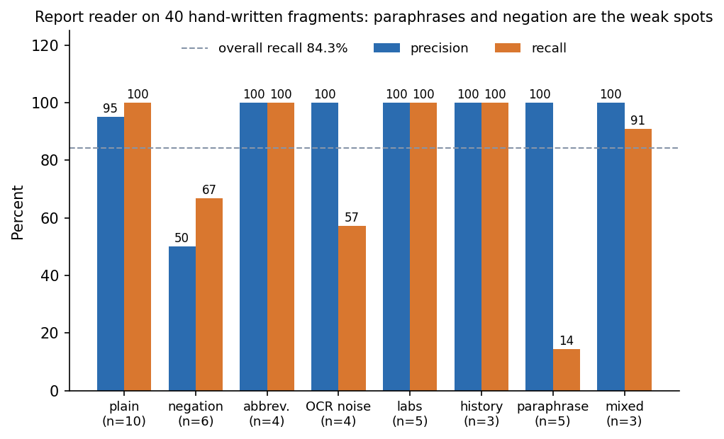
Figure 16: Precision and recall of the report reader on the hand-written stress fragments, by kind of wording.
Plain statements, abbreviations, laboratory values and history are read well. The weak spots are specific and were found by reading the misses and the spurious flags:
• Negation is incomplete. "Afebrile" matches the fever pattern; "Chest pain: absent" (negation after the term) still flags chest pain; and "Denies syncope but reports chest tightness" loses the chest pain because the 45-character negation window does not stop at "but".
• A pattern is too broad. "Haematemesis" also triggers vomiting, because the vomiting pattern contains "emesis".
• OCR damage that splits a word ("vomit ing", "elevat ion") defeats the lexicon, although run-ons without spaces are handled.
• Wording outside the lexicon is missed. Of seven expected flags in five paraphrased fragments ("cannot catch his breath", "crushing pain in the centre of the chest", "not responding to voice") only one was found: recall 0.14. "Fall at home" is not recognised as trauma.
• Page handling is correct: a finding on page 2 is reported with page 2.
The defects were reported, not repaired, in this release, so that the measured behaviour matches the shipped code. A separate observation concerns the explanation: the direction text ("raises urgency" or "lowers urgency") is derived from the sign of the attribution toward the predicted class. For a predicted priority of 1 that reading is right; for a prediction of priority 5 a positive attribution pushes toward less urgency, so the wording is inverted. The bars on the result screen are labelled as attributions toward the model's choice and are correct; the text field in the API is the part that misleads.
Table 39: Edge cases and how they were checked.
Case | Behaviour | Checked by
Negated finding ("denies chest pain") | No flag | test_negation_drops_flag
Abbreviations (SOB, HTN, DM2, STEMI) | Mapped to flags | test_abbreviations; stress set
OCR run-ons ("shortnessofbreath") | Found | test_ocr_run_on_words
Normal laboratory values | No flag | test_normal_labs_do_not_set_flags
Empty upload; unsupported file type | 400; 422 | test_extract_rejects_empty_and_unsupported
Implausible vitals (SpO2 20); unknown arrival mode | 422 | test_create_patient_validates_vitals
Change of priority without a reason; priority 9 | 422 | test_create_patient_and_override_flow; test_override_priority_out_of_range
Unknown patient id | 404 | test_missing_patient_is_404
Patient with no report at all | Model runs on vitals only (every report flag 0); accuracy falls to about 34% in the synthetic experiment | Section 8.8; the API accepts it by construction, no dedicated API test
Scanned image, first use of OCR | A few seconds while the engine loads | Timing in Section 7.7
Multi-page PDF with no text layer | Falls back to OCR on the first embedded image | Not tested (no such sample exists)
Upload above 15 MB | Specified as 413 | Not tested (limit is in the code only)
Concurrent users; long sessions | Not specified | Not tested

Model validation, the other kind of validation, is done by repetition rather than by single runs: the shipped recipe was retrained on five other train/test splits and gave a mean accuracy of 71.57% (standard deviation 0.93%), and 5-fold cross-validation of the gradient-boosted model gave 72.37% (standard deviation 1.52%); the shipped split (69.42%) is a below-average draw (Chapter 8). The test split is never used for fitting or calibration.

7.7 Performance testing
Latency was measured over HTTP against a running server on 127.0.0.1 (the name localhost adds about two seconds of IPv6 fall-back on this Windows machine and would have inflated every figure) with a scratch database. Each call was repeated 10 to 50 times after a warm-up, using one patient report (sample 01) and one scan (sample 09). The table gives the median and the 95th percentile.
Table 40: API latency over HTTP on 127.0.0.1 (milliseconds).
Call | Median | 95th percentile | Repetitions
GET /api/health | 2.7 | 3.3 | 50
POST /api/auth/login (bcrypt check) | 216.1 | 225.4 | 10
GET /api/patients (queue) | 9.4 | 10.7 | 30
POST /api/reports/extract, text PDF | 9.3 | 10.6 | 30
POST /api/reports/extract, PNG scan (OCR) | 2,232.9 | 2,706.8 | 10
POST /api/patients (fuse, model, SHAP, store) | 21.7 | 27.8 | 30
GET /api/patients/{id}/summary.pdf | 9.0 | 10.7 | 20
GET /api/metrics | 16.2 | 18.6 | 20
Flow: read a PDF, then assign a priority | 30.2 | 43.0 | 20
Flow: read a PNG scan, then assign a priority | 2,149.7 | 2,290.7 | 10

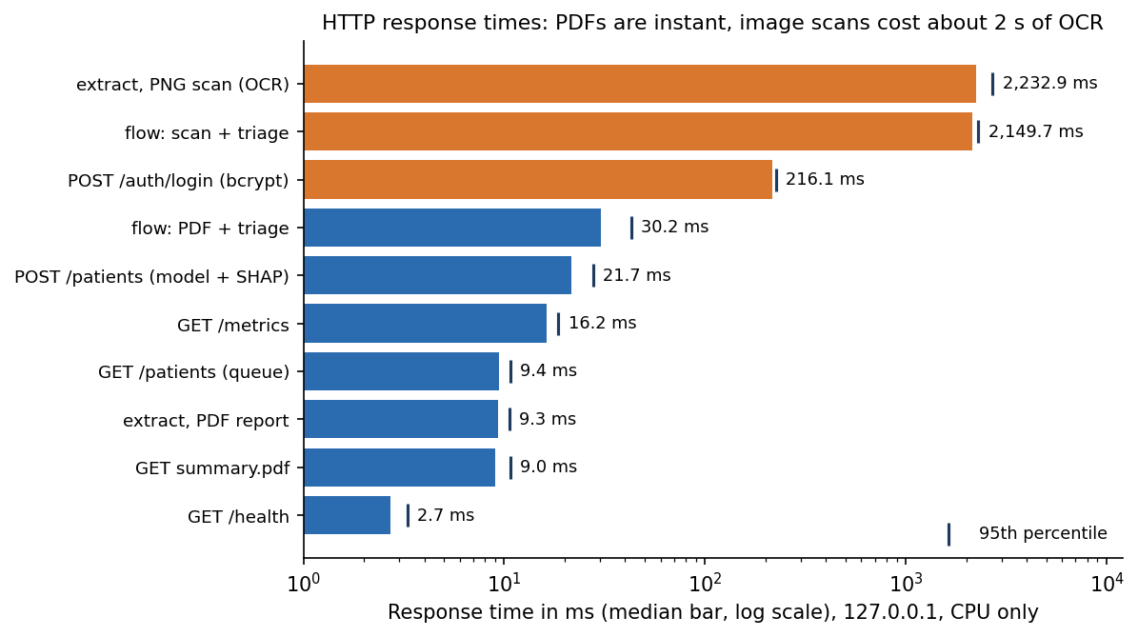
Figure 17: Median and 95th-percentile latency of the API calls; a scanned image costs about two orders of magnitude more than a text PDF because of OCR.
Three observations follow. First, with a text PDF the whole path from upload to priority takes about 30 ms (median), of which the model with SHAP is about 22 ms; the database write, the queue and the PDF writer are each around 10 to 20 ms or less. Second, a PNG scan costs a median of 2.2 s because the OCR engine runs on the CPU; the complete scan-then-triage flow took 2.1 s. Third, the bcrypt check makes login the slowest cheap call (216 ms), which is intended.
The offline end-to-end timing of the 12 generated sample reports (ml/eval.py) gave a mean of 1.261 s per patient, a median of 0.017 s and a maximum of 4.323 s; the mean is dominated by the four scans. The model alone took about 0.012 ms per patient in a batch of 1,200 and 0.44 s to train. Two cold-start costs are real: in a fresh process the first SHAP call took 11.7 s (the explainer is built on first use) and the first scan took 7.6 s to read (the OCR engine loads on first use). The server warms both in its start-up code, and the measurements above are taken after that warm-up. The performance page of the console shows a live average per patient, 0.30 s in the captured session, which mixes PDF and scan cases and so is not comparable with the table.
What the measurements do not cover is throughput under concurrent load, memory use, a database larger than a few dozen rows, and any network between the browser and a remote server.

7.8 User acceptance testing
No user acceptance test was held. There was no test group, no questionnaire and no acceptance criteria agreed with a clinician, and this chapter does not claim one; triage is a clinical task and no clinician took part. What was done instead is a scripted walk-through by the project team of the complete journey on the demo data: sign in, choose a sample report, read it, enter or confirm the vitals, assign a priority, read the explanation, change the priority with a reason, watch the queue reorder, download the summary and open the performance page. Every step produced the expected screen (Section 7.4).
The walk-through also exposed usability points that a real acceptance test would be expected to find. The performance page shows 69.4 % beside a banner that says the data are synthetic; a reader who skips the banner will over-trust the figure. The confidence shown for the STEMI sample is 100 %, which invites trust that Chapter 8 does not support for the most urgent class (recall 43.9 % for priority 1). And a clinician cannot correct a misread report finding in the interface: the extracted items are read-only, so a wrong one can only be repaired by replacing the file or re-entering the case.

7.9 Defects and observations from testing
Table 41: Findings of the test and measurement runs.
No. | Finding | Consequence
1 | Negation scope ignores "but"; "afebrile" and "absent" are not treated as negation; "haematemesis" triggers vomiting | Documented; one expected-failure test added; code not changed in this release
2 | Reader recall is 84.3% on the stress fragments but 100 % on the generated samples | The 100 % describes reports written with the lexicon in view; the lower figure is the more honest guide
3 | The API direction wording is inverted when the predicted priority is 4 or 5 | Documented in Section 7.6; the on-screen bars are correct
4 | High-risk (P1 or P2) cases are found with recall 66.2%; P1 recall is 43.9% | A clinician must review every priority; a lower alarm threshold is listed as future work (Chapter 8)
5 | Logistic regression scores higher than the shipped gradient-boosted model on the synthetic data | Reported as a finding in Chapter 8; the design was not altered to hide it
6 | First SHAP call and first OCR call are slow (seconds) after a cold start | Both are warmed when the server starts
7 | Default JWT secret, no HTTPS, no rate limiting, no role separation | Documented as limits; the product is a demonstrator
8 | scripts/download_data.py and the fresh-environment setup.bat path were never run | Listed under what was not tested

7.10 Limits of the testing done
The results above support the claims of this report, but they have limits that the reader should know:
• One machine, one operating system. All timings come from a single Intel i5-12500 computer running Windows 11 with CPU-only inference; no other operating system, browser other than Chromium, or Python version was tested.
• No real patient data and no real scans. Every model test uses synthetic records, and the only images read are the four generated PNG scans. Real scans (skew, stamps, handwriting, poor contrast) were never tried.
• The reader tests are developer-written. The 12 generated reports and the 40 fragments were written with the reader in mind; no independent clinical text was used.
• No load, soak or concurrency testing, no memory measurement and no test with more than a few dozen stored patients.
• No security audit. The checks in Section 7.5 are functional; no penetration test, dependency audit or fuzzing was done.
• No user study. No clinician has used the system; usability, trust and workload effects are unknown.
• Front-end components are not unit-tested. The React console was verified by the screenshot walk and the responsive script only.
• Not run in this session: the fresh-virtual-environment setup.bat path, scripts/download_data.py (the route to a real dataset), scripts/check_responsive.py and npm run build.
Table 42: What was and was not tested.
Area | Tested | Not tested
Report reading | Text PDFs, 4 generated scans, 40 stress fragments | Real scans, handwriting, non-English text, image-only multi-page PDFs
Triage model | Synthetic hold-out, 5 splits, 5-fold CV, 8 model types, calibration, robustness | Real patient data, any other population, prospective use
Explanation | Ordering, labelling, hiding rule; global importance against the known generating rule | Whether clinicians find the explanation useful or correct
API and database | 16 component tests, 17 smoke checks, latency | Concurrency, large data volumes, backups
Interface | 12 screens with data, responsive script (at build time) | Screen readers, users with disabilities, other browsers
Security | Token, validation, upload and path checks | Penetration test, HTTPS, rate limits, role separation, regulation

7.11 Requirements traceability
Chapter 4 numbers the functional requirements FR-1 to FR-12 and the non-functional requirements NFR-1 to NFR-11. The table shows which test or measurement covers each and what the outcome was. A requirement is marked Pass only where the evidence in this chapter supports it; the model-quality requirements hold on synthetic data only.
Table 43: Requirements against the evidence in this chapter.
Requirement | Evidence | Outcome
FR-1 | test_wrong_password_rejected; test_protected_routes_require_token; test_garbage_token_rejected; smoke checks 2 to 4 | Pass
FR-2 | test_extract_rejects_empty_and_unsupported; test_unsupported_upload_rejected; test_all_sample_reports_read_exactly; smoke check 5 | Pass (15 MB cap not tested)
FR-3 | test_negation_drops_flag; test_abbreviations; test_abnormal_labs_set_flag; test_items_keep_their_page; 40-fragment stress set (Section 7.6) | Partly: known wording read, defects listed
FR-4 | test_create_patient_validates_vitals; screen 06 | Pass
FR-5 | test_fused_record_has_36_inputs_in_model_order; screen 07 | Pass
FR-6 | test_probabilities_sum_to_one_and_priority_is_argmax; test_sick_patient_is_more_urgent_than_well_patient; smoke checks 7 and 8; Chapter 8 | Pass (synthetic data)
FR-7 | test_shap_sorted_by_absolute_impact_and_labelled; smoke check 9; screen 08 | Pass (wording defect, Section 7.6)
FR-8 | test_create_patient_and_override_flow; smoke checks 10 and 11; screens 09 and 10 | Pass
FR-9 | test_sample_queue_seeded_and_ordered; smoke checks 12 and 13; screens 04 and 11 | Pass (filter and search by screen only)
FR-10 | test_summary_pdf; smoke check 16 | Pass
FR-11 | test_metrics_reports_live_counts; smoke checks 14 and 15; screen 12 | Pass
FR-12 | test_sample_queue_seeded_and_ordered; test_sample_download_blocks_path_traversal; test_all_sample_reports_read_exactly; screens 04 and 06 | Pass
NFR-1 | Section 7.7: PDF flow median 30 ms; scan flow median 2.1 s; end-to-end maximum 4.3 s on the samples | Pass on this machine
NFR-2 | Model 0.012 ms per patient in batch; POST /patients median 21.7 ms | Pass
NFR-3 | Chapter 8: 99.67% within one level (synthetic hold-out) | Pass on synthetic data only
NFR-4 | test_create_patient_and_override_flow (explanation present); test_shap_sorted_by_absolute_impact_and_labelled | Pass
NFR-5 | Chapter 8: ECE 0.041, 0.8 to 0.9 bin over-confident | Partly
NFR-6 | Section 7.5: token, bcrypt, pydantic ranges, upload checks, path-traversal test | Pass for the controls tested; gaps listed
NFR-7 | Tests for 400, 401, 404 and 422; 413 and 503 paths not exercised | Partly
NFR-8 | scripts/check_responsive.py at build time; not re-run in the documentation session | Not re-verified
NFR-9 | By design no network call at run time; not verified with the network disabled | Not verified
NFR-10 | 47 pytest tests (46 pass, 1 expected failure) in about 15 s | Pass
NFR-11 | Screen 12 banner and landing text state the data are synthetic | Pass

CHAPTER 8: RESULTS AND OUTPUT SCREENS
This chapter reports what was measured and what the running application shows. Section 8.1 describes the set-up and the data, Section 8.2 presents the output screens, Sections 8.3 to 8.9 give the triage-model results (headline metrics, eight model types, the effect of fusing the report with the vitals, calibration and confidence, the safety view, robustness to missed findings and what the model relies on), Section 8.10 the report-reading results, Section 8.11 the comparison with the base paper, Sections 8.12 and 8.13 sample output and the analysis of successes and failures, and Sections 8.14 and 8.15 the limits of the evaluation and the objectives against the outcomes. Every model figure is on seeded synthetic data. Where a result is weak it is reported as weak.

8.1 Experimental set-up
All measurements in this chapter were made on one machine: Intel Core i5-12500 (12 threads), 15.7 GB RAM, Windows 11 Pro, no GPU, Python 3.11.9, Node 24.19.0. The machine was shared with other programs while the experiments ran, so absolute timings are indicative; accuracy figures do not depend on load. Every figure and table below was produced from stored JSON by ml/train.py, ml/eval.py, scripts/run_experiments.py, scripts/extract_stress.py and scripts/measure_api.py; no result was typed in by hand.
A caution that applies to every number in this chapter: the triage model is trained and tested on seeded synthetic data. No real patient record was used. The 'recorded priority' that the model is scored against is a label produced by a hand-written severity rule plus noise, standing in for a clinician's recorded decision. A high score therefore means the model has recovered that rule; it is not evidence about agreement with clinicians or about patient outcomes.
Table 44: Data used in the evaluation
Item | Content | Source and status
Synthetic triage dataset | 6,000 rows, 36 inputs plus a priority from 1 to 5; priority shares P1 5.5%, P2 19.9%, P3 26.1%, P4 26.7%, P5 21.8% | Generated by ml/make_data.py (seed 7307) from seven clinical archetypes and a severity score with Gaussian noise (sd 0.4); not patient data
Split used by the shipped model | 3,840 fit / 960 calibration / 1,200 test (stratified) | Test rows never used for fitting or calibration
Generated sample reports | 12 files: 8 two-page PDFs and 4 PNG scans, each with an expected flag list | scripts/make_sample_reports.py; written with the reader's lexicon in view
Reader stress fragments | 40 hand-written fragments, 70 expected flags | scripts/extract_stress.py; written by the developers
Demo queue | 12 sample cases drawn from the hold-out rows, each labelled as sample data | Seeded into an empty database at start-up

Test conditions: the shipped model is XGBoost (220 trees, depth 4, learning rate 0.1) with isotonic calibration; the comparison models of Section 8.4 were trained on the same 3,840 fit rows without calibration and scored on the same 1,200 test rows. No significance test was run; spread is given by five further random splits and by 5-fold cross-validation.

8.2 Output screens
The captures below are real screens of the running application (Chrome, 1440 by 900 pixels), made by scripts/capture_screens.py with the backend and the React console running and data in every view. The remaining screens (landing page in both themes, sign-in, the empty intake form, the change dialog and the queue after a change) are in Appendix C.
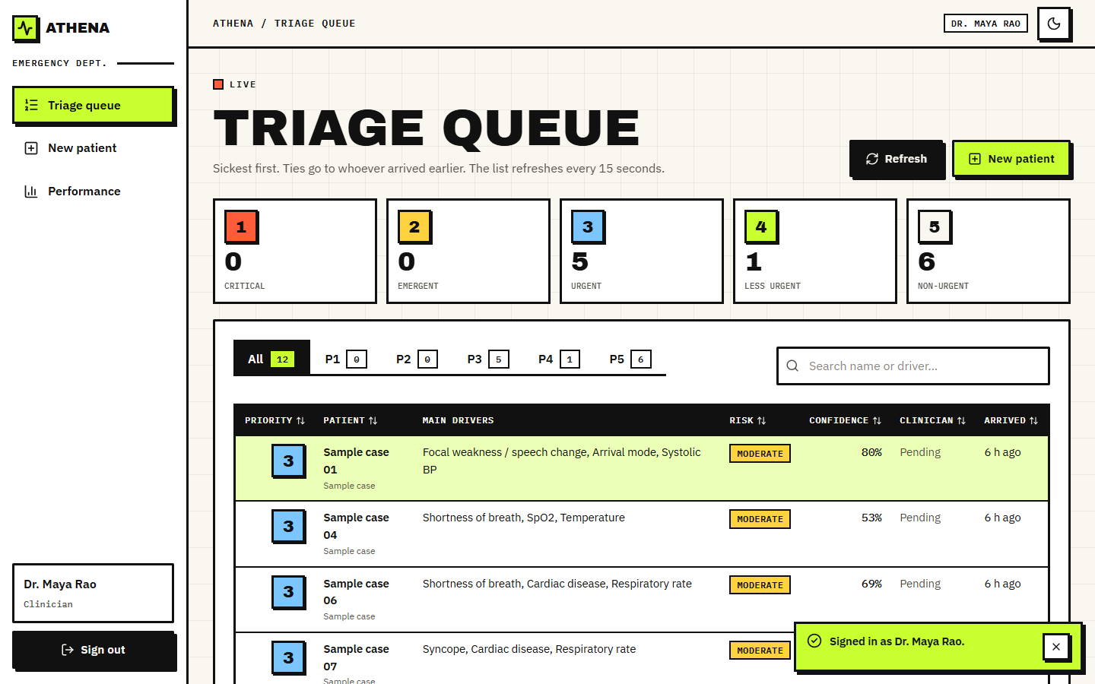  Figure 18: Output screen: the triage queue. Twelve sample cases, counts per priority along the top (0 / 0 / 5 / 1 / 6), filter tabs, a search box, and rows with the main drivers, risk level, confidence and arrival time. | 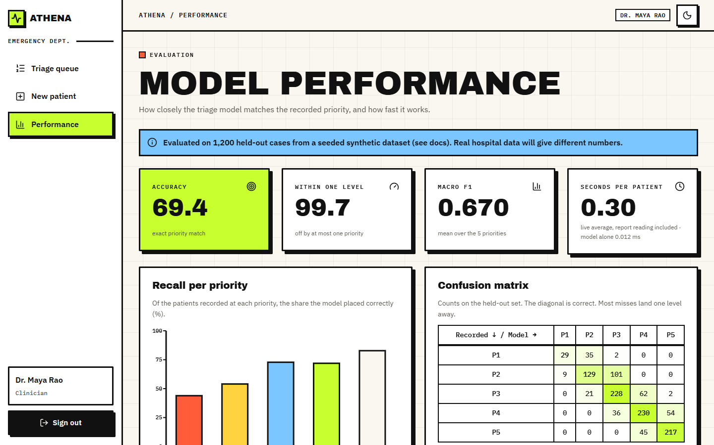  Figure 19: Output screen: model performance. Accuracy 69.4 %, within one level 99.7 %, macro F1 0.670, 0.30 s average per patient in that session, recall per priority and the confusion matrix. The blue banner states that the data are synthetic.

The queue is the page a nurse returns to. Rows are ordered sickest first and, within one priority, by arrival time; the list refreshes every 15 seconds. The Main drivers column shows the three largest explanation items so that the reason is visible without opening the case. The Clinician column reads Pending until someone has accepted or changed the priority.
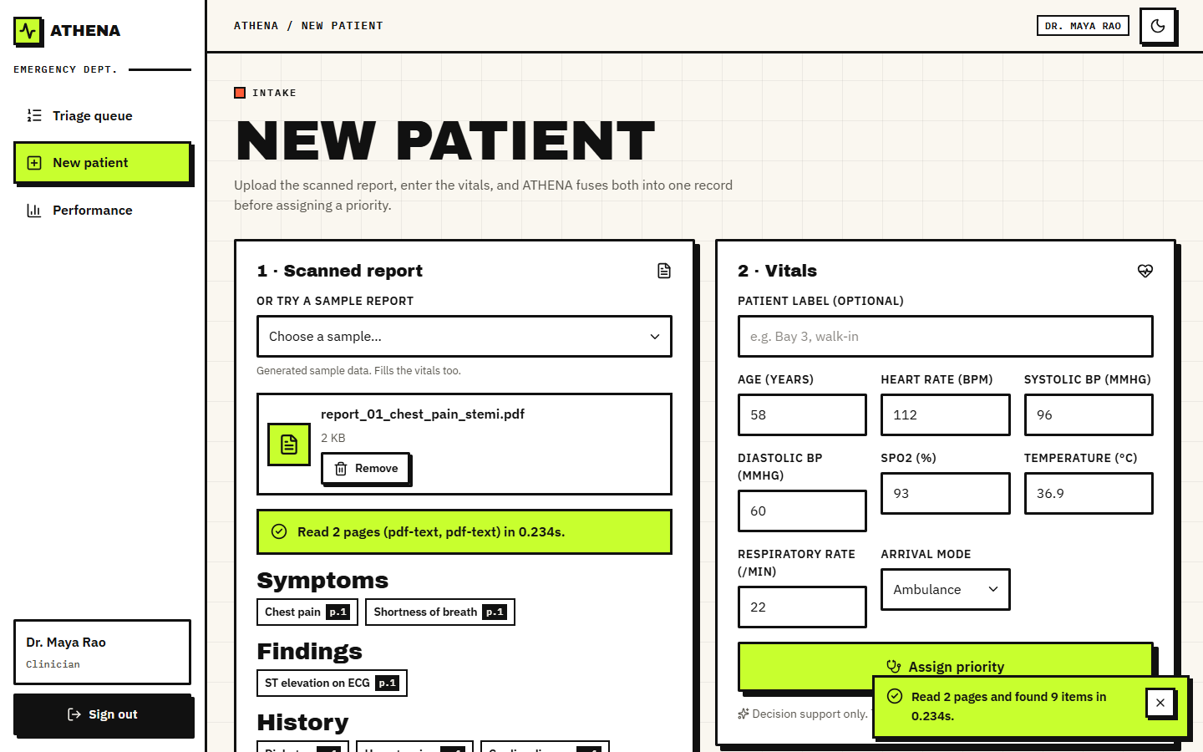
Figure 20: Output screen: new patient. Sample report 01 was chosen and read in 0.234 s; its symptoms, findings and history are listed with the page each came from, and the vitals fields were filled from the sample.
The intake screen shows the two inputs side by side: the scanned report on the left, the eight vitals on the right. A report can be uploaded or chosen from the generated samples, which also fills the vitals. Each extracted item carries a page badge (p.1, p.2), so the clinician can check it against the source page. The extracted items are read-only.
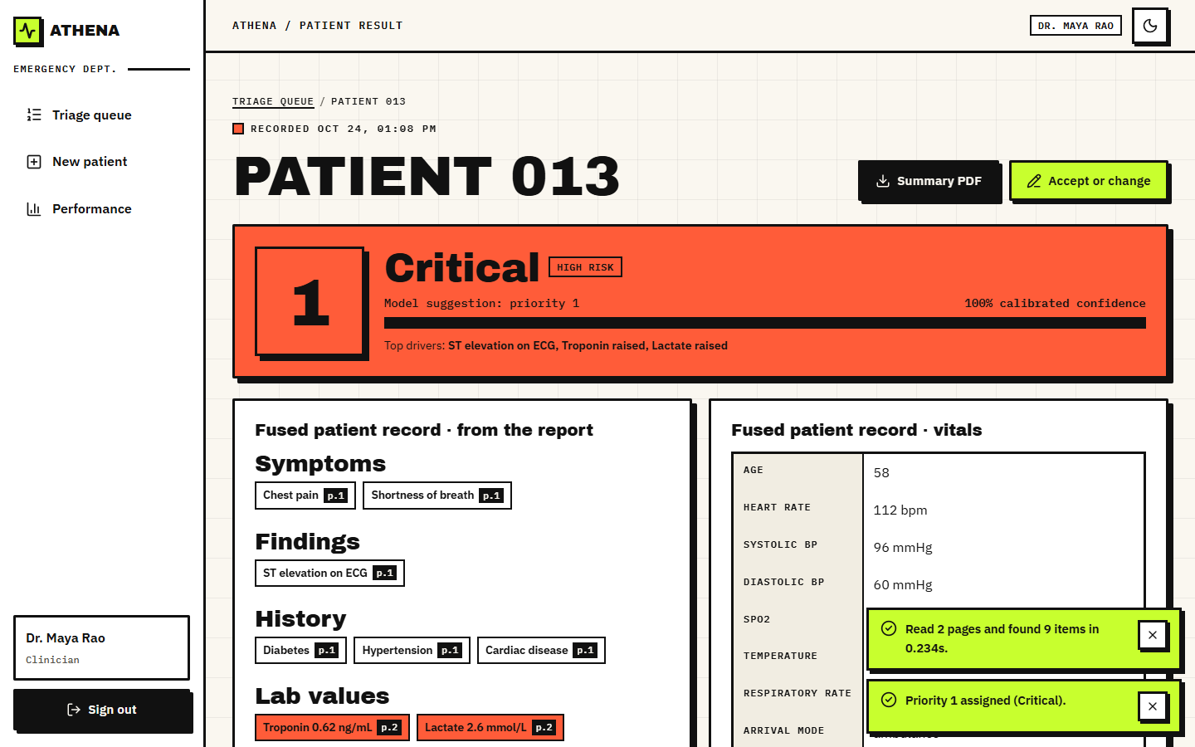
Figure 21: Output screen: result for the live patient. Priority 1 Critical, High risk, calibrated confidence 100 %, top drivers named, with the fused record (report items and vitals) below.
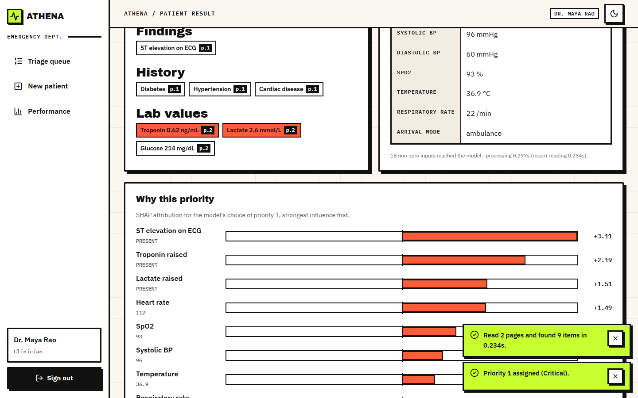
Figure 22: Output screen: why this priority. The report's findings with their pages, the vitals, and SHAP bars toward the chosen priority: ST elevation +3.11, troponin +2.19, lactate +1.51, heart rate +1.49.
The result screen shows the model's suggestion as a decision and its reasons. Laboratory values outside range are drawn in red with their units and pages. The SHAP list is ordered by absolute influence and names each factor with its value (for example heart rate 112). The same strongest factors appear in the queue row, so the explanation travels with the case.
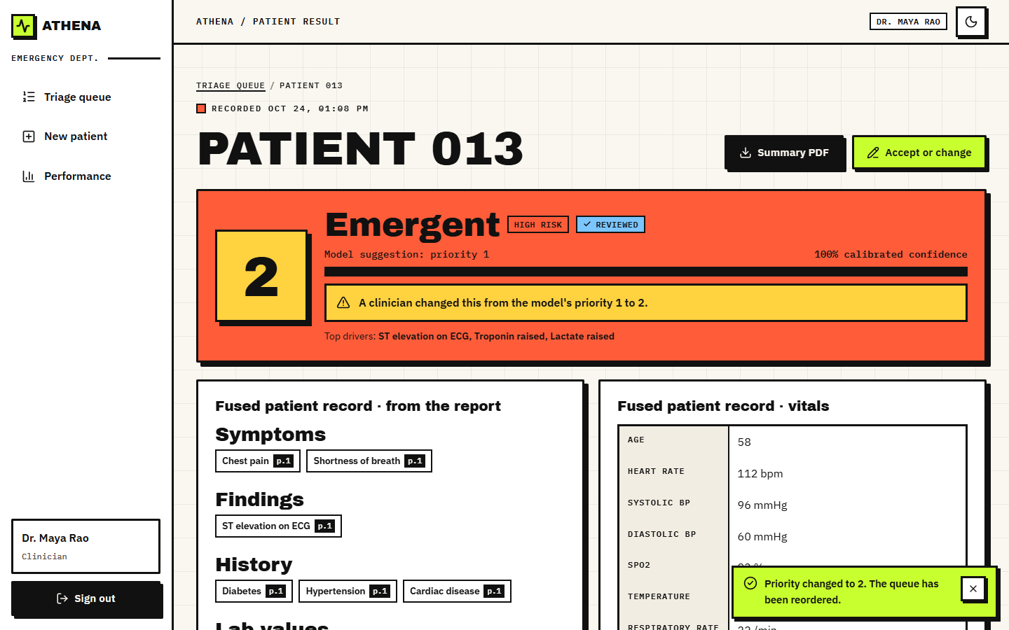
Figure 23: Output screen: after a clinician changed the priority from 1 to 2 with a reason. The banner states the change, the case is marked REVIEWED, and the model's original suggestion stays visible.
The performance page reads the stored evaluation and adds live counts. The banner at the top says the evaluation used a seeded synthetic data set and that real hospital data will give different numbers; it was kept deliberately where the numbers are. Of the 69.4 % exact accuracy and the per-priority recall bars, the weak bar is the first: recall for priority 1 is 43.9 %.

8.3 Triage model performance (synthetic hold-out)
On the 1,200 held-out synthetic cases the shipped model assigns the recorded priority exactly in 69.42% of cases and within one level in 99.67%. The macro F1 is 0.670, the quadratic weighted kappa 0.880 and the top-2 accuracy (recorded priority among the two most probable) 95.3%. Mean confidence is 0.732, close to the accuracy, as a calibrated model should give. Without calibration the same trees reach 68.25% accuracy and a macro F1 of 0.653, so calibration cost nothing in accuracy. Training took 0.44 s on the CPU.
Table 45: Shipped model: per-priority results on the 1,200 synthetic test cases.
Priority | Support | Recall | Precision | F1
P1 Critical | 66 | 43.9% | 76.3% | 0.558
P2 Emergent | 239 | 54.0% | 69.7% | 0.608
P3 Urgent | 313 | 72.8% | 62.1% | 0.671
P4 Less urgent | 320 | 71.9% | 68.2% | 0.700
P5 Non-urgent | 262 | 82.8% | 79.5% | 0.811

Table 46: Confusion matrix (rows: recorded priority, columns: model priority).
Recorded \ model | P1 | P2 | P3 | P4 | P5 | Total
P1 Critical | 29 | 35 | 2 | 0 | 0 | 66
P2 Emergent | 9 | 129 | 101 | 0 | 0 | 239
P3 Urgent | 0 | 21 | 228 | 62 | 2 | 313
P4 Less urgent | 0 | 0 | 36 | 230 | 54 | 320
P5 Non-urgent | 0 | 0 | 0 | 45 | 217 | 262

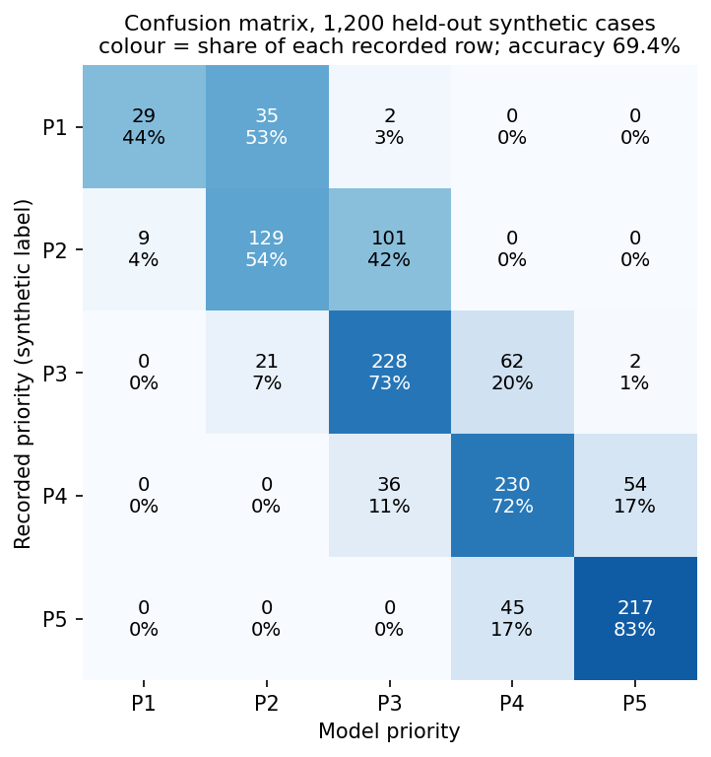  Figure 24: Confusion matrix of the shipped model on the synthetic hold-out set; the diagonal is correct, nearly every error is one level away. | 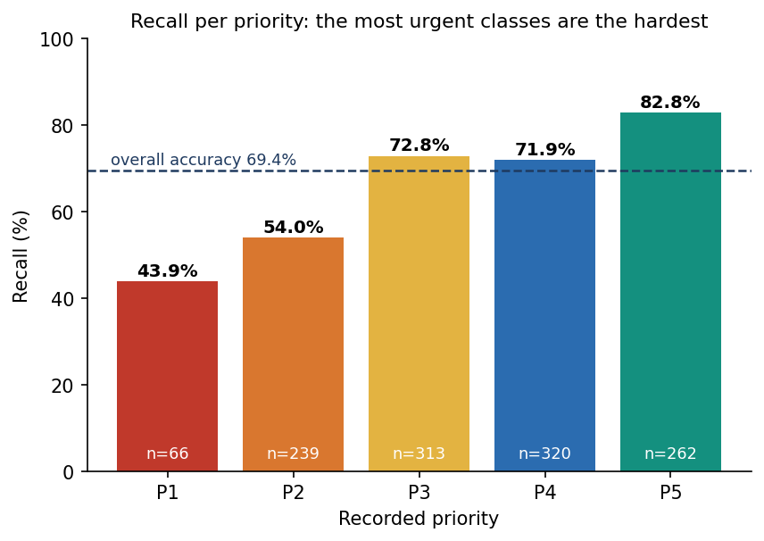  Figure 25: Recall for each priority on the synthetic hold-out set: highest for the non-urgent end, lowest for priority 1.

Two features of the matrix matter. First, the errors are almost all adjacent: only 4 of 1,200 cases are two levels off, and none further. Second, the two most urgent classes are the weakest. Priority 1 is rare (5.5% of the data, 66 test cases) and only 43.9% of those were found; 35 of the 66 were placed at priority 2. Priority 2 recall is 54.0%: 101 of 239 were placed at priority 3. The model leans toward the less urgent neighbour for the sickest patients, which is the safer-looking error to avoid and the more dangerous one to make (Section 8.7).

8.4 Comparison of eight model types
The base paper's central exercise is to compare many classifiers on one task [1]. The same was done here on a smaller scale: eight model types on the same fit rows and the same test rows, all uncalibrated, with settings chosen once and not tuned (no search of the kind the base paper ran with Optuna).
Table 47: Eight model types on the synthetic hold-out set (same split, uncalibrated).
Model | Accuracy | Within 1 | Macro F1 | QWK | Top-2 | Fit s
Logistic regression | 72.4% | 99.7% | 0.727 | 0.897 | 96.4% | 0.07
Decision tree | 54.7% | 94.7% | 0.530 | 0.761 | 80.5% | 0.02
Random forest | 67.2% | 99.7% | 0.623 | 0.871 | 95.1% | 0.52
Extra trees | 69.1% | 99.2% | 0.653 | 0.872 | 94.3% | 0.50
k-nearest neighbours | 62.6% | 97.8% | 0.564 | 0.830 | 89.2% | 0.00
MLP | 70.9% | 99.3% | 0.701 | 0.888 | 97.2% | 6.07
HistGradientBoosting | 70.3% | 99.6% | 0.669 | 0.884 | 95.6% | 0.94
XGBoost (shipped config) | 68.2% | 99.7% | 0.653 | 0.877 | 95.5% | 0.48

Figure 26: Accuracy and macro F1 of eight model types on the synthetic hold-out set.
The ranking is not the one the design implies. Logistic regression is the best single model (72.42% accuracy, macro F1 0.727) and the shipped gradient-boosted configuration reaches 68.25% uncalibrated (macro F1 0.653). The reason is in how the data were made: the label comes from an additive severity score, which a linear model can represent almost exactly, whereas trees must approximate it with steps. On real triage records, where interactions and thresholds matter, the order could be different, but this experiment cannot say so. The comparison agrees with the literature that tree ensembles are strong on tabular data [21], but it does not show an advantage for them here. The choice of XGBoost for the product rested on three other reasons: an exact and fast per-patient explanation with TreeExplainer [17], graceful handling of mixed binary and numeric inputs, and an established calibration recipe [18], [19]. A decision tree (54.7 %) and k-nearest neighbours (62.6 %) were clearly worse; the random forest and extra trees sit near the shipped model.
Stability was checked two ways. Five-fold cross-validation over all 6,000 rows gave 71.58% (sd 2.15%) for logistic regression, 71.12% (sd 0.91%) for the random forest and 72.37% (sd 1.52%) for XGBoost. Retraining the shipped recipe on five other splits gave a mean accuracy of 71.57% (sd 0.93%) and a mean macro F1 of 0.682. The shipped split (seed 7307, 69.42%) is therefore a below-average draw by about two points; the honest summary is 'about 70 % to 72 % exact accuracy'. Differences of one to two points between model types are inside this spread.
A ceiling. Because the labels are the severity score plus noise, there is a best possible exact accuracy. A reader that knew the noiseless severity score would reproduce 86.25% of the recorded priorities (and 100% within one level). No model can exceed about 86%. The shipped model's 69.4% is about 17 points below that ceiling; the gap is learning error, mostly on the rare urgent classes.

8.5 What fusing the report with the vitals adds
The gap named in the literature survey is that surveyed models use one modality of structured data. To measure what the second modality adds, the same XGBoost configuration was trained on subsets of the 36 inputs and scored on the same synthetic test cases.
Table 48: Modality ablation (XGBoost, uncalibrated, synthetic hold-out).
Inputs used | Inputs | Accuracy | Within 1 | Macro F1 | QWK | Top-2
Vitals only (8) | 8 | 40.6% | 82.2% | 0.367 | 0.489 | 70.3%
Vitals + lab flags (14) | 14 | 46.9% | 87.9% | 0.429 | 0.608 | 77.8%
Vitals + text flags (30) | 30 | 61.5% | 96.9% | 0.577 | 0.824 | 89.7%
Report only (28) | 28 | 63.2% | 97.2% | 0.615 | 0.835 | 92.2%
Fused (36) | 36 | 68.2% | 99.7% | 0.653 | 0.877 | 95.5%

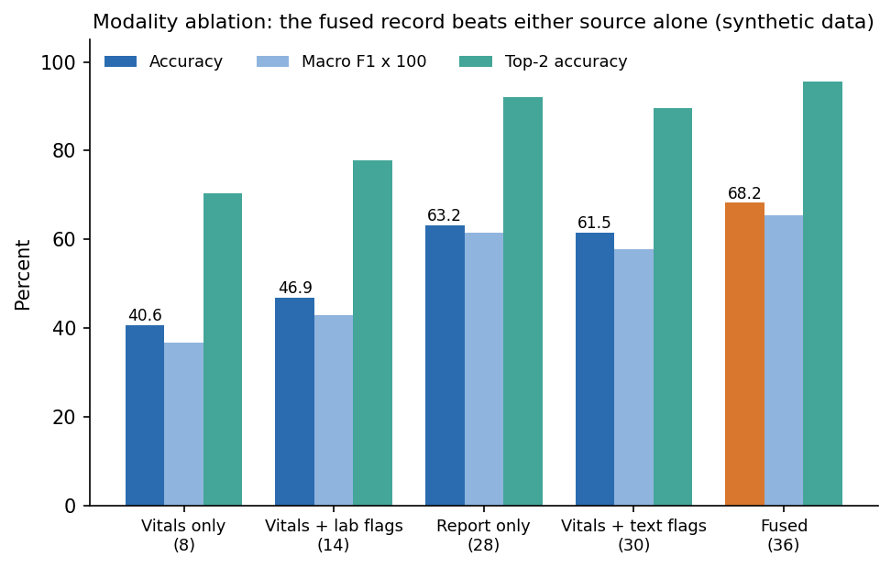
Figure 27: Accuracy and macro F1 for vitals only, report only and the fused record (synthetic hold-out).
The fused record is 27.7 points more accurate than the vitals alone (40.6%) and 5.1 points more accurate than the report alone (63.2%). Within-one accuracy tells the same story: 82.2% for vitals, 99.7% fused. The text flags carry most of the report's value (vitals plus text flags 61.5%); the six laboratory flags add less on their own (vitals plus labs 46.9%). This supports the design, but with the same caveat as every result here: the synthetic generator draws the labels from both the vitals and the report flags, so the data were built to reward fusion. How much a real report adds is an open question that only real records can answer.

8.6 Calibration and the confidence threshold
A triage tool shows a confidence next to the priority, so that number should mean something. Isotonic calibration on a separate split lowered the expected calibration error (10 bins, top label) only modestly, from 0.0466 to 0.0412, and the summed multiclass Brier score from 0.4187 to 0.4104. Mean confidence rose from 0.646 to 0.732, against an accuracy of 69.4%. The uncalibrated model was already under-confident; calibration corrected that. The reliability bins show where it is still wrong:
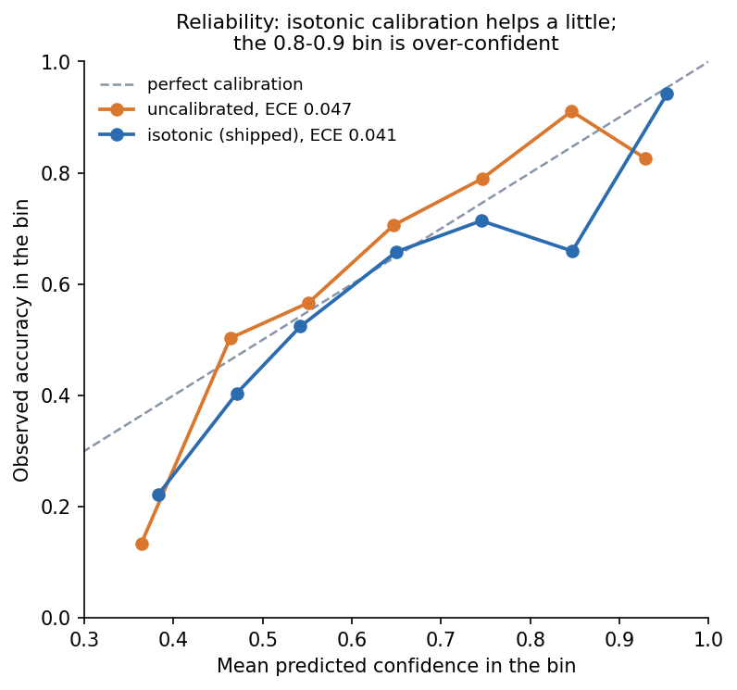  Figure 28: Reliability diagram of the calibrated and uncalibrated model on the synthetic hold-out set. | 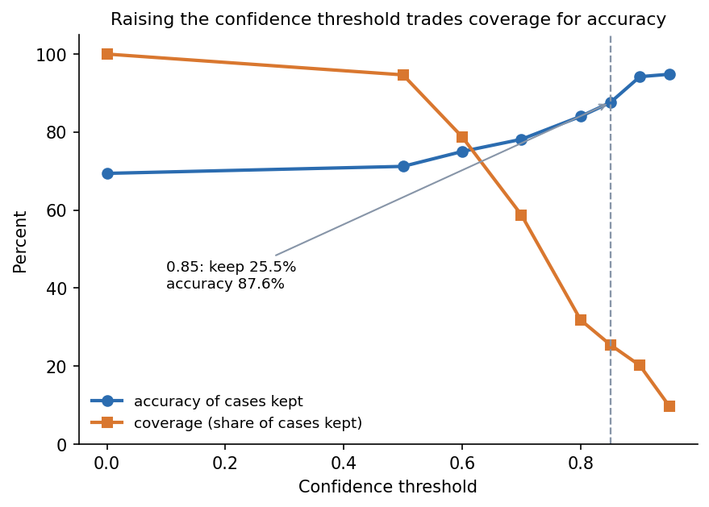  Figure 29: Exact accuracy and coverage as the confidence threshold is raised (synthetic hold-out).

The bins from 0.5 to 0.8 are close to the diagonal. The 0.8 to 0.9 bin is over-confident: 138 cases with a mean confidence of 0.847 were right only 65.9% of the time. Confidence is therefore a useful ranking signal, not a probability to quote to a patient. This is the modest end of what calibration literature reports for non-neural models [20].

8.6.1 Accuracy against coverage
The base paper accepts a diagnosis as highly probable when its probability exceeds 0.85 and reports that such predictions are more accurate than the average [1]. The same analysis was made here: how accurate is the model on the cases where it is more confident, and how many cases are left?
Table 49: Accuracy of the calibrated model when only cases above a confidence threshold are kept (synthetic hold-out).
Threshold | Coverage | Cases | Accuracy | Within 1
0.00 | 100.0% | 1200 | 69.4% | 99.7%
0.50 | 94.7% | 1136 | 71.2% | 99.8%
0.60 | 78.8% | 945 | 75.0% | 99.8%
0.70 | 58.8% | 705 | 78.2% | 99.7%
0.80 | 31.8% | 382 | 84.0% | 100.0%
0.85 | 25.5% | 306 | 87.6% | 100.0%
0.90 | 20.2% | 242 | 94.2% | 100.0%
0.95 | 9.7% | 116 | 94.8% | 100.0%

Accuracy rises from 69.4% for all cases to 87.6% at a threshold of 0.85, but that threshold keeps only 25.5% of the cases; at 0.9 the figures are 94.2% and 20.2%. ATHENA does not apply any threshold: every case gets a priority. The table shows what a 'confident cases first, others to a senior nurse' rule could look like. It was computed on the test set, so it describes the trade-off and is not a tuned operating point.

8.7 The safety view: under-triage and missed high-risk cases
Accuracy treats every error alike, but in triage an error that sends a sicker patient down the queue is worse than one that moves a well patient up. The errors were therefore split by direction.
Table 50: Direction and size of the model's errors (synthetic hold-out, 1,200 cases).
Measure | Value
Under-triage: model less urgent than recorded | 21.33%
Over-triage: model more urgent than recorded | 9.25%
Under-triage by two or more levels | 0.33% (4 cases)
Over-triage by two or more levels | 0.00%
Recorded priority 1 placed at priority 3 or less urgent | 2 of 66
High risk (P1 or P2) found at arg-max: recall / precision (305 cases) | 66.2% / 90.6%
High risk found when P(1) + P(2) is at least 0.4 (not implemented): recall / precision | 84.3% / 81.6%

The model under-triages 21.3% of cases and over-triages 9.2%: it errs toward the less urgent side more than twice as often as toward the more urgent. Almost all of this is one level. For the question that matters most, 'is this patient high risk?', recall at arg-max is only 66.2% with precision 90.6%, so about one high-risk case in three is labelled Moderate or Low. Raising an alarm whenever the combined probability of priorities 1 and 2 reaches 0.4 would lift recall to 84.3% at a precision of 81.6%. That rule is not in the product; it is the most direct improvement the results suggest (Chapter 10). Until then, a clinician must review every priority, which is what the override loop is for. These figures are on synthetic data and are consistent with the known tendency of triage scales themselves to miss critical illness [9].

8.8 Robustness to missed report findings
The base paper stresses that clinical records are incomplete and treats an unreported symptom as absent rather than imputing it [1]. ATHENA follows the same rule: a report flag that the reader does not find is 0. To see what that costs, each positive report flag in the test set was removed with a given probability before scoring, imitating a reader that misses findings. The vitals were left intact.
Table 51: Accuracy when report findings are dropped at random (shipped model, synthetic hold-out).
Probability a finding is dropped | Accuracy | Within 1 | Macro F1 | Top-2
0.0 | 69.4% | 99.7% | 0.670 | 95.3%
0.1 | 66.2% | 98.1% | 0.633 | 93.1%
0.2 | 62.1% | 96.3% | 0.594 | 90.1%
0.3 | 59.5% | 95.0% | 0.565 | 88.4%
0.5 | 50.9% | 89.5% | 0.465 | 81.8%
1.0 (no report) | 33.9% | 70.4% | 0.246 | 64.0%

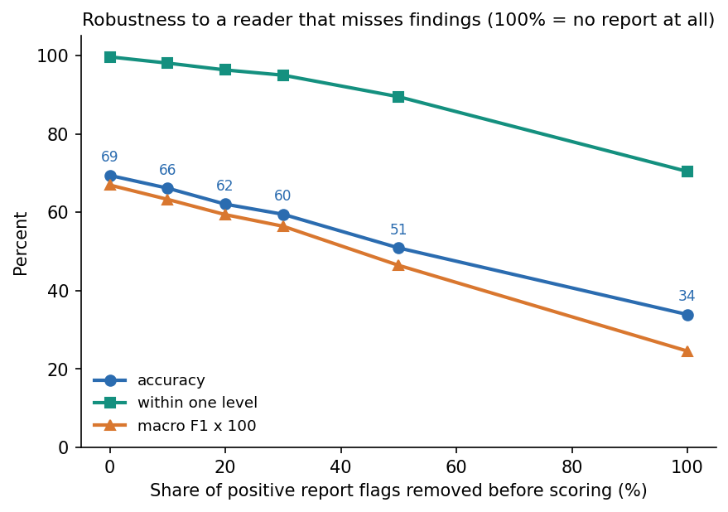
Figure 30: Accuracy and within-one accuracy as report findings are dropped at random.
The model degrades gradually: 66.2% accuracy when one finding in ten is missed, 62.1% at one in five, and 33.9% with no report at all (within-one 70.4%). A missed finding is costly. The report reader's recall on the stress fragments is 84.3%, which puts real use nearer the 0.1 to 0.2 rows than the 0.0 row; on wording outside the lexicon it is far lower. The result also shows why the reader is the part of the system to improve first (Chapter 10).

8.9 What the model relies on
Averaging the absolute SHAP attribution over all test cases and classes gives a global picture of the inputs the model uses [16], [17].
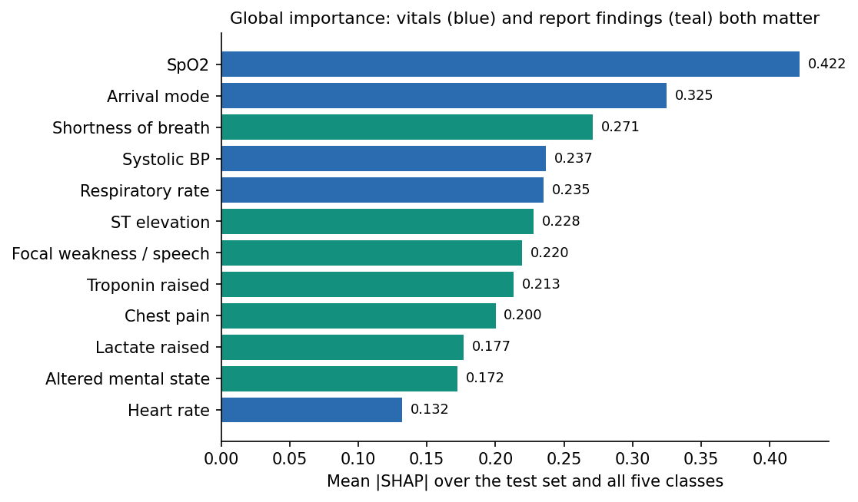
Figure 31: Mean absolute SHAP value of the fifteen most influential inputs on the synthetic hold-out set.
Oxygen saturation, arrival mode, shortness of breath, blood pressure and respiratory rate lead, followed by ST elevation, focal weakness, raised troponin and chest pain. That is what the synthetic severity rule rewards, so the ranking is a check that the explainer reports what the model learned and that the model learned the rule; it is not clinical validation. Whether the explanation is useful to a clinician is untested.

8.10 Report reading
On the 12 generated sample reports (8 PDFs and 4 PNG scans read through OCR) the reader found every expected flag and no extra one: precision 100%, recall 100%, 12 of 12 read exactly. That figure shows that the pipeline works end to end; it does not show that real scans are solved, because these reports were written and drawn with the lexicon in view. On the 40 hand-written stress fragments the figures are lower and more informative: precision 95.2%, recall 84.3%, 27 of 40 read exactly. Wording the lexicon contains (plain statements, abbreviations, laboratory values, history) was read almost perfectly; negation edge cases, OCR-damaged words and paraphrases were not (Section 7.6).
Reading time per patient (ml/eval.py, 12 samples): mean 1.26 s, median 0.017 s, maximum 4.32 s from upload to priority. A text PDF is read in a few milliseconds; a scan takes 2 to 5 s on the CPU. Over HTTP the median for a text PDF through to a priority is 30 ms and for a scan 2.1 s.

8.11 Comparison with the base paper
The two studies are not comparable on accuracy, and no claim is made that ATHENA outperforms the base paper. They differ in task (diagnosis among 87 ICD-10 classes against a five-level priority), in data (real clinical cases against a synthetic generator), in input (typed indicators against a scanned report fused with vitals), and in metric difficulty. A five-class problem with an ordinal structure and a rule-generated label is a different, easier kind of problem than 87-class diagnosis from incomplete real records, so a higher or lower accuracy in either direction would prove nothing. The table sets the two side by side by feature.
Table 52: The base paper [1] and ATHENA, feature by feature.
Aspect | Base paper | ATHENA (synthetic data)
Task | Diagnosis as an ICD-10 class (87 classes, 32 in paediatrics, 55 in internal medicine) | Triage priority, 5 ordered classes, plus risk level
Data | 1,655 real clinical cases (616 internal medicine, 1,039 paediatrics); external check on 120 cases | 6,000 synthetic rows; no real data, no external check
Input | 479 typed symptom, sign and laboratory indicators; missing = absent | Scanned report (OCR + lexicon) fused with 8 vitals into 36 inputs; missing = absent
Models compared | 19 algorithms, Optuna tuning (100 trials each) | 8 model types, settings not tuned
Best exact accuracy | Gradient Boosting 84.74% (internal medicine); Multi-Layer Perceptron 87.20% (paediatrics) | Logistic regression 72.42%; shipped XGBoost 69.42% (synthetic)
Ranked output | TOP-3: mean 77.43% / 81.99%; best 91.72% / 94.71% | Top-2 95.3% (2 of 5 classes; not the same difficulty as 3 of 87)
High-confidence threshold | 0.85, 'highly probable'; sensitivity analysis 0.70 to 0.95 | Threshold table (Section 8.6): at 0.85 coverage 25.5%, accuracy 87.6%
Explanation | SHAP and LIME, global, by ICD-10 block | SHAP only, per patient, shown beside each decision; no LIME
Incomplete data | No imputation; analysis of six kinds of incompleteness | No imputation; dropped-finding experiment (Section 8.8): 62.1% at 20 % dropped
Statistics | Bootstrap 95 % intervals, McNemar tests | Five splits and 5-fold cross-validation; no significance test
Scanned documents | Not handled | Reader recall 100 % on generated samples, 84.3% on stress fragments
Time per case | Not reported in the sections read | Median 30 ms (PDF) and 2.1 s (scan) over HTTP

Where ATHENA does follow the base paper it adopts four ideas: comparing several algorithms on one task, reading the probabilities as a ranking (top-k) rather than only the arg-max, studying a high-confidence threshold, and treating an unreported finding as absent. Where it goes beyond the paper is the intake of scanned reports, fusion with vitals, a five-level target, calibrated confidence, a per-patient explanation shown with the decision, the clinician override record, and the measured processing time. Where it falls short is evidence: the base paper used real cases, tuned 19 algorithms, reported intervals and tests, and validated on an external facility. ATHENA did none of these.

8.12 Sample inputs and outputs
Three illustrative cases were run through the real reader and the shipped model with the project environment (backend.app.services.extract and triage.predict) on the generated sample reports, using the vitals that accompany each sample. They are chosen to show a clear critical case, a case the model is less sure of, and a trivial one; they are not a test set. All three are synthetic documents.
Table 53: Three illustrative cases (computed with the shipped model; synthetic sample data).
Case | Vitals entered | Flags read from the report | Model output | Largest explanation items
A: sample report 01 (chest pain, ambulance) | Age 58, HR 112, BP 96/60, SpO2 93, 36.9 C, RR 22 | chest pain, shortness of breath, ST elevation, diabetes, hypertension, cardiac disease, troponin raised, lactate raised | P1 Critical, High, confidence 1.00 | ST elevation +3.11; troponin +2.19; lactate +1.51; heart rate 112 +1.49; SpO2 93 +0.97
B: sample report 03 (fever, cough, low oxygen) | Age 66, HR 118, BP 104/64, SpO2 89, 39.1 C, RR 28 | shortness of breath, fever, lung infiltrate, COPD, diabetes, WBC raised, lactate raised | P1 Critical, High, confidence 0.74 (P2 0.26) | SpO2 89 +2.92; lactate +1.76; resp. rate 28 +1.28; heart rate 118 +0.86; lung infiltrate +0.68
C: sample report 07 (minor cold, walk-in) | Age 22, HR 74, BP 118/74, SpO2 99, 36.8 C, RR 15 | none found | P5 Non-urgent, Low, confidence 0.98 (P4 0.02) | arrival mode walk-in +0.65; no trauma +0.25; SpO2 99 +0.20; systolic BP 118 +0.19; no chest pain +0.19

Case A is the screen shown in Section 8.2: the reader found eight flags, including the ST elevation and two raised laboratory values from page 2, and the model is certain. Case B reaches priority 1 mainly through low oxygen saturation, raised lactate and a fast breathing rate, but the second-most probable class takes 26 % of the probability, which is the kind of case a clinician would look at twice. In case C every finding flag is zero and the model returns the lowest priority with high confidence; here the arrival mode (walk-in) is the largest single factor, an effect of how the synthetic data were generated more than a clinical truth. A fourth case, the generated scan of an ankle sprain (sample 12), was read through OCR in 7.6 s on the first call in a fresh process, found one flag (trauma) and gave priority 4 with confidence 0.66.
The 12 sample cases seeded into the queue come from the synthetic hold-out rows with their recorded priority. The shipped model matches that recorded priority for 8 of the 12 (67 %); the four misses (sample cases 01, 02, 09 and 12) are all one level away and all recorded as priority 4, which is the kind of error the noise in the labels produces.

8.13 Success and failure analysis

8.13.1 Where the system works
• The pipeline works end to end. A PDF or scan goes in; findings with pages, a priority, a calibrated confidence and an explanation come out in about 30 ms for a text PDF and about 2 s for a scan (Section 7.7).
• Errors are close. 99.67% of priorities are within one level of the recorded one on the synthetic hold-out, and the quadratic weighted kappa is 0.880.
• Fusion helps on this data: 28 points over vitals alone.
• The explanation names the right things. The largest attributions for the critical sample are ST elevation, troponin and lactate; globally the model relies on oxygen saturation, arrival mode, breathlessness and blood pressure, as the generating rule does.
• The reader is strong on what it knows: negated statements, abbreviations, laboratory ranges and pages are handled, and 12 of 12 generated reports (including four OCR scans) were read exactly.

8.13.2 Where it fails
• The most urgent classes are the weakest. 35 of 66 priority-1 cases went to priority 2 (recall 43.9%), and 101 of 239 priority-2 cases went to priority 3 (recall 54.0%). The cut points between these classes lie where the added noise matters most and the classes are rare.
• High-risk recall is 66.2% at arg-max; one high-risk case in three would be labelled Moderate or Low.
• Over-confidence in one band. Cases scored 0.8 to 0.9 were right about two times in three.
• A linear model does as well or better (72.4% against 68.2%), so the added machinery is not justified by the synthetic data alone.
• The reader misses what the lexicon does not contain, and a few spurious or lost flags follow from the negation rules (Section 7.6). A missed finding lowers accuracy by about three points for every ten per cent of findings dropped.
• The explanation wording is inverted in the API for low-priority predictions (Section 7.6), and the interface cannot correct a misread finding.
• Nothing here is a real-world test. The model was never shown a real patient.
The pattern of failure is consistent with the data rather than with a bug in the model. The recorded priority is the severity score plus noise of standard deviation 0.4, cut at four thresholds; cases close to a threshold carry a label that even a perfect reader of the score gets wrong about one time in seven. The classes at the sick end are rare, so there are few examples to learn their boundary from.

8.14 Limitations of the evaluation
• Synthetic data throughout. Every accuracy, recall and calibration figure describes recovery of a known rule. The study cannot say how ATHENA would perform on real patients, and it should not be quoted as an accuracy for triage.
• Circular design. The same author-written assumptions generate the data, the sample reports and the lexicon; the 100 % reading score and the benefit of fusion are partly built in.
• One dataset, one generator, one split for the headline numbers. Five other splits and cross-validation show a spread of about one point, and the shipped split is two points below their mean.
• Developer-written stress fragments and a small number of generated scans; no independent clinical text and no real scans.
• Threshold, safety and robustness analyses were run on the test set and describe trade-offs; none was tuned.
• No external validation, no prospective study, no clinician review of the explanations, and no comparison with a nurse's own triage or with a standard scale such as ESI [14].
• No significance tests, and the model settings were not searched, unlike the base paper's 100-trial tuning.

8.15 Objectives versus outcomes
Table 54: The six objectives of the project against what was achieved.
Objective | Status | Evidence
1. Build an OCR stage that converts scanned reports to machine-readable text | Met | PDF text layer plus local RapidOCR (PaddleOCR-family models on ONNX Runtime) for scans; 12 of 12 generated reports read; scans take 2 to 5 s
2. Apply a medical language model to extract symptoms, findings and history | Partly met | A rule-based lexicon of 22 terms with negation and 6 lab rules was used instead of BioBERT [22]; precision 95.2%, recall 84.3% on stress fragments, 100 % on generated samples
3. Combine text-derived features with vitals in a single representation | Met | 36-input fused record (8 vitals + 28 report flags), shown side by side in the interface
4. Train a model that assigns a risk level and a triage priority | Met on synthetic labels | Calibrated XGBoost, priority 1 to 5 and High/Moderate/Low; 69.4% exact, 99.7% within one level on synthetic hold-out
5. Add an explainability layer showing which findings drove the priority | Met | Per-patient SHAP beside every decision, strongest first; no LIME; usefulness to clinicians untested
6. Evaluate accuracy against clinician-assigned priority and measure processing time per patient | Partly met | Accuracy measured only against the synthetic recorded priority, not clinicians; time per patient measured (median 30 ms for a PDF, 2.1 s for a scan)
Batch brief: BioBERT, RAG, multi-agent orchestration, six disease-risk models, MongoDB, Node.js and Flask | Not built | Replaced by a lexicon, no RAG, a single pipeline, no disease models, SQLite, and FastAPI with React; listed as future work

Taken together, the project delivered a working, tested, honestly evaluated decision-support prototype whose weakest links are the ones the batch brief most wanted: a medical language model for reading reports, and accuracy against real clinician judgement. Both remain open.

CHAPTER 9: CONCLUSION

9.1 Summary of the work
This project built ATHENA, a decision-support tool for emergency departments. It reads a scanned clinical report (PDF text layer or local OCR), parses symptoms, findings, history and six laboratory values with a lexicon that handles negation, fuses them with eight vitals into 36 inputs, and uses an isotonic-calibrated XGBoost to give a triage priority from 1 to 5, a risk level and a calibrated confidence. Per-patient SHAP shows the strongest drivers, a clinician accepts or changes the priority with a reason, and the queue, the performance page and a summary PDF follow from that. The system was measured on a seeded synthetic data set (6,000 cases, 1,200 held out), compared with seven other models, probed for calibration, robustness and safety, and verified with 47 automated tests and 17 smoke checks.

9.2 Objectives achieved
Table 55: The six objectives of the batch against the outcome
# | Objective | Outcome
1 | OCR stage for scanned reports | Met: PDF text layer plus local RapidOCR (PaddleOCR-family models on ONNX Runtime); 12 of 12 generated samples read exactly; real scans untested
2 | Medical language model to extract symptoms, findings, history | Partly met: a lexicon with negation, not BioBERT; precision 95.2% and recall 84.3% on 40 hand-written fragments
3 | Fuse text features with vitals in one representation | Met: 36 inputs; fused 68.25% against 40.58% (vitals) and 63.17% (report)
4 | Model assigns risk level and priority | Met on synthetic labels: 69.4% exact, 99.7% within one level, macro F1 0.670
5 | Explanation layer showing what drove the priority | Met: per-patient SHAP, strongest factor first, with the page each finding came from
6 | Accuracy against clinician-assigned priority; time per patient | Partly met: accuracy against the synthetic recorded priority only; median 30 ms for a PDF and 2.1 s for a scan, end to end over HTTP

9.3 Key findings
1. Fusing the report with the vitals pays on this data. Exact accuracy is 68.25% fused, 63.17% report only and 40.58% vitals only; within one level the fused model is right 99.7% of the time.
2. The shipped model recovers its rule well but not perfectly. 69.4% exact, 99.7% within one level, macro F1 0.670, quadratic weighted kappa 0.880, Top-2 95.3%; the label noise caps any model near 86.25%.
3. The sickest patients are the weak point. Priority 1 recall is 43.9% and high-risk (P1 and P2) recall 66.2%. Flagging high risk when P(1) + P(2) is at least 0.4 would raise recall to 84.3% at precision 81.6%; this threshold is not implemented.
4. A simple baseline matches the chosen model. Logistic regression 72.42%, MLP 70.92%, XGBoost 68.25% (uncalibrated); five-fold XGBoost accuracy is 72.4% (sd 1.5).
5. Confidence is informative but coarse. Calibration lowers ECE only from 0.047 to 0.041; keeping predictions with confidence of at least 0.85 covers 25.5% of cases at 87.6% accuracy, and 0.9 covers 20.2% at 94.2%.
6. The reader is the fragile stage. 100% on generated samples, recall 84.3% on hand-written fragments, and the triage model loses accuracy quickly when findings are dropped (66.2% at 10%, 62.1% at 20%, 33.9% with no report).
7. Against the base paper ATHENA shares the ideas of ranked output, a 0.85 confidence threshold, SHAP and absent-equals-zero, but the task (five priorities against 87 ICD-10 classes) and the data (synthetic against 1,655 real cases) differ, so no accuracy comparison is claimed.

9.4 Practical applications
• A teaching and prototyping platform for decision support that reads documents, fuses them with measurements, explains itself and records the clinician's decision.
• A reference design for triage software: queue ordered by priority then arrival, reasons beside each decision, override log, summary PDF.
• A starting point for training on real triage records once such a data set is available (Chapter 10), with the evaluation scripts already in place.
• A template for reporting a clinical-AI result honestly: data source in every sentence, baselines, ceiling, calibration, safety direction and robustness.

9.5 Known limitations
All model results are on synthetic data; priority-1 recall is 43.9% and under-triage 21.3%; a linear model is as good as the shipped one; the reader is a lexicon with known negation and OCR defects; BioBERT, RAG, multi-agent orchestration, LIME, MongoDB and the six disease-risk models were not built; security is demo-grade; and no clinician used the system. Chapter 8 and the Scope and Limitations document give the full list.

9.6 Lessons learned
• Write the data a number was measured on in the same sentence as the number; a synthetic 69% and a real-hospital 69% are different claims.
• Run the simple baseline first. Logistic regression beating XGBoost would have stayed hidden without a comparison table.
• Work out the noise ceiling of a synthetic data set before celebrating or lamenting an accuracy.
• Test the reader on text it was not written for; the generated samples gave 100% and the first honest stress test gave 84.3% recall.
• Keep experiments scripted and their output stored as JSON, so every number in the documents can be traced and regenerated.

CHAPTER 10: FUTURE SCOPE

10.1 Improvements to the existing system
• Train and test on real triage records. The Kaggle "Hospital Triage and Patient History Data" set is wired to scripts/download_data.py (never run; licence not stated); MIMIC-IV-ED is a public benchmark but needs credentialed access [13]. Report agreement with recorded triage levels, per-level recall and calibration on a patient-disjoint split.
• Add the high-risk safeguard. Raise a High-risk flag when P(1) + P(2) is at least 0.4: on the synthetic hold-out this raises P1-P2 recall from 66.2% to 84.3% at precision 81.6% (against 90.6%); choose the threshold on validation data with clinicians.
• Improve negation scope and OCR tolerance. Stop the window at "but" and "however", handle post-positioned negation ("absent") and prefixes ("afebrile"), join split OCR words, and fix the emesis match inside haematemesis.
• Better calibration. Compare temperature scaling and merged bins with isotonic regression; the 0.8 to 0.9 confidence bin is over-confident today (ECE 0.041).
• Replace the lexicon by a clinical language model (BioBERT-class [22]) for extraction, keeping the lexicon as a fallback and the stress set as the regression test.
• Strengthen security. Require JWT_SECRET, add HTTPS, rate limiting, audit logging of views and downloads, and remove the seeded passwords.

10.2 Additional features
• Chief-complaint and pain-score inputs, which real triage relies on, and free-text notes next to the scan.
• Retrieval of guidance (RAG) so that a priority comes with the relevant protocol passage, and multi-agent checks (for example a second reader that audits the first) as named in the batch abstract.
• LIME or counterfactual explanations next to SHAP, and an explanation of why a finding was not read.
• Disease-risk modules for diabetes, heart disease, chronic kidney disease, breast cancer, liver disease and sepsis, as named in the batch brief, each with its own evaluation.
• Trend views for repeated vitals and an alert when a waiting patient's risk changes.

10.3 Scalability and deployment
• Move from SQLite to a server database, run several API workers behind a reverse proxy, and cache the OCR engine per worker; creating a patient already takes a median 22 ms, so reading scanned images (about 2.2 s each on this CPU) is the cost that needs a worker pool or a GPU.
• Integrate with hospital systems through HL7 or FHIR and a monitor feed instead of typed vitals.
• Containerise the service, publish the model bundle with its metrics and monitor the distribution of inputs and of clinician overrides in production, retraining when they drift.

10.4 Further research
• A prospective, clinician-in-the-loop study: how often is the suggestion kept, and does the explanation change the clinician's decision?
• Fairness checks across age and arrival mode on real data, and measurement of under-triage by subgroup.
• Comparison of tree models, linear models and small networks on real triage records, following the tabular-data evidence [21].
• Top-k and abstention policies: when the model should refuse to suggest a priority, building on the confidence-coverage curve measured here.
• Reporting to a clinical-AI standard such as TRIPOD+AI [30] once real data are used.

REFERENCES
[1] M. Mlodawski, S. Deniziak, M. Plaza, A. Kwiatkowska, D. Jaszczyk, A. Gajda and K. Twardowski, "Multidimensional analysis of the diagnostic performance of machine learning models in disease classification: implications for clinical decision support systems," IEEE Access, vol. 14, pp. 92149-92177, 2026, doi: 10.1109/ACCESS.2026.3703248.
[2] "Identifying the high-risk obstetric patient at triage," J. Emerg. Nurs., 2026 (authors, volume and pages not verified).
[3] "The effects of patient triage management strategies on clinical outcomes and risk management in emergency departments: a prospective comparative study," Anatolian Curr. Med. J., vol. 7, no. 1, Jan. 2025.
[4] T. L. Pinn-Woodcock, J. Pigott and S. A. L. DeNotta, "Emergency diagnostic assessment during triage," in Emergency Triage of the Horse. Hoboken, NJ, USA: Wiley, 2025, ch. 6, p. 91.
[5] "Assessment of knowledge of triage among patient attendants presenting in the emergency department: a single center observational study," J. Gen. Pract. Emerg. Med. Nepal, 2024 (authors and pages not verified).
[6] H. Cheng, C. Yu, Y. Shi, C. Wang, C. Liu and Z. Jin, "Collaborative medical triage under uncertainty: a multi-agent dynamic matching approach," arXiv:2507.22504, Jul. 2025.
[7] H. Jang, G. Chu, C. Kim, J. Park et al., "TRIAGE: dialectical reasoning for explainable risk prediction on irregularly sampled medical time series with LLMs," arXiv:2606.09030, Jun. 2026.
[8] M. Fernandes, S. M. Vieira, F. Leite, C. Palos, S. Finkelstein and J. M. C. Sousa, "Clinical decision support systems for triage in the emergency department using intelligent systems: a review," Artif. Intell. Med., vol. 102, Art. no. 101762, Jan. 2020, doi: 10.1016/j.artmed.2019.101762.
[9] J. S. Hinson, D. A. Martinez, S. Cabral et al., "Triage performance in emergency medicine: a systematic review," Ann. Emerg. Med., vol. 74, no. 1, pp. 140-152, Jul. 2019, doi: 10.1016/j.annemergmed.2018.09.022.
[10] W. S. Hong, A. D. Haimovich and R. A. Taylor, "Predicting hospital admission at emergency department triage using machine learning," PLoS ONE, vol. 13, no. 7, Art. no. e0201016, Jul. 2018, doi: 10.1371/journal.pone.0201016.
[11] S. Levin et al., "Machine-learning-based electronic triage more accurately differentiates patients with respect to clinical outcomes compared with the Emergency Severity Index," Ann. Emerg. Med., vol. 71, no. 5, pp. 565-574, May 2018, doi: 10.1016/j.annemergmed.2017.08.005.
[12] Y. Raita et al., "Emergency department triage prediction of clinical outcomes using machine learning models," Crit. Care, vol. 23, Art. no. 64, Feb. 2019, doi: 10.1186/s13054-019-2351-7.
[13] F. Xie et al., "Benchmarking emergency department prediction models with machine learning and public electronic health records," Sci. Data, vol. 9, Art. no. 658, Oct. 2022, doi: 10.1038/s41597-022-01782-9.
[14] N. Gilboy, P. Tanabe, D. Travers and A. M. Rosenau, Emergency Severity Index (ESI): A Triage Tool for Emergency Department Care, Version 4, Implementation Handbook 2012 Edition, AHRQ Pub. no. 12-0014. Rockville, MD, USA: Agency for Healthcare Research and Quality, 2011.
[15] T. Chen and C. Guestrin, "XGBoost: a scalable tree boosting system," in Proc. 22nd ACM SIGKDD Int. Conf. Knowl. Discovery Data Mining, San Francisco, CA, USA, 2016, pp. 785-794, doi: 10.1145/2939672.2939785.
[16] S. M. Lundberg and S.-I. Lee, "A unified approach to interpreting model predictions," in Proc. Adv. Neural Inf. Process. Syst. (NeurIPS), vol. 30, 2017, pp. 4765-4774, arXiv:1705.07874.
[17] S. M. Lundberg et al., "From local explanations to global understanding with explainable AI for trees," Nat. Mach. Intell., vol. 2, no. 1, pp. 56-67, Jan. 2020, doi: 10.1038/s42256-019-0138-9.
[18] B. Zadrozny and C. Elkan, "Transforming classifier scores into accurate multiclass probability estimates," in Proc. 8th ACM SIGKDD Int. Conf. Knowl. Discovery Data Mining, Edmonton, AB, Canada, 2002, pp. 694-699, doi: 10.1145/775047.775151.
[19] A. Niculescu-Mizil and R. Caruana, "Predicting good probabilities with supervised learning," in Proc. 22nd Int. Conf. Mach. Learn. (ICML), Bonn, Germany, 2005, pp. 625-632, doi: 10.1145/1102351.1102430.
[20] C. Guo, G. Pleiss, Y. Sun and K. Q. Weinberger, "On calibration of modern neural networks," in Proc. 34th Int. Conf. Mach. Learn. (ICML), PMLR vol. 70, 2017, pp. 1321-1330.
[21] L. Grinsztajn, E. Oyallon and G. Varoquaux, "Why do tree-based models still outperform deep learning on typical tabular data?" in Proc. Adv. Neural Inf. Process. Syst. (NeurIPS) Datasets Benchmarks Track, vol. 35, 2022, pp. 507-520, arXiv:2207.08815.
[22] J. Lee, W. Yoon, S. Kim, D. Kim, S. Kim, C. H. So and J. Kang, "BioBERT: a pre-trained biomedical language representation model for biomedical text mining," Bioinformatics, vol. 36, no. 4, pp. 1234-1240, Feb. 2020, doi: 10.1093/bioinformatics/btz682.
[23] Y. Du et al., "PP-OCR: a practical ultra lightweight OCR system," arXiv:2009.09941, Sep. 2020.
[24] L. Breiman, "Random forests," Mach. Learn., vol. 45, no. 1, pp. 5-32, Oct. 2001, doi: 10.1023/A:1010933404324.
[25] F. Pedregosa et al., "Scikit-learn: machine learning in Python," J. Mach. Learn. Res., vol. 12, pp. 2825-2830, 2011.
[26] M. T. Ribeiro, S. Singh and C. Guestrin, "'Why should I trust you?': explaining the predictions of any classifier," in Proc. 22nd ACM SIGKDD Int. Conf. Knowl. Discovery Data Mining, San Francisco, CA, USA, 2016, pp. 1135-1144, doi: 10.1145/2939672.2939778.
[27] M. Plaza, "Multimodal system for automated medical documentation and clinical decision support integrating contact center solutions," Sci. Rep., vol. 16, no. 1, p. 15017, Mar. 2026, doi: 10.1038/s41598-026-45879-2.
[28] P.-F. Chen et al., "Automatic international classification of diseases coding system: deep contextualized language model with rule-based approaches," JMIR Med. Informat., vol. 10, no. 6, Art. no. e37557, Jun. 2022, doi: 10.2196/37557.
[29] H. Takita et al., "A systematic review and meta-analysis of diagnostic performance comparison between generative AI and physicians," npj Digit. Med., vol. 8, no. 1, p. 175, Mar. 2025, doi: 10.1038/s41746-025-01543-z.
[30] G. S. Collins et al., "TRIPOD+AI statement: updated guidance for reporting clinical prediction models that use regression or machine learning methods," BMJ, vol. 385, Art. no. e078378, Apr. 2024, doi: 10.1136/bmj-2023-078378.
[31] J. G. Richens, C. M. Lee and S. Johri, "Improving the accuracy of medical diagnosis with causal machine learning," Nat. Commun., vol. 11, no. 1, p. 3923, Aug. 2020, doi: 10.1038/s41467-020-17419-7.
[32] B. Vasey et al., "Association of clinician diagnostic performance with machine learning-based decision support systems: a systematic review," JAMA Netw. Open, vol. 4, no. 3, Art. no. e211276, Mar. 2021, doi: 10.1001/jamanetworkopen.2021.1276.

APPENDIX A: IMPORTANT CODE
The key functions are copied from 8.ProjectCode in the state in which the results were measured (excerpts of whole statements; the full files are in the repository).

A.1 Report reading: negation and the sentence loop (`extract.py`)
NEGATION = re.compile(r"\b(no|denies|denied|without|negative for|absence of|not|nil|free of|ruled out)\b[^.;\n]{0,45}$", re.I)
...
def parse(pages: list[dict]) -> dict:
items = {} # flag -> item
labs = []
for pg in pages:
for sent in _sentences(pg["text"]):
for name, rx, flag, test, unit, ref in LAB_RE:
for m in rx.finditer(sent):
val = float(m.group(1))
labs.append({"name": name, "value": val, "unit": unit, "reference": ref,
"abnormal": bool(test(val)), "page": pg["page"], "flag": flag})
for flag, rx in COMPILED.items():
if flag in items:
continue
m = None
for cand in rx.finditer(sent):
# a brain bleed is the finding "ct_hemorrhage", not the symptom "bleeding"
if flag == "bleeding" and re.search(r"(intracranial|subarachnoid|cerebral|subdural)\s*$", sent[: cand.start()], re.I):
continue
m = cand
break
if not m:
continue
if NEGATION.search(sent[: m.start()]):
continue
...

A.2 Fusing the record and predicting the priority (`features.py`, `triage.py`)
def fuse(vitals: dict, flags: dict) -> dict:
"""One patient representation: vitals plus report flags, in model column order."""
row = {}
for v in VITALS:
if v == "arrival_code":
mode = vitals.get("arrival_mode", "walk-in")
row[v] = ARRIVAL_CODES.get(mode, 0)
else:
row[v] = float(vitals[v])
for f in FLAGS:
row[f] = 1 if flags.get(f) else 0
return row

def predict(vitals: dict, flags: dict, top: int = 8) -> dict:
t0 = time.time()
b = _bundle()
row = fuse(vitals, flags)
X = pd.DataFrame([row])[FEATURES]
proba = b["calibrated"].predict_proba(X)[0]
cls = int(np.argmax(proba))
sv = b["explainer"].shap_values(X)
# shap returns list per class or (n, features, classes) depending on version
if isinstance(sv, list):
contrib = np.asarray(sv[cls])[0]
else:
arr = np.asarray(sv)
contrib = arr[0, :, cls] if arr.ndim == 3 else arr[0]
order = np.argsort(-np.abs(contrib))
shap_items = []
for i in order:
name = FEATURES[i]
is_flag = name not in ("age", "heart_rate", "sbp", "dbp", "spo2", "temp_c", "resp_rate", "arrival_code")
if is_flag and row[name] == 0 and abs(contrib[i]) < 0.15:
continue
shap_items.append({
"feature": name, "label": label_for(name), "value": _display(name, row[name]),
"impact": round(float(contrib[i]), 4),
"direction": "raises urgency" if contrib[i] > 0 else "lowers urgency",

A.3 Training and calibration (`train.py`)
def main():
csv = ROOT / "data" / "sample" / "triage_synthetic.csv"
df = pd.read_csv(csv) if csv.exists() else generate()
X, y = df[FEATURES], df["priority"] - 1
X_tr, X_te, y_tr, y_te = train_test_split(X, y, test_size=0.2, stratify=y, random_state=SEED)
X_fit, X_cal, y_fit, y_cal = train_test_split(X_tr, y_tr, test_size=0.2, stratify=y_tr, random_state=SEED)

base = XGBClassifier(n_estimators=220, max_depth=4, learning_rate=0.1, subsample=0.9, colsample_bytree=0.9,
objective="multi:softprob", eval_metric="mlogloss", random_state=SEED, n_jobs=4)
t0 = time.time()
base.fit(X_fit, y_fit)
train_s = time.time() - t0
cal = CalibratedClassifierCV(FrozenEstimator(base), method="isotonic")
cal.fit(X_cal, y_cal)

t0 = time.time()
proba = cal.predict_proba(X_te)
per_patient = (time.time() - t0) / len(X_te)

A.4 The clinician override route (`routes/api.py`)
@router.post("/patients/{pid}/override")
def override(pid: int, body: OverrideIn, db: Session = Depends(get_db), user: User = Depends(current_user)):
p = db.get(Patient, pid)
if not p:
raise HTTPException(404, "Patient not found.")
action = "accept" if body.priority == p.priority else "change"
if action == "change" and not body.reason.strip():
raise HTTPException(422, "Give a reason when changing the priority.")
db.add(Override(patient_id=p.id, user_id=user.id, user_name=user.name, old_priority=p.priority,
new_priority=body.priority, action=action, reason=body.reason.strip()))
p.priority = body.priority
p.risk_level = "High" if body.priority <= 2 else "Moderate" if body.priority == 3 else "Low"
db.commit()
db.refresh(p)
return patient_out(p)

APPENDIX B: INSTALLATION AND USER GUIDE

B.1 Requirements and start
• Windows 10 or 11, Python 3.11 or newer and Node.js 18 or newer on the PATH, about 1.5 GB of free disk for the Python environment, and a current browser; internet access is needed for the first installation only (measurements used Python 3.11.9 and Node 24.19.0).
• Double-click run.bat in 8.ProjectCode: on a fresh checkout it runs setup.bat (creates venv/, installs requirements.txt, trains the model if missing, generates the sample reports, runs npm install), then starts the API (http://localhost:8307) and the web application (http://localhost:5307) in two minimised windows and opens the browser. Close those two windows to stop.
Table 56: Demo accounts
Role | E-mail | Password
Clinician | clinician@athena.health | Athena@123
Admin | admin@athena.health | Athena@123

B.2 Using the application
1. Sign in (the buttons on the login page fill the demo accounts). The Triage queue opens with twelve labelled sample cases.
2. Open New patient. Pick a sample report (for example report 01 chest pain stemi) or drop your own PDF, PNG or JPG; the findings appear with their pages and the vitals fill in for samples.
3. Check or enter the eight vitals and press Assign priority. The Result screen shows the priority, confidence, fused record and the Why this priority bars.
4. Press Accept or change, choose a priority and give a reason if it differs; the queue reorders. Summary PDF downloads the triage summary.
5. Performance shows the evaluation figures (synthetic data) and the live review counts.

B.3 Checks and troubleshooting
venv\Scripts\python -m pytest tests # 47 tests
venv\Scripts\python scripts\smoke_test.py # 17 checks, API must be running
venv\Scripts\python ml\train.py # retrain; restart the API afterwards

• "Cannot reach the ATHENA API": the API window is not running; run run.bat again. Port in use: another copy is running; close its windows. First scan is slow: the OCR engine loads on first use; PDFs with a text layer are read instantly. Reset: delete data\app.db.

APPENDIX C: ADDITIONAL SCREENS
These screens complete the set of real captures of the running application (1440 x 900, with the seeded sample queue and one live patient). The screens used in Chapter 8 (queue, filled form, result, SHAP explanation, decision and performance) are not repeated here. All model figures shown in them come from the synthetic dataset.
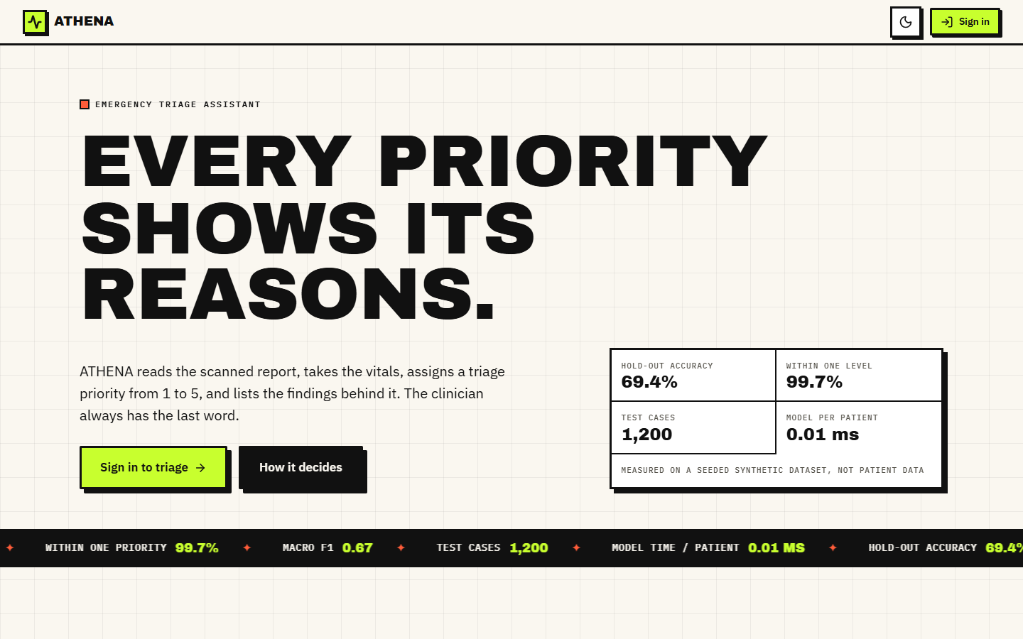  Figure 32: Landing page (light theme): headline, evaluation figures and a scrolling ticker of the key numbers. | 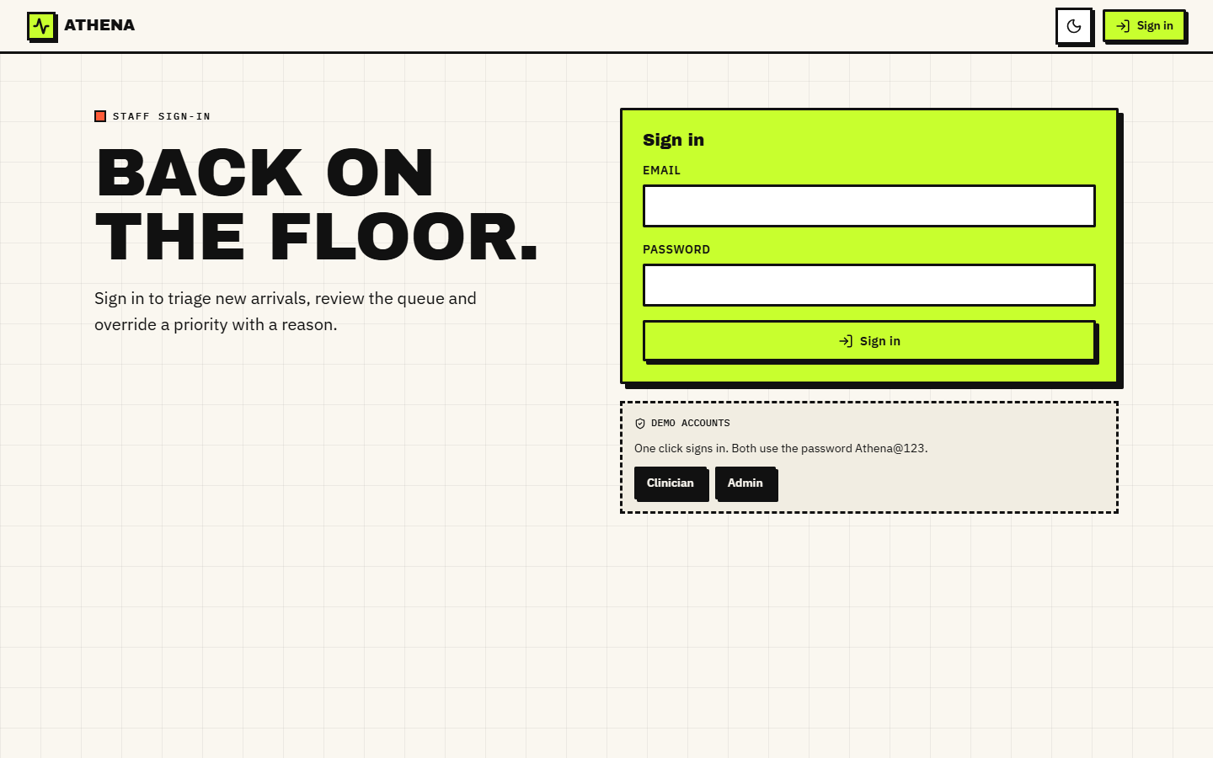  Figure 33: Sign-in page with the two demo accounts.

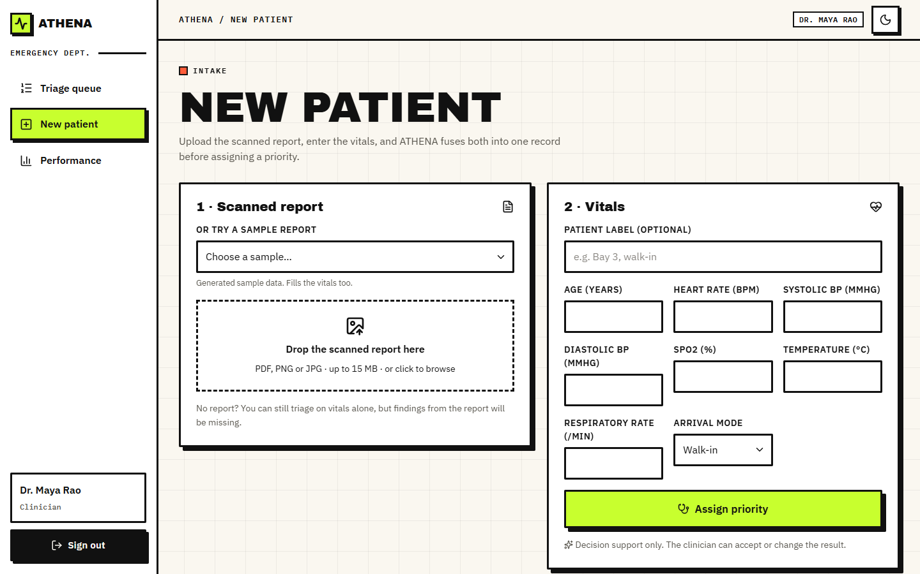  Figure 34: New patient screen before a report is chosen. | 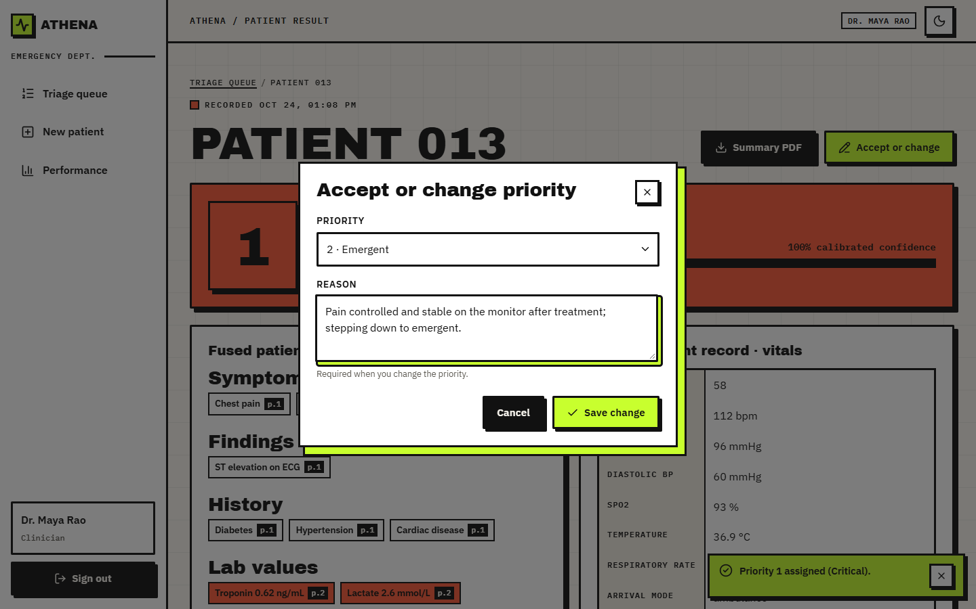  Figure 35: The accept-or-change dialog on the result screen.

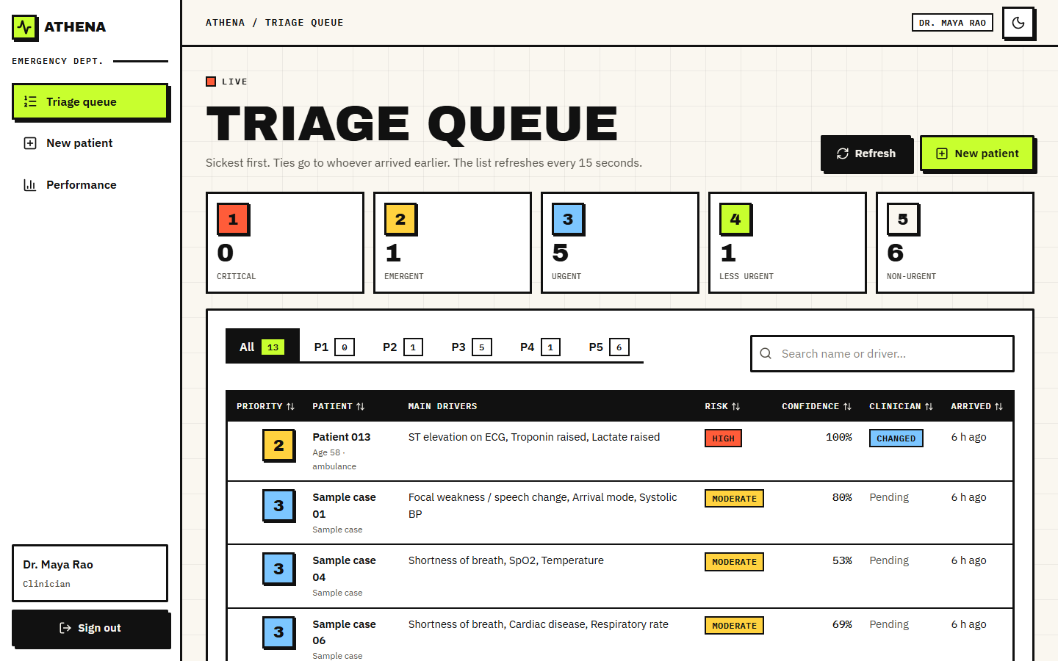
Figure 36: Triage queue after a clinician changed a priority.

